Blindata Release Note 5.8.8 

27 April 2012

Bug Fixes and Enhancements

3785. Administration > Users

If you tried to edit a user record, an error appeared. Fixed.

3786. Sales Files > Customers

If you copied a customer record, the new record could not be seen in the customer enquiry form. This was because there was no address_id value held in the new customer record. Fixed.

3787. Administration > Archiving

An error was coming up when you tried to archive orders. Fixed.

3788. Cutting Sheet

We have made the cutting sheet (with blind diagrams) form slightly shallower because it was not possible to see the ‘Print’ button on some screens.

3789. Sales Analysis Remake

We have made the font smaller, narrowed column headings, made complaint type a lot wider, fitted in fabric description, and removed the VAT column.

3793. Purchase Order Enquiry > PO Label 2

The margins and page length of this report are now identical to ‘Label print – Bespoke 33A’.

3794. Paul Simon Import (csv Order Import)

When a detail line is imported, the price is now looked up and saved.

3795. Order Processing > Orders

If you enter a repair detail line, the discount has now been disabled.

3797. Administration > Import From Excel > Discounts

When you import discount records, the ‘Fabric Class’ flag got switched on for that discount order you are importing. Fixed.

New Work and Customer Requests

2609. Order Processing > Orders > Component Detail Entry

This form has been amended a lot over time and was starting to look a bit messy. There were also fields in it that were only relevant to certain customers.

We have now redesigned the form to make it look cleaner (and more like the blind detail entry), and have also created parameters so that fields can be hidden.

So in Administration > Users, there is a new tab called ‘Forms Visibility’, where fields can be switched off or on for the ‘Component Detail Entry’.

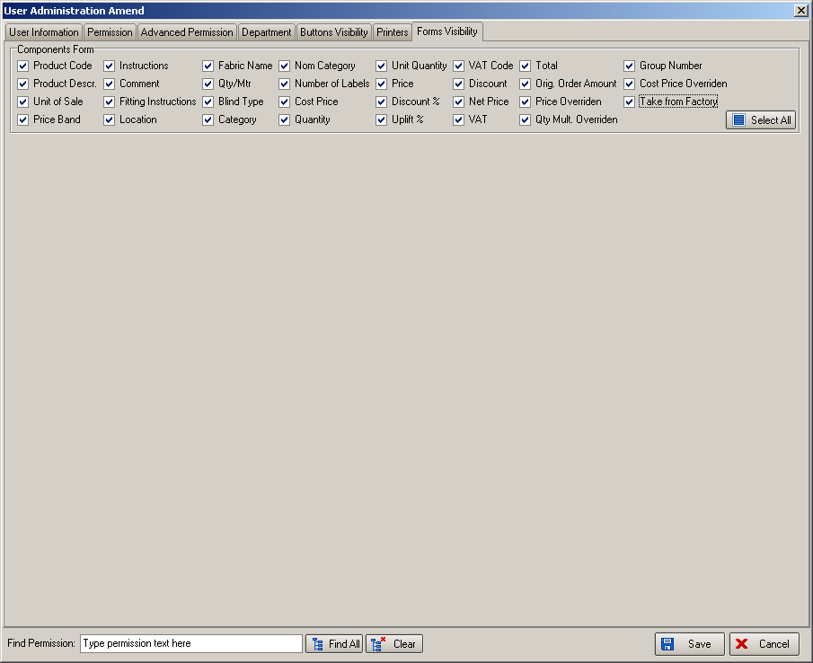

The ‘Component Detail Entry’ now looks like this:

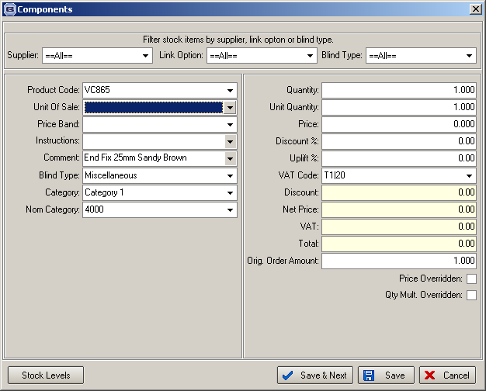

2640. Order Processing > Production Documentation

There is a new button on this form called ‘History’ that allows specific users to see the choices that have been made for previous production documentation runs. There is an advanced permission flag for this button in Administration > Users.

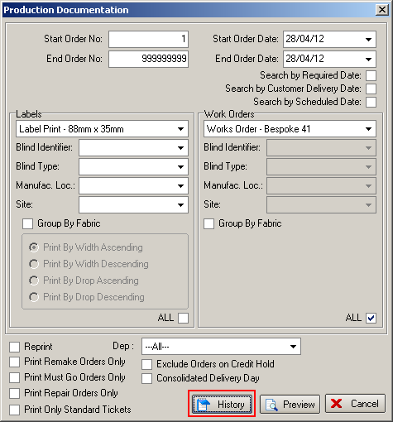

When this is selected, the following form will be displayed.

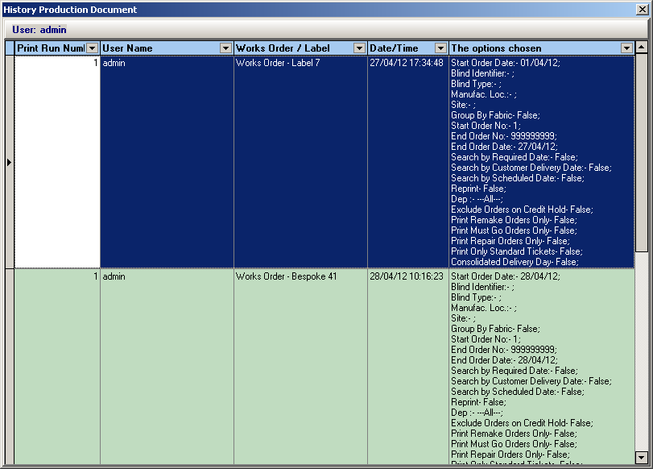

2641. Panel Blinds Calculator

There is new calculator called ‘Panel Multiple’. This multiplies the quantity field in the relevant record in the ‘Dimension Calculation’ table by the number of panels required for the blind.

2646. Order Processing > Order Enquiry > OOS Scan

There is a new parameter in Administration > Parameters called ‘Re-schedule on Promised Date’. The following functionality will only be applied if this parameter is switched on, and only affects the ‘Blind In Stock’, ‘Blind Out Of Stock’, ‘Order In Stock’ and ‘Order Out Of Stock’ buttons in Order Processing > Order Enquiry.

When any of the Out of Stock scan functions were run in the Order Enquiry screen, the order was removed from the schedule. This has changed this so that the order is rescheduled into the ‘promised date’ on the order. The promised date is the date the customer is told their order will be back in stock. This will help production keep track of capacity as previously out of stock orders were not accounted for.

When the scan takes place, the order is removed from its current scheduled slot. If is then re-scheduled based on the order ‘Promised Date’. If there is not enough capacity on the ‘Promised Date’ then the order is scheduled into the next available slot after the Promised Date. If the quantity is less than the Large Quantity figure on the Manufacture Location system table, then the whole order is scheduled on the same day as normal. If the quantity is greater than the Large Quantity then it is split over multiple days, starting from the Promised Date.

Lastly, if the Promised Date is blank, or is less than the current date, then the order remains unscheduled. Also the Required date on the order is set using the normal rules taking consolidated days into consideration.

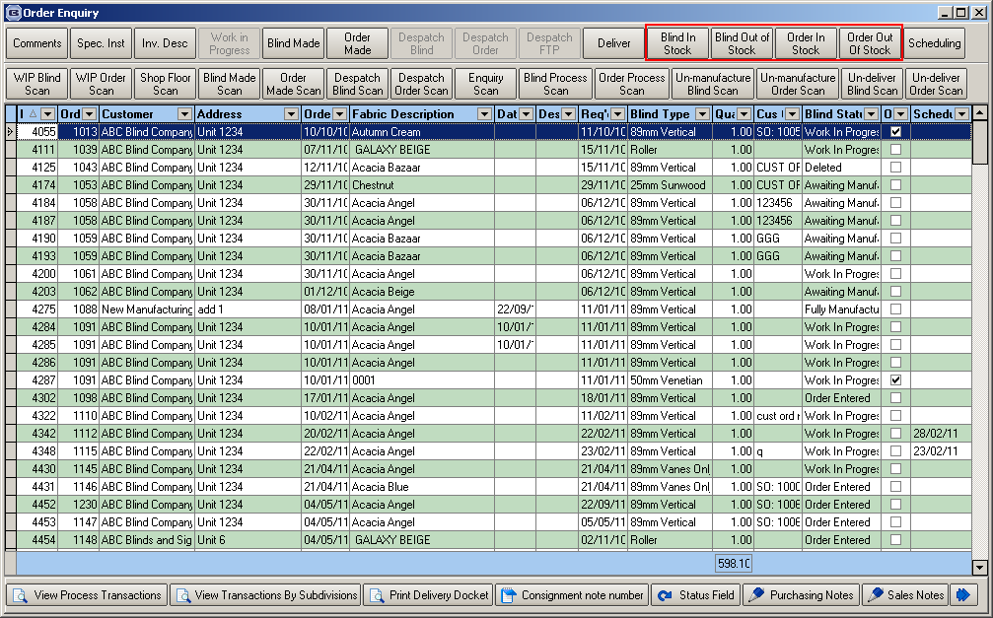

2647. Order Processing > Order Enquiry > BIS Scan

Along with the above changes to the OOS scan, the BIS (Back in Stock) scan has also changed slightly. The BIS scan function will no longer re-schedule the order. It will only remove the OOS flag from the order. The exception to this will be if there was a problem with the Promised Date and the order was not scheduled during the OOS scan. In this case, the BIS scan will schedule the order into the next available slot as it does currently.

Again, this functionality is only applied if ‘Re-schedule on Promised Date’ is switched on.

2648. Order Processing > Orders > Wood Default Options

Previously, the default Slat Valance and Bottom Bar options that are set for wooden venetians via the Wood Sizes system table were not editable. If you tried and change an option, it would automatically reset itself back to the default option. However it is possible for a customer to want their valance or bottom bar to be a different colour from the rest of the blind. It is now possible to change the option so it will not be reset to the default if another option is changed.

2649. Order Processing > Orders > Original Order No

On remake orders, there is an Original Order field on the Totals tab in the form of a drop down box which is populated by the original order number. If the original order for the remake has been fully archived, it is now also available to select in the lookup.

2650. Order Processing > Orders

If the Valance Width or Return Size of a blind were modified to be different from the default that is generated from the ‘Return Valance Size Add On’ system table, and then an option on the blind is modified, previously the Valance Width and Return Size were recalculated back to the default. The modifications to these fields are now held and retained even if an option is chaged. They are only reset by changing the blind type.

2655. Despatch Label Print 3 ½ x 1

A new ‘Despatch Label’ has been created called ‘Despatch Label Print 3 ½ x 1’ which is a choice in Administration > Parameters > Reports > Despatch Label.

It prints delivery company name, a bar code for the customer reference and box number (eg 1 of 2).

2656. Works Order – Bespoke 41

A new works order report has been created called ‘Works Order – Bespoke 41’.

It groups orders by blind type and can be printed in metric or imperial.

2657. Invoice – Bespoke 41

A new invoice report has been created (regular, batched, pdf) called ‘Invoice – Bespoke 41’. It is based on ‘Invoice – Bespoke 36’ but with the following changes.

Includes discount column, and has registered office information at the bottom of the page.

2666. Purchase Order Bought In (Blind Size)

There is a new parameter in Report Parameters called ‘Print Supplier Part No on Bought In PO’.

If this parameter is set to true, then the supplier part no replaces fabric description in the report.

