Blindata Release Note 5.8.7 

20 April 2012

Bug Fixes and Enhancements

3775. Order Processing > Orders > BOM

The panel blind BOM was not working properly for a consumable. Fixed.

3778. EDI Import

Euro online customers were getting confused by order acknowledgments because it showed a sterling symbol against their total. The EDI import was not assigning the currency symbol correctly. Fixed.

3781. EDI Transmit > Transfer File 2

When this file is sent, it now starts with the word ‘Order’ instead of ‘Transaction’.

3782. Acknowledgement – Bespoke 17 (report and pdf)

The company name, telephone and fax number are now taken from ‘Company Name’ in the department record, not ‘Company Details’.

New Work and Customer Requests

2620. Order Processing > Remakes

The ‘Complaint reason’ field can now be displayed if ‘Remake’ is ticked. If an order is flagged as a remake, then the user has to enter a ‘Complaint Type’ (lookup from ‘Complaint Type in System Tables’). However some customers may not want this so there is a new parameter called ‘Remake Complaint Type Required’.

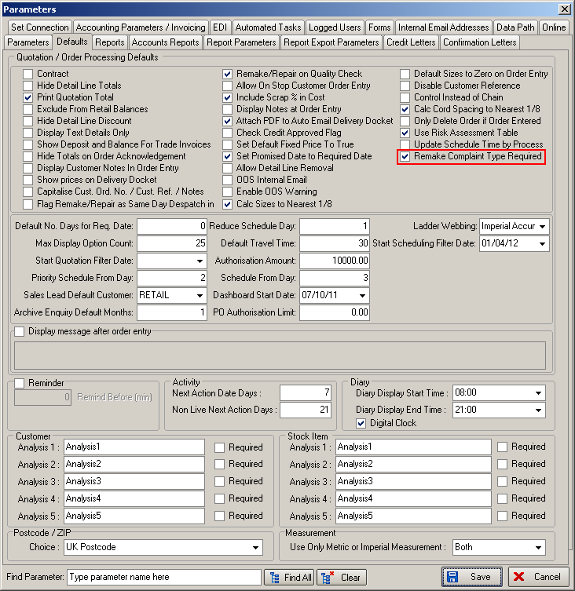

2621. Sales Analysis > Sales Analysis Remake Report

There is a new report called ‘Sales Analysis Remake Report’. This is based on ‘Sales Analysis by Order’ but also contains blind type (2R, 1 S25 style), orig ord no, orig del date, remake o/n, remake del date, total blinds on original order, complaint type, cost price remake.

It prints in landscape and only show remakes.

2622. Purchase Order Enquiry

Required date is now on ‘View Related Sales order’ and also prints on the PO label.

2636. Posting to Sage

We have improved the parameters to identify which fields get updated to the relevant Sage fields. The following choices are now possible.

In Sage the Ref column is updated from the Inv No from Blindata.
The Details column is updated from the Order No/Contact Last name

Therefore we added two new parameters:

‘Update Invoice number to Ref’
‘Update Order No / Contact Last Name to Details’.

Receipt Postings
Also in Sage the Ref column is updated from Order No and the Details column is updated from Order No/Contact Last name

And for receipts there are also two more parameters:

‘Update Receipt Order No to Ref’
‘Update Receipt Order No / Contact Last Name to Details’

The Parameters form has been reorganized so all the parameters relating to posting fields to Sage are held together.

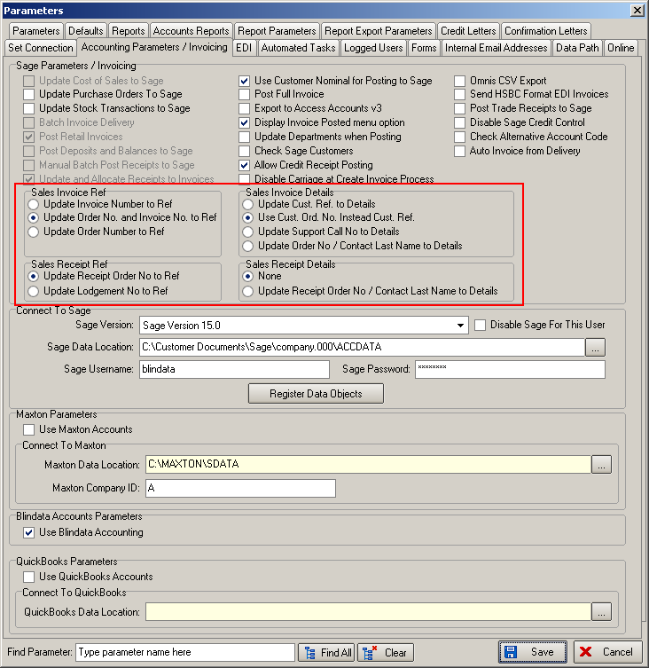

2637. Administration > Parameters > Reports

There is a new report choice in here called ‘Purchase Order Label’. This determines the label layout that is printed in Purchase Order Enquiry > PO Label button.

The only label that printed out now is called ‘PO Label 1’. There is another label print called ‘PO Label 2’. This prints what is on ‘PO Label 1’, but prints onto the same labels that are used in works order print ‘Works Order – Label Blind Size’.

2639. Order Processing > Production Documentation

There is a ‘Group by Fabric’ button in production documentation, but previously this only worked for labels. It has now been enabled for works orders (tickets) as well.

The group order will be by fabric first then by order number.

2642. Acknowledgement – Schedule Date

We have made a change to ‘Order Acknowledgement – Schedule Date’. The text at the end of each line on the acknowledgement previously displayed the scheduled date. This remains the case for standard orders, but any orders that have an Out of Stock Flag now display the following information text which states the order ‘Promised Date’ instead of ‘Scheduled Date’ (for all lines on the order): ‘This order is planned for despatch on [Promised Date]’
If an out of stock order does not have a Promised Date, or the Promised Date is less than the current days date, then this line is not displayed on the acknowledgement.

2644. Acknowledgement – Schedule Date

For any blind type that has ‘Enter Valance Size’ enabled, the Valance Width and Return Size are now printed on the order acknowledgement detail line.

2645. Works Order – Label 1

The Valance and Return Size fields have been moved slightly to the right to make them more recognisable. The ‘Valance’ label has been moved to where the ‘Return’ label was previously.

2651. Purchase Order Enquiry

When the form opens, the record pointer now defaults to pointing at the most recent record.

2653. Administration > Export Data > Blind Type Dataset

Previously it was only possible to either export all blind type datasets or select individual blind types. This was not ideal if we wanted to be able to select a lot of blind types to export (but not all).

There is now a new flag in the blind type record called ‘Export Blind Type Dataset’, which should defaults to true.

It has also been added to the column choices in the blind type enquiry form.

When the blind type dataset is exported, it only exports those blind types that have ‘Export Blind Type Dataset’ = true.

2654. Label Print 3 ½ x 1 – No Desc

If there is a fabric description in Stock items > Customer Descriptions, then for the relevant customer, this fabric description prints on the label instead of the main fabric description.

