Blindata Release Note 5.8.6 

13 April 2012

Bug Fixes and Enhancements

3772. Acknowledgement – Bespoke 34 pdf

If a component line is entered, it was overlapping on the acknowledgment report that is emailed (Report Export Parameters).

New Work and Customer Requests

2615. System Tables > Customer Default Options

We now hold a customer column in this form. If it is left blank, then the functionality will remain as it currently is in order processing. But if there is a customer record then when the defaults are selected, it will check the customer for that order as well and apply the default options just for that customer.

Please note that this will not work if there are already ‘Default Options’ set for the fabric/slat. We are working on this in a separate development.

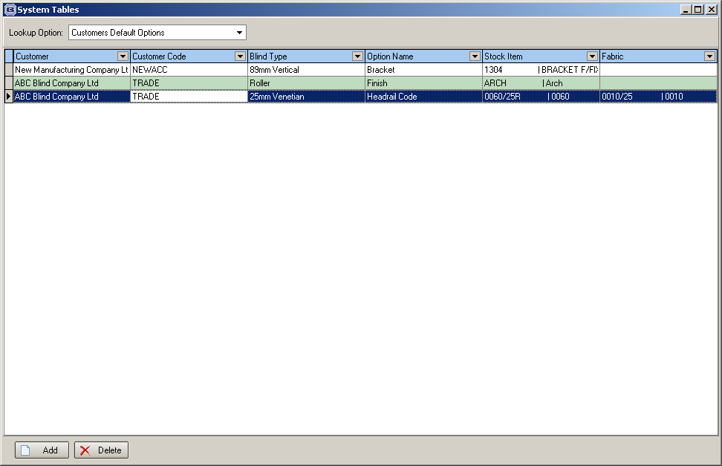

2616. Scheduling

There is now a ‘Start Scheduling Filter Date’ in Administration > Parameters, for the dates that are displayed in the Scheduling form. This determines the start date of records that are shown when the Scheduling form is opened.

2617. Stock Setup > Stock Items

There is now a column choice for ‘Roll Length’

2618. Stock Setup > Fabric Group Setup

There is now a column choice for ‘Roll Length’

2624. Paul Simon Import

There is a new flag in the customer record called ‘CSV Order Import’. There is also a new flag in the customer section of ‘Button Visibility’ which will display a ‘CSV Order Import’ button on the customer form. If both of these flags are selected, then the ‘CSV Order Import’ button at the bottom of the Customer enquiry form will be enabled, and orders can be imported for that customer.

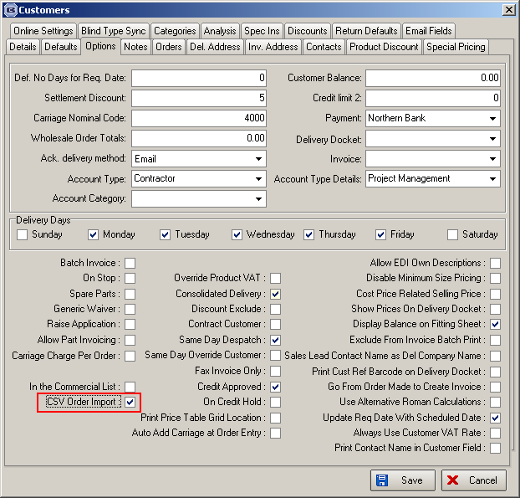

2627. Departments > Quickbooks

We now hold the Quickbooks data location in the department record (in the same way it is done for Sage). If this is filled in, then this Quickbooks company is updated instead of the one in Parameters.

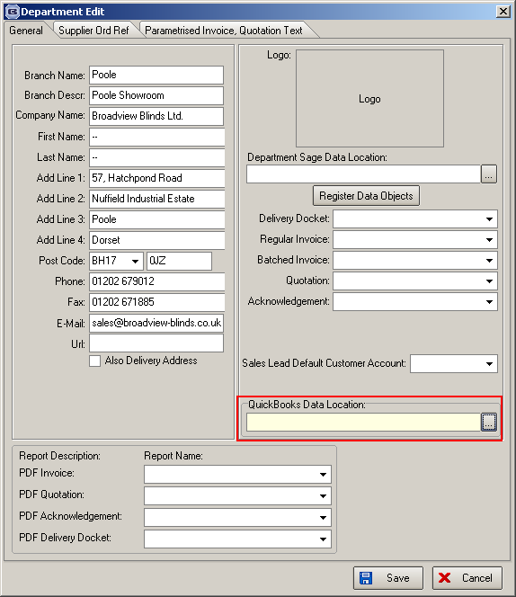

2628. Invoice – Laser Print (Letterhead Logo) 8.5 x 11

If there is a logo held against the department for the order, then the logo from the department and the company name from the department is printed in place of these fields.

2629. Administration > Maintenance

We have been asked by a customer to adjust the categories for blind types so that the ‘Sales Analysis by Customer Class by Category’ report shows different columns. This should affect all orders retrospectively.

We have also been asked by another customer to do the same thing, but with nominal codes.

We have therefore created two new options on the Administration > Maintenance form, one to update categories and the other to update nominal codes.

Please note the respective categories or nominals must be changed in the blind type record before these options will work.

If either of these are chosen, then the category code (or nominal code) that is in the blind type record will be updated to the order detail lines (and archive order detail lines). This will only be for non miscellaneous blind types. For miscellaneous blind types the nominal code should be taken from the stock record.

2630. Order Processing > Receipts

In Parameters, if ‘Update and Allocate Receipts to Invoices’ is switched on, this Receipts form has been upgraded so the following things can be done.

Receipts can be posted to Sage (in the same way as they are done in the receipt entry in Order Entry). This means the order status is updated (if necessary) and allocations done (if relevant)

If ‘Post Trade Receipts to Sage’ is switched on, it is also possible to enter receipts in here.

2631. Invoice – Bespoke 8

The logo from ‘Company Details’ now prints on this invoice, in the top centre. Also this invoice print is now available in ‘Report Export Parameters’

2632. Reports > System Reports > Customer Product Discount

There is now an option to choose this report by rep. Previously it could only be chosen by customer.

2633. Delivery Docket – Laser Print

If delivery notes are entered (in the ‘Delivery Notes’ button in Order Amend Enquiry), they now print out at the bottom of this report.

2635. Works Order – Label 7

If the order is flagged as a repair and a repair detail line is entered, it now says ‘Repair’ on the big label and also prints the repair text on the big label.

