Blindata Release Note 5.8.5 

6 April 2012

Bug Fixes and Enhancements

3768. Acknowledgement – Bespoke 34 (Email pdf version)

- There is now a gap between the : and the company name.
- The company name is now cut off 0.5cm before the end of the page.
- There is a gap between the : and the despatch method.
- If there is a component line, the text was being overwritten. Also, if it is a component line, the width and drop are now blank. This section is now the same as the print version of ‘Acknowledgement – Bespoke 34’.

3769. Works Order – Bespoke 40

For some blind types, the word ‘Pleat Qty’ was missing on the works order. Fixed.

Also, if a component line is entered, we have made a few changes.

- ‘Brackets’ is now ‘Quantity’.
- ‘Pleat Qty’ is not required.
- ‘Finished Size’ is not required
- The fabric description has been moved just to the right of ‘Blind No’.

New Work and Customer Requests

2595. Updating Blindata Online

We have created a completely new synchronisation program for Blindata Online. This utilises Replication in SQL Server and so will only work if a full version of SQL Server is installed on the main server.

The main reasons for making this change are as follows:

Replication is a more stable and quicker method of updating the online database
Users do not have to be logged out of the online database for replication to take place
The status of the orders will be updated properly.

2610. Order Processing > Orders > Component Entry

It is now possible to do scheduling of orders for component detail lines. We will have some customers that do not want this so there is a new flag in the blind type record called ‘Disable Scheduling’. This new flag defaults to false (so the program will behave as it currently does).

When a component detail line is entered, it should be scheduled in exactly the same way as a blind detail line is (unless ‘Disable Scheduling’ = true).

2611. Order Enquiry > Blind Process Scan / Order Process Scan

Previously, if process scanning is used and scheduling is switched on, the scheduling minutes only got reduced when the blind was made.

There is now a new flag called ‘Update Schedule Time by Process’ in the Parameters table. This defaults to false (so the program will behave as it currently does).

If the new flag is switched on, when a process is scanned, it should check the scheduled minutes held for the relevant process scan, then reduces the minutes in the schedule for the relevant manufacturing location. This means the schedule minutes are not altered when the blind is changed to ‘Blind Made’, because the schedule has already been updated.

2613. PO Settlement Discount

We can now calculate the VAT settlement discount on purchase invoices. The settlement discount % is held against the supplier record. If this is set to > 0, it is now displayed on the purchase invoice form and the VAT amount calculated. There is also a new flag so that the amount can be posted to Sage (or Blindata accounts) or to the Lakeview PI file as well, with the VAT amount altered.

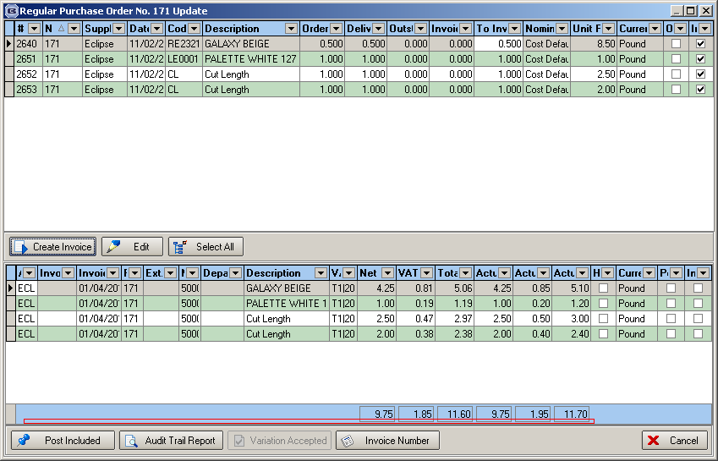

The following should be printed (if settlement discount is in the supplier record). In this example the settlement discount is 2.5%, the goods total is 9.75, so the VAT is calculated as 9.75 * ( VAT %/100) * (100 – 2.5)/100.
‘Calculations after settlement discount of 2.5% (0.24) applied: 9.75 1.80 11.55

In this case the amount that would be posted to Sage or Blindata Accounts or to the Lakeview PI record is a net figure of 9.75 and VAT of 1.80.

