Blindata Release Note 5.7.7 

10 February 2011

Bug Fixes and Enhancements

3714. Administration > Export Data

When data is exported using ‘Blind Type Dataset’, if a fabric or an option has ‘Fabric Not In Use’ = true, then it is not exported.

3715. Works Order – Bespoke 40

- The fabric quantities are now being calculated properly.
- The cutting size descriptions were being cut off slightly. Fixed.
- The ‘Finish Size’ column now has the heading ‘Finished Size’ instead of ‘Finish Size’ and the actual sizes are the man width and man drop, not the entered sizes.

New Work and Customer Requests

2567. Purchase Order Enquiry

When a regular PO is manually created, the sales order numbers relating to the stock item entered can be shown in a drop down list. This is done by right clicking on the purchase order detail line and selecting ‘View Related Sales Orders’.

When the sales orders are displayed, it is now possible to select records and flag them, so they are then tied to the purchase order. When the PO label is printed, it now shows the sales order numbers on it.

2570. Scheduling

There is a new parameter called ‘Priority Schedule From Day’. Previously orders that came in from a priority customer are scheduled asap in the priority scheduled time. This means they are often being scheduled for the same day as the order is entered, which is not practical for most of our customers. The same logic now applies to ‘Priority Schedule From Day’ as currently is used in ‘Schedule From Day’ for non priority orders. In other words the number of days held in ‘Priority Schedule From Day’ is added to the current date to give the priority scheduled date (provided there is time available).

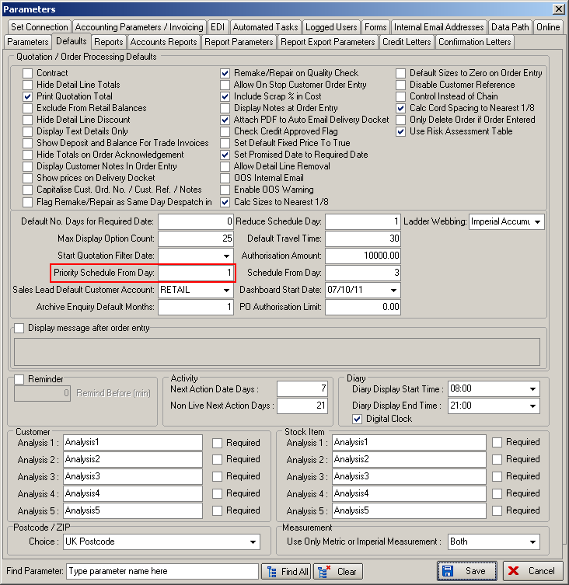

2571. Carriage

There is a new flag in the customer record to say that carriage is always charged. This flag is called ‘Auto Add Carriage at Order Entry’.

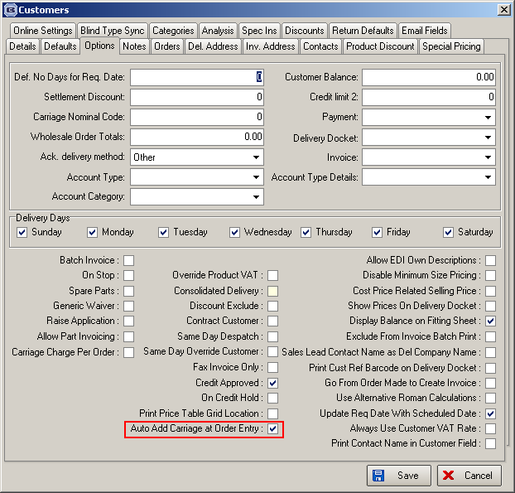

So when an order is entered and this flag is switched on for the customer, a carriage detail line is automatically added to the order when it is saved.
This feature is required because when the order acknowledgement is sent to the customer, they want to see the carriage on it.

If this new flag is switched on, then carriage does not get added again at the ‘Create Invoice’ stage.

We have also made sure that this carriage line has no impact on the changing of status values e.g. if there are two blinds on an order and one carriage line, when both blinds are manufactured, the order status changes to ‘Fully Manufactured’.

Also carriage lines do not appear in ‘Order Enquiry’ and ‘1M’ does not appear on works orders or labels if there is a carriage line.

2572. Scheduling

For certain despatch methods, it is now possible to disable ‘Update Required Date with Scheduled Date’ and actually make the required date the next available delivery day in customer record after the scheduled date.

To activate this, there is a new flag in System Tables > Despatch Method, called ‘Disable Update Required Date From Scheduled Date’.

For example, if the scheduled date was Wed 08/02/12 but the only delivery day for a customer was a Tuesday, then the required date would become Tue 14/02/12.

2574. Diary

There is a new ‘Create Customer Account’ in the ‘Sales Lead Amend’ form. This means that an appointment can be created, and a new customer record created for it at this point.

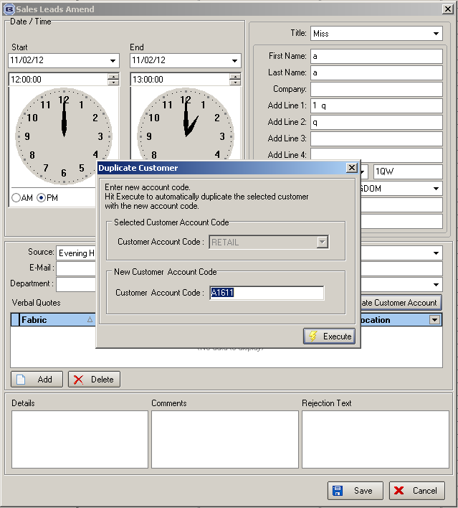

When this choice is made, the new account code defaults to the appointment number prefixed with A.

2575. Order Processing > Orders

There is no longer an option for cancelling an order in ‘Status Fields’. This choice has been removed when ‘Status Fields’ is selected.

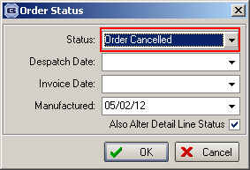

2578. Works Order – Bespoke 40

All verticals in an order are now shown on the same worksheet. Previously the report was split into different pages for each blind type. All other blind types remain separate.
Headings have been corrected to fit boxes.
Supplier description now appears in the top right fabric section.
If ‘Must Go’ is selected, it is printed in red on top of the works order.
Pleated blinds – all entered sizes (except hypotenuse) figures now print.

W146. Order Processing

We have created an admin login page for the online site so we can change the statuses of payment pending orders.

