Blindata Release Note 5.7.9 

24 February 2011

Bug Fixes and Enhancements

3724. Acknowledgement – Lead Time Text

Repair Text is now appearing on this report. It is on both the print and the pdf.

3725. EDI Import

The OOS Warning flag was preventing EDI orders from checking. It no longer does this.

New Work and Customer Requests

2577. Quotation - Bespoke 40

This report has now been completed.

2582. Quotation – Bespoke 21

There is now a field for Quotation Text in the Department record so it can be printed on this report. This text is held against the department record in the following tab. If the ‘Quotation Text’ field is left blank, then the existing text will print.
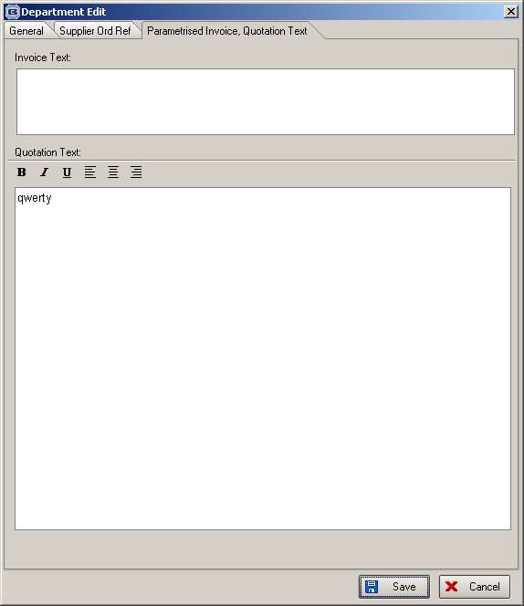

2583. Bought In Purchase Order > Alternative XML File(Partly)

If the blind identifier = head rail, the bli_colourway is no longer put in the file.
If measure to = glass size, then the measure to is no longer put in the file.

These items only relate to the alternative XML file.

2585. Import From Excel > Stock Updates

It is now possible to import ‘Location’ and ‘Product Group’ from a spreadsheet – the first column of the spreadsheet must contain the stock code of the record that these fields are being updated to.

2586. Order Processing > Orders > Components

We have a customer that sells mostly box blinds, but as components. When they enter a component detail line, they want to choose from several different possible selling prices. There will be lots of products that fall into the same product group, so we need to be able to group the prices.
As we do not use ‘Fabric Group’ in the component detail entry, let’s use this field, along with ‘Product Group’.

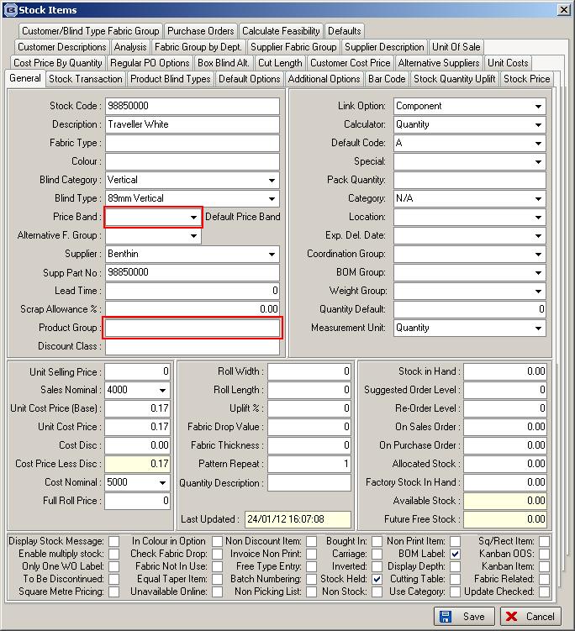

Work Done

There is a new field in Parameters called ‘Use Component Price Band’.

There is a new menu option in Pricing called ‘Component Group Price Table’. This holds ‘Product Group’, ‘Price Band’ (fabric group) and Price.

If ‘Use Component Price Band’ = true, in the component order detail entry, there is now a field choice for ‘Price Band’. This will lookup the ‘Fabric Group’ table and store the result in fabricgroup_id in the OrderDetail table. Once the price band has been selected (and the ‘Product Group’ found from the stock/fabric table), the program searches the component group price band table to find a price. If either the product description product code or price band is changed, the price lookup is re-done. The ‘Price Band’ defaults to the fabric group set up in the stock record.

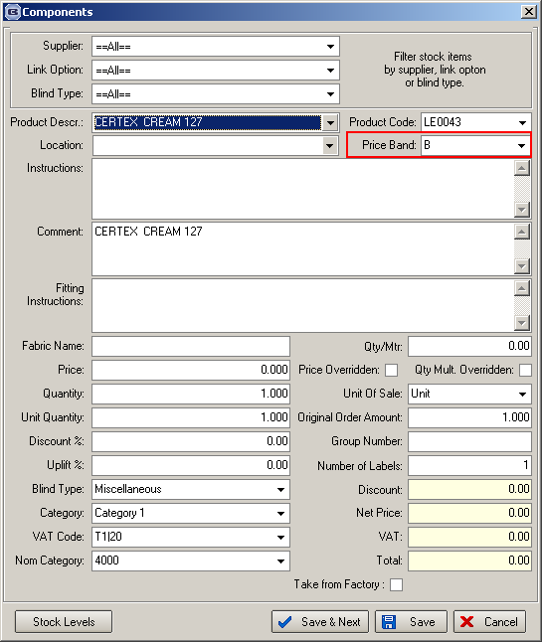

There may be a lot of records in the component group price band table, so we have created an import routine. There is a new option in ‘Import From Excel’ called ‘Component Group Price Table’, and it has the following layout.

Price Band | Product Group | Price
A | Group 1 | 10
B | Group 2 | 20

2587. Dashboard

The ‘Delivered Orders’ amount for the week is now shown on the dashboard.

2588. Order Processing > Orders > Components

If a particular component detail line is entered, a reminder message can now appear to tell the user to enter something else. To do this, we now hold a text field against a new tab called ‘Default’ in the stock item. There is a new field in there called ‘Reminder Text’. If this is not blank, then in the component detail line entry window, a message appears when the component detail line is saved with the ‘Reminder Text’ for the stock item just entered.

