Blindata Release Note 5.7.8 

17 February 2011

Bug Fixes and Enhancements

3716. Label Print – Bespoke 33A

If a blind type is flagged to show the cord spacing and there are cutting sizes set up as well, the cutting sizes no longer overwrite the cord spacing.

3719. Order Processing > Orders

If ‘Allow Part Despatch’ is set to true in Parameters and if you tried to reprint a delivery docket using the ‘Deliver’ button on the Order Amend Enquiry form, the message ‘The report is empty’ appeared. Fixed.

New Work and Customer Requests

2569. Order Processing > Orders

There is now a new advanced permission option to stop users from being able to amend orders from the ‘Create Invoice’ stage onwards.

2576. Administration > Import From Excel

There is now an option to import contact records to attach to customer records. There is a new form choice called ‘Customer Contacts’, where we can import records so they appear here.

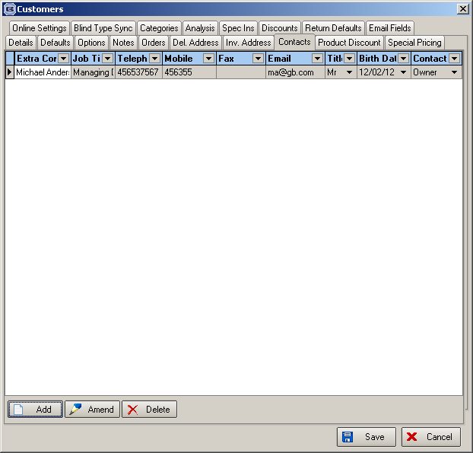

The spreadsheet contains headers and records for:

Customer account code, extra contact name, job title, telephone, mobile, fax, email, title, birt date, contact type.

It is possible for any of the fields to be blank except customer account code and extra contact name.

2580. Formula

When entering a formula, it is now possible to correct a mistake more easily. Previously all you could do is to clear the whole formula and start again. It is now possible to edit the text. We have also allowed the validation of a 0 result.

