Blindata Release Note 5.7.1 

4 January 2011

Bug Fixes and Enhancements

3671. Order Processing > Orders

If a blind type is set up to be bought in, and there are option prices for the blind that have an uplift %, the selling price uplift worked properly, but the cost price did not. The cost price is now uplifted properly.

3672. Works Order Label 1

If ‘Kanban Item’ is set to true in the fabric record, the word ‘Kanban’ was printing. It has been removed.

New Work and Customer Requests

2462. Archive Enquiry

It should be possible to view and print BOM from an archived order. If you right click on an order, the detail lines can be viewed and then the bill of materials printed by clicking on this button.

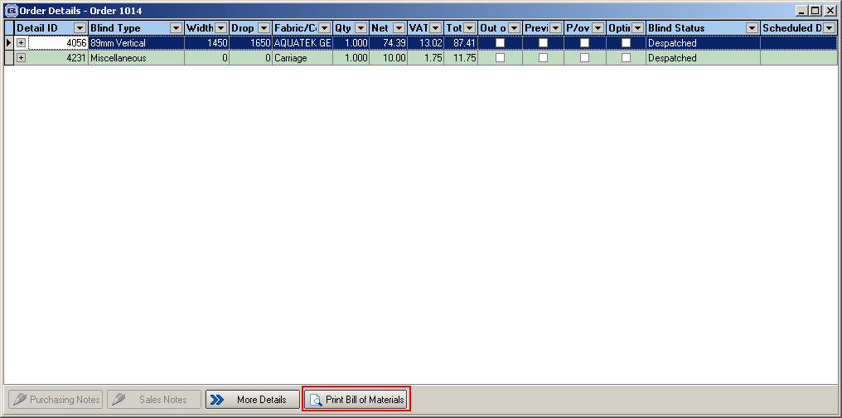

2472. Diary > Email To Rep

There is now an option to email a diary for a full day to a rep. We have tied this in with what we are doing to send out appointment data to the iPhone app.

There are therefore two new flags held against the employee record

Email Diary To Rep
Create Appointment XML

Only one of these flags can be switched on at a time.

We also hold a folder location for the appointment XML file.

There is a new option on the diary form called ‘Appointments to Rep’. This then displays a form that has ‘Appointment Date’ and ‘Rep’ as choices. The appointment date defaults to the next working day and rep defaults to ‘All’. There is also a button called ‘Run’.

When ‘Run’ is pressed, either an email with a pdf of the diary for the day (same report as in ‘Preview’) will be emailed to the rep, or an XML file will be sent to the relevant folder. This will be dependent on the flag that is switched on (either ‘Email Diary to Rep’ or ‘Create Appointment XML’).

2473. Administration > Archiving

There is now functionality for archiving diary appointments. There is a tab in the Archiving form so appointments can be archived in the same way as orders and quotations are.

All archived appointments will still display on the Diary form and they will be found after “Find” button is used. Archived Appointments will be read only.

2476. Order Processing > Orders

If a customer is a ‘contract customer’, then when an order is created, the ‘Contract’ flag is set to true in the order.

Also it is now possible to hold default contract text. This is held in Company Details > Child Safety / Cooling Off Period. If ‘contract’ is ticked in the order, the default contract text is put in the ‘Contract Text’ box. If there is nothing in the default contract text box, then nothing happens.

2477. Delivery Docket – Bespoke 15

For retail customers, the balance has been added to the footer in the report.

2479. SMS Messaging

Fitting date is now a field choice option in the text in Company Details > SMS Delivery Text.

2484. Order Processing > Archive Enquiry

We have added delivery note number as a column choice on archive enquiry.

2485. Order Processing > Orders

There is now a user advanced permission to be able to change a fabric group in an order detail line. Previously it was only available as a main parameter.

2486. Administration > Parameters > Reports

There is a new parameter called ‘See Report Selection’ which defaults to false. If it is set to true, then when any of the reports that are selectable are printed, the user gets the choice of which one to print. This has only been applied to the following buttons:

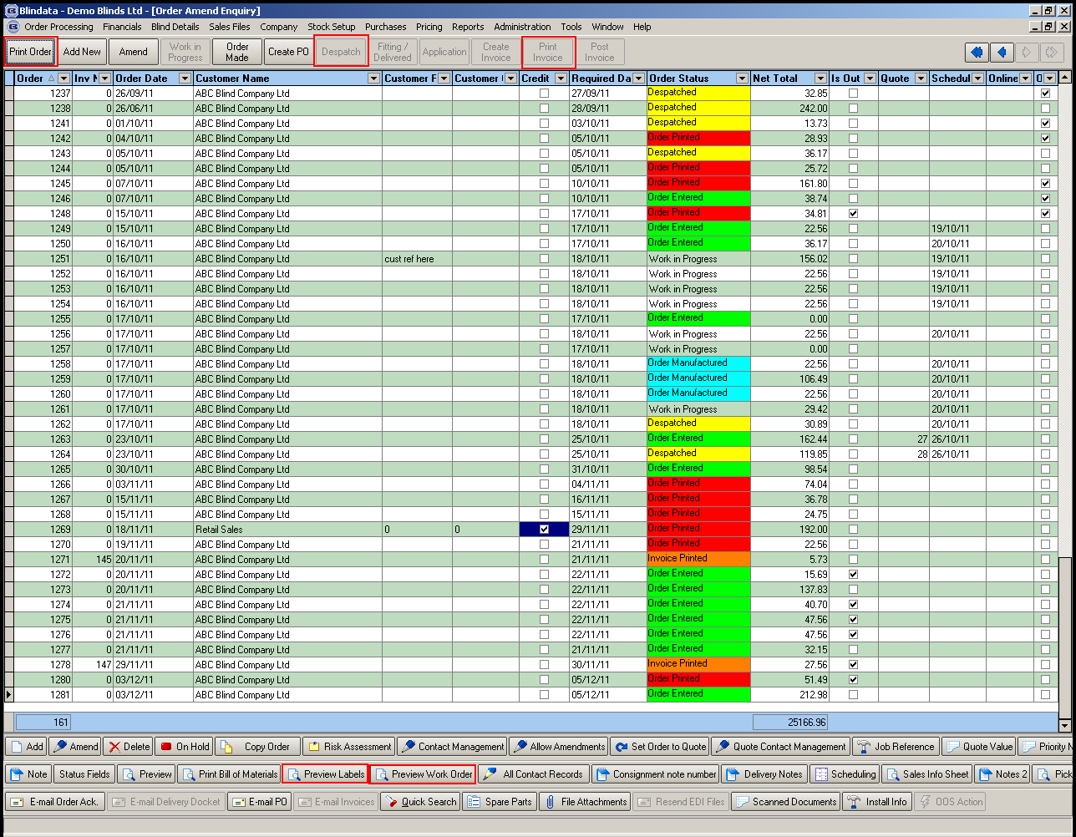

2497. Omnis Export by Department

If Omnis CSV Export is switched on in Parameters, we need a method of exporting customers and invoices by department.

We’ve checked CSV Export functionality and we have several questions on it.

- There is already a possibility to export invoices by department:

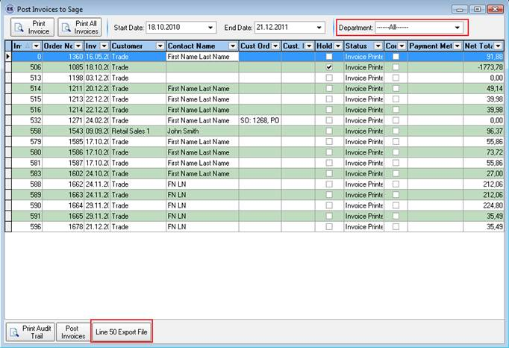
Should we change anything here?

Correct, so we do not need to do anything

- Did we understand properly we have to add ‘Department’ drop down list on the form below (for ‘Customer Records’ choice only) as it’s on the ‘Post Invoices to Sage’ form above?

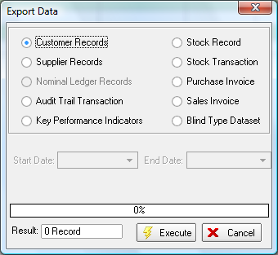

Yes, let’s have ‘Department’ as a drop down list with the default choice being ‘All’.

2504. Administration > Maintenance

We are trying to get customers to use the stock codes that are provided by the suppliers. At the moment if other codes are used, then the customer has to go into each stock record and change the stock code.

We have added two different routines to the Maintenance menu. Both will look at a spreadsheet that has two columns – the first is the old stock code and the second is the new one.

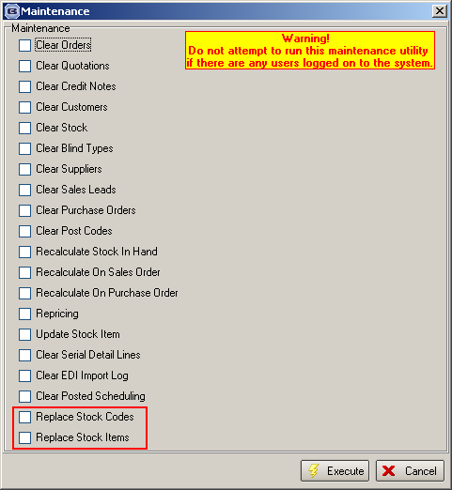

The first routine simply replaces one code with the other for each stock record.

The second routine is more complex. Example – T6J2 and 18011138A are both Alaska Berry, with the latter flagged as ‘fabric not in use’. But 18011138A is the stock code that we want to use, so we should change T6J2 to be 18011138A. We should then remove the original 18011138A.

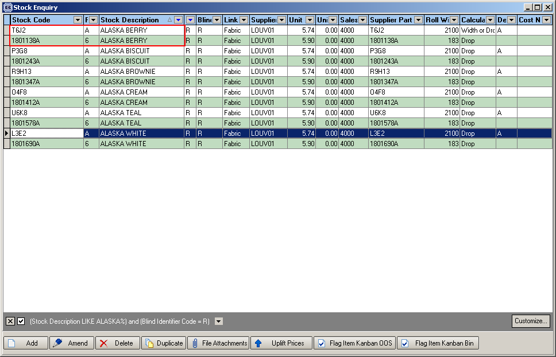

2505. Invoice – Bespoke 29

Print terms and conditions (from Customers > Invoice Terms) now appears on bottom left of invoice. This prints to the left of ‘Net Total’ and in line with the ‘Order’ column.

2506. Reports > System Reports > Contact Management by Employee / Customer

These contact management reports now show ‘Further Details’ field as well as existing fields.

2510. Administration > Import From Excel

There is a new choice on this form called ‘Import Stock Dummies’. This import records from a spreadsheet with two columns: stock code, dummy code.

