Blindata Release Note 5.7.6 

7 February 2011

Bug Fixes and Enhancements

3708. EDI Import

Sometimes orders that were imported via EDI, which had OOS warnings applied, were being flagged as ‘Checked’, which should not happen. Fixed.

3709. Fitter Sheet / Sales Leads

If you tred to change the status of a survey to ‘Completed’ and there was no first name, you could not change the status of the survey appointment. Fixed.

3710. Works Order – Bespoke 34A

- Blind type description should go here.
- Customer company name and delivery address prints to right of blind type description
- Moved logo up slightly.
- Made option names smaller so they fit in the boxes
- Hardcoded boxes now appear at the bottom of the report..

3711. Purchase Order Enquiry

If you use the ‘Generate Bought In PO’ button to create bought in purchase orders and ‘Enable WIP Status’ = true and ‘Change Order Status after PO Create’ is true, then the sales orders now changes to ‘Work In Progress’ after the PO is created.

3712. Purchase Order Enquiry > Deliver Scan

If ‘Generate Bought In Po’ is used and more than one sales order is on the Po, when the ‘Deliver Scan’ is done, it now delivers all the records in the bought in PO. Previously it was only delivering one blind (the one that was scanned). It now deliver all the blinds that are in the PO.

This means it changes the sales order to ‘Fully Manufactured’ for each sales order that is in the PO (providing there are no other blinds in the sales orders).

It also changes the status of the bought in purchase order to ‘Delivered’.

3713. Label Print – Bespoke 33A

If an order is flagged as a repair, the repair text appears on the small labels, and it now also appears in the large label. This was not working previously (in 5.7.5).

New Work and Customer Requests

2556. Solar Solve Marine Reports

We have made the following changes to the export order, despatch note and invoice reports for one particular customer.

- Different logos can be printed out depending on the department assigned to the order. The logos are held against the departments in System Tables > Departments.
- It is possible for the customer to amend text on the order and the invoice. The text is held in System Tables > Bank Payment Details, and the bank payment details field can be held against the customer.

2557. Despatch > City Link CSV

In the customer record it is possible to hold default delivery instructions specified in the Carriage text field. When the order is despatched, these go into the special instructions field 1 and if over 60 characters continue into special instructions 2 in the City Link CSV file. However if there is text in the ‘Delivery Notes’ field in the order record, then this text replaces the carriage text from the customer record.

2558. Order Processing > Orders

If ‘Activate Amendment Reason’ is set to true in Parameters, the following form will appear when the detail line is saved.

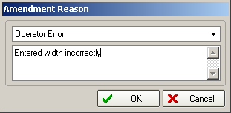

There is a new user permission called ‘Prompt Amend Reason’ which, if set to true, will force the user to add a reason code from the dropdown after amending and saving. If false, then the user will not have to add an amendment reason. This flag, in effect, overrides the ‘Activate Amendment Reason’ flag.

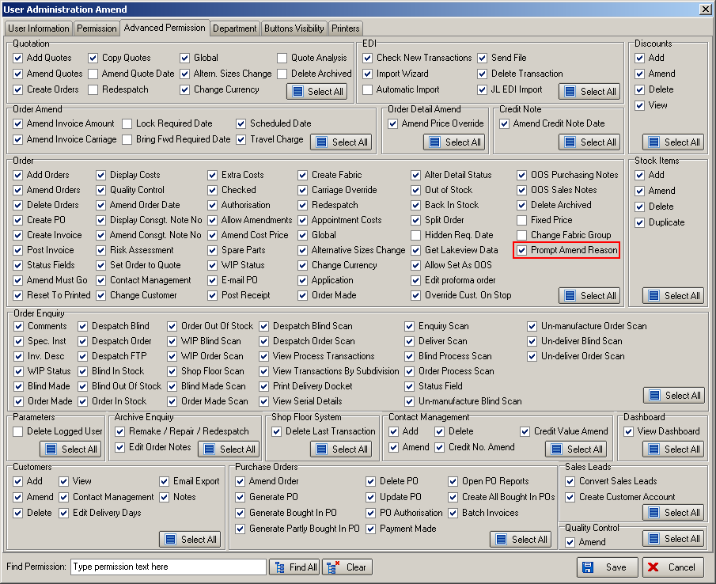

2560. Customer Specific Same Day Despatch Cut Off Times

There is a new flag on the customer record called ‘Special Same Day’, which will override the cut off time in the EDI parameters, and replace it with a time specified in the customer record (a field called ‘Cut Off Time’ that is only enabled if ‘Special Same Day’ is switched on).

If this flag remains switched off, then the cut off logic remains as it is currently.

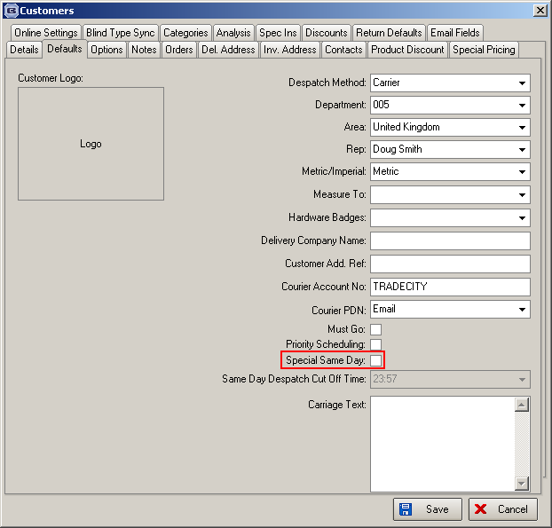

2561. Customer Specific Online Options/Fabrics

Scenarios can sometimes arise where certain customers may have specific option requirements or be restricted from access to certain fabrics.

To cater for this we have improved the current ‘Option Restrictions’ system table. Previously if a record was in here for a customer, then it was not available as a choice when an order was entered. We now have a flag here called ‘Available’ to indicate it is a choice for the relevant customer (but not for any other customer).

This has been implemented in both the desktop and online systems.

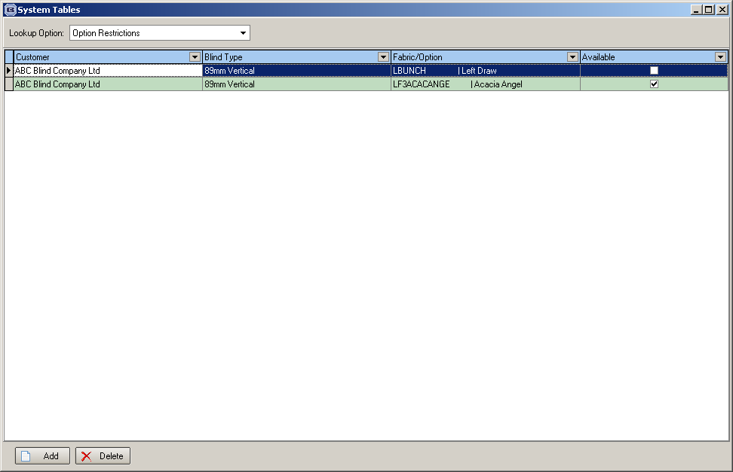

2562. Quotations > Delivery Notes

The ‘Delivery Notes’ button is now available on the quotation enquiry form. When a quote is converted to an order, the delivery notes are brought across as well.

2563. Acknowledgement – Lead Time

If an order is flagged as a repair, the repair notes now print out on the acknowledgement as special instructions, in the same way as is done in ‘Works Order Label 1’.

2564. Despatch

There is a new parameter in Administration > Parameters > Report Parameters called ‘Delivery Docket Immediate Print’. If this is set to true then despatch dockets and labels are printed automatically and not print previewed.

If no printer is mapped for the reports, then a warning message will appear.

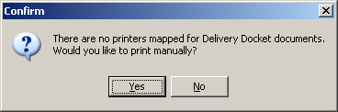

W147. Order Processing

The online warnings for roller blinds where width and/or drop are exceeded are now the same as the warnings on the desktop system.

W148. Order Processing

Panel blinds can now be entered online and imported using the EDI import. For the time being the ‘Number Of Panels’ field on the online order entry is not validated at source, only at the EDI import stage.

