Blindata Release Note 5.7.5 

31 January 2011

Bug Fixes and Enhancements

3696. Delivery Run Report

Report now only shows order records, not all blinds. For the time being we have reverted to 2R etc for the blind description. The report is also now in landscape to stop overlapping fields.

3697. Purchase Order Reports

If ‘Show Cost Price on PO’ is false, then cost prices and values no longer show on any purchase order reports. Previously this worked for the bought in purchase orders, but it now also work for all regular purchase orders as well.

3698. Archive Enquiry

Works order and labels now print if orders have been fully archived for ‘Works Order – Bespoke 31’ and ‘Label Print – Bespoke 33A’.

3699. Label Print – Bespoke 33A

The cord spacing has been moved down because, for very wide blinds, it was overlapping onto options.

3705. Reports > Stock Valuation Report

This report now takes into account the ‘cost disc’ % in the stock record. It builds this into the stock value figures.

New Work and Customer Requests

2519. Optimisation > Cutting Sheet Report

Previously this report showed different colours for fabric shapes, depending on whether the fabric had to be turned or not. As well as that, a ‘T’ has been added for fabric shapes that are ‘turned’.
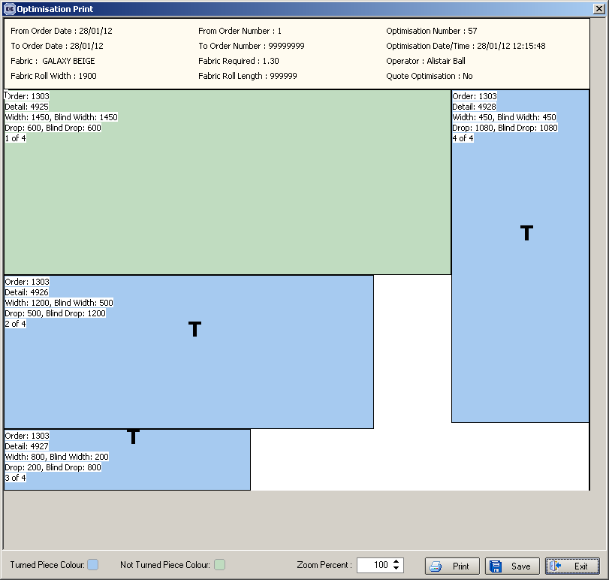

2520. Order Processing > Orders

We now hold a flag against the blind type called ‘Optimise Fabric at Order Entry’. If this is set to true, then when an order is saved, if there are any detail lines with blind types with ‘Optimise Fabric at Order Entry’ switched on and there are fabrics to be optimised, the fabrics are optimised automatically.

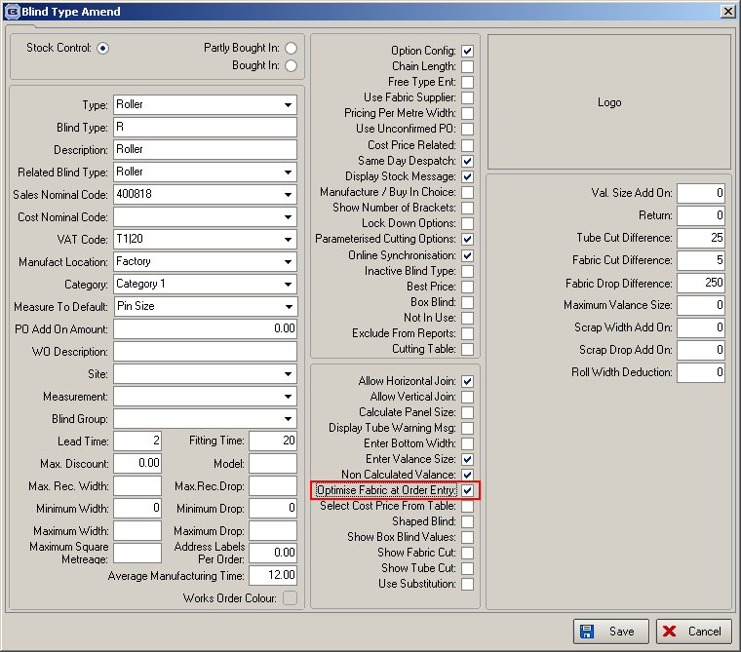

2521. Production Documentation

It is now possible to print out a cutting sheet at the same time as the works order is printed out. There is a parameter for this in Parameters > Report Parameters called ‘Print Cutting Sheet’.

2537. Financials > Daily Sales Report > Email

We have changed the layout of the spreadsheet file that is sent for invoices. We have also added a separate file for orders that have been dispatched that day.

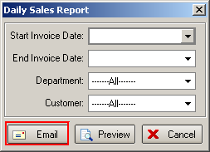

When this button is selected, two files are now sent instead of one.

Invoice Report – a summary.csv file listing all invoices issued to the relevant customer that day. The file should be called SuppName_Invoice.csv

Supplier | AccountName | InvoiceDate | InvoiceNumber | OrderNumber | TotalNet | TotalInvoiceValue
SuppName | AccName | 40890 | SN028110 | 348184400 | -18.06 | -21.67
SuppName | AccName | 40890 | 54874 | 777785600 | 42.29 | 50.74

Despatch Report – a summary .csv file listing all orders despatched to that customer for that day, with this layout. The file should be called SuppName_Despatch.csv.

OrderNo247 | SupplierOrderNo | DateDespatched | Courier | TrackingNo | Supplier | AccountNo
563908558 | ORD00864 | 19/12/11 | UK Mail | 563908558 | Supplier name | 123456
563899558 | ORD00873 | 19/12/11 | UK Mail | 563899558 | Supplier name | 123456

We have added in a new email address for the ‘Despatched Orders Email’.

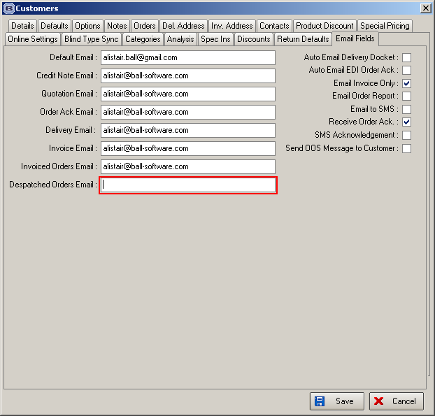
2539. Administration > Import From Excel

It is possible to import a spreadsheet with a list of stock locations, which will import to the ‘Fabric Locations’ table. This can be done with a new choice in this form called ‘Stock Locations’.

2541. Administration > Import From Excel

At the moment a lot of customers use the Fabrics import function, which is extremely useful. Therefore we decided it would be useful if there was a more flexible import for stock items. This is called ‘Stock Update’ and is only used for updating records and not adding new records.

The spreadsheet can contain a variable number of columns. The first column should always be the stock code, and the subsequent columns can be determined by the user. The column header will determine which field is to be updated. The only current restriction is that it is one of the existing fields in the main stock import routine.

2542. Acknowledgement – Laser Print 8.5 x 11

If the order is only for miscellaneous detail lines, then the header columns for type, colour, width and drop have been replaced by ‘Stock Code’, ‘Description’ and ‘Quantity’.

2548. Purchase Order Processing

A new parameter has been created called ‘Change Order Status After PO Create’. The purpose of this parameter is, if true, is to change the status of sales orders if bought in purchase orders are created. It is only relevant if ‘Enable WIP Status’ = true.

So if the new parameter is true, for bought in blinds, when the PO is created, the sales order is changed to WIP. This is providing all the detail lines in the sales order are for bought in blinds.

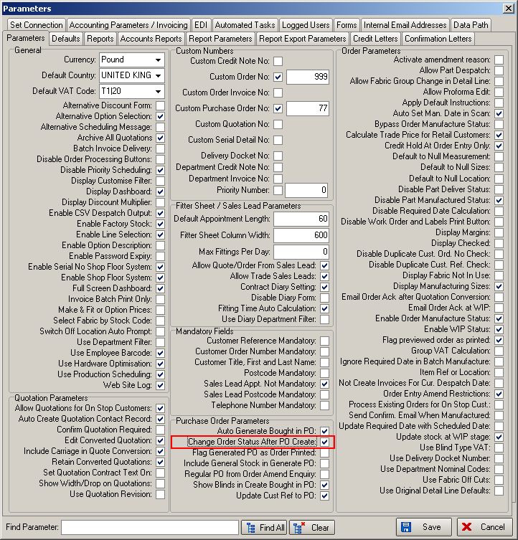

2549. Purchase Order Enquiry

There is now a barcode scan for bought in purchase orders being delivered. On this form there is a new button called ‘Deliver Scan’ so that a scan can be done to deliver a bought in blind. It has the same functionality as the ‘Deliver’ button in Purchase Order Enquiry ie if all the blinds are delivered, then the order status of the PO is changed to ‘Delivered’ and if the order has detail lines that are all manufactured, then the sales order is changed to ‘Fully Manufactured’.

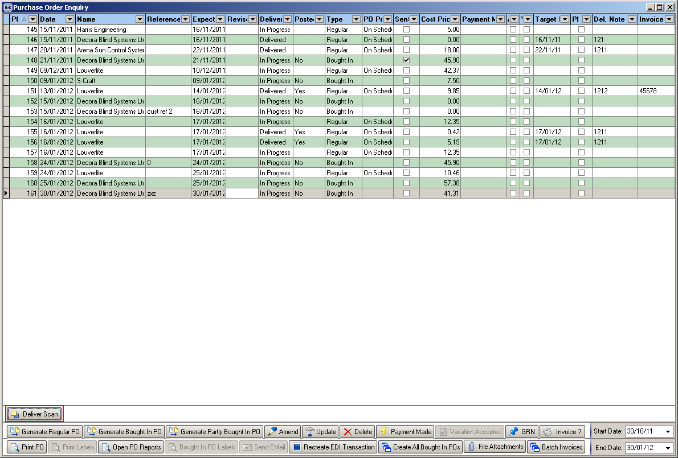

2550. Works Order A4 Individual

- All pleated shaped sizes now print here if the blind type record has ‘Shaped Blind’ = true.
- A barcode is now printed (if ‘Print Barcode’ = true in Report Parameters).

2551. Fitters Sheet / Sales Leads

The ‘Print Appointment’ button now says ‘Print Appointments’. This will print all the appointments for the day for the employee the user is pointing at. If only one appointment needs to be printed, then the user can right click on the relevant appointment and select the new ‘Print Appointment’ menu choice.
