Blindata Release Note 5.7.4 

20 January 2011

Bug Fixes and Enhancements

New Work and Customer Requests

2460. Stock Items > Stock Transactions tab

We’ve noticed that the system is slow to open a stock record if there are a lot of stock transactions on it.

Stock transactions get archived when ‘Archiving’ is run, so it makes sense that only non archived stock transactions are now shown here.

2522. Works Order – Bespoke 31

‘Carriage Type’ is now printed in the header of this works order.

2525. System Tables > Unit Of Sale

It is now possible to enter a decimal amount in the Quantity field.

The ‘Unit Of Sale’ is used in sales order processing and PO processing and both have also been changed to take decimal places into account.

It is also used as a field in Import From Excel > Unit Of Sale etc
It is used in Stock Items > Unit Of Sale tab and Unit Costs tab.

2526. Parameters > Reports > Sales Lead / Fitter Sheet - Full

A new report has been created called ‘Reps Day Sheet’.

2527. Fitters Sheet / Sales Leads > Sales Lead Amend

It is now possible to tab through the ‘Verbal Details’ fields in this form.

2528. Diary / Order Processing > Orders

When entering customer address in either the diary or order entry screens, using postcode lookup, once a selection of addresses appears for a given postcode, it is now possible to just double click the address required and it is placed automatically in the address fields in the relevant form.

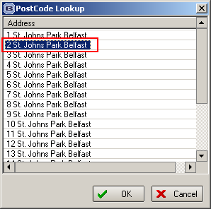

2530. Sales Lead / Fitters Sheet

In the diary screen, the ‘Change to / Find’ section of the diary was greyed out until an appointment is highlighted. This is now enabled to do the customer search, even though an appointment has not been highlighted.

If the ‘Find’ torch button is used to find a customer, the user can now select the relevant customer, then click on a new button called ‘Create Sales Lead’. This copies the relevant data to the sales lead.

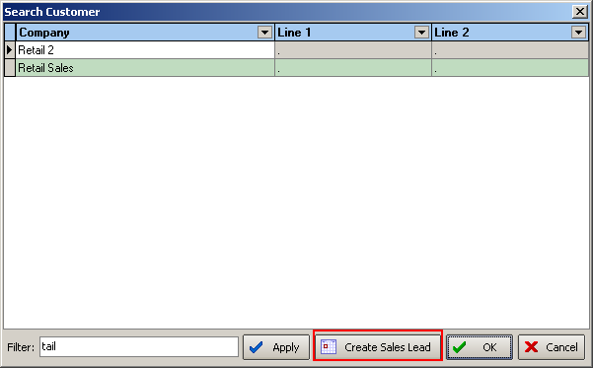

2531. Sales Lead / Fitter Sheet

There is now a button on the ‘Sales Lead Add’ form so that a customer record can be created automatically from this form. There is an advanced permission for this button called ‘Create Customer Account’ (held in the ‘Sales Lead’ section in Advanced Permissions).

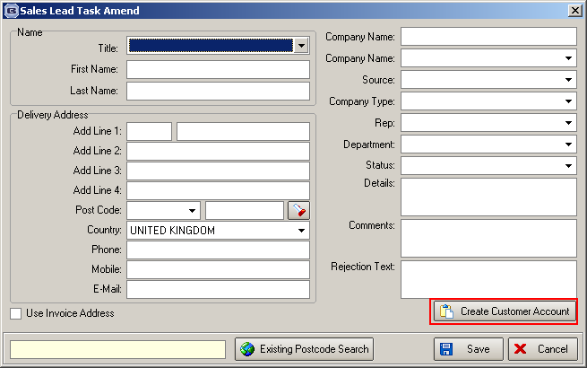

When the ‘Create Customer Account’ button is selected, the user is prompted to enter an account code. The program checks if this account code exists. If it does, then a message appears saying ‘This account already exists’. If it does not exist, then a new customer record is created from an existing account. This account code is held in Administration > Parameters in a field called ‘Sales Lead Default Customer Account’.

2532. Purchase Order Bought In – Blind Size

Previously if ‘Show Cust Ref on PO’ was switched on in Parameters, the Cust Ref from the sales order was printed in the detail section. We have a customer that only creates one PO for one sales order, and they want the ‘Cust Ref’ to be in the header section. So we have created a new parameter called ‘Show Cust Ref in PO Header’.

2533. Order Processing > Orders > Receipts tab

There is now a context menu with a column choice in this form. There is now an additional column choice of ‘Sage Transaction No’, which should default to not being shown. All other fields default to being shown – same as the form is currently.

2534. Reports > System Reports > All Contact Management Reports

Previously the start date and end dates for all these reports was only order date. There is now also an option of start and end contact date. There is a flag that can be selected called ‘Contact Date’.

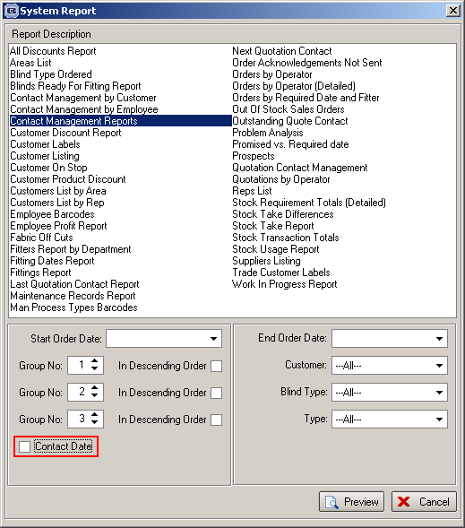

2535. Invoice Laser Print (Letterhead Logo) (pdf as well)

We now show the bank details and registered office name and address details on the footer of this invoice. The registered office line is centred.

Bank Payment Details: Sort Code 99-99-999, Account Code 99999999
Registered Office: Demo Blinds Ltd, Add Line 1, Add Line 2, Add Line 3, Add Line 4, Postcode

2536. Quotation Laser Print (Letterhead Logo)

There is now a quotation print (print and pdf) that has the same layout as ‘Invoice Laser Print (Letteerhead Logo), including the changes in 2535.

2538. Reports > System Reports > Customer List by Rep

There is now an option to exclude inactive customers from this report.

2540. Picking List

There is now a column for ‘Stock Location’ on the picking list report.

2547. Order Processing > Orders

The Repair flag is now a column choice in the Order Amend Enquiry form.

2555. User Activity

If there is a problem with Blindata (eg the connection to the database is lost) and you have to go into Task Manager to stop Blindata, when you try to log back in, it says the user is already logged in. After a few minutes the record in the user_activity table is cleared and the user can log back in.

We are now able to reduce the time that the user_activity record is held for. There is a new parameter called ‘User Activity Update’ in Administration -> Parameters -> Automated Tasks with a default value of 2 minutes (as it was before this change).

