Blindata Release Note 5.7.2 

9 January 2011

Bug Fixes and Enhancements

3677. Order Processing > Orders > Component Detail Entry

If you enter a component detail line and it had a minus discount percentage set up, an error occurred. Fixed.

3678. Works Order – Bespoke 34

Previously the location field was being cut off if it was too long. It now wraps round onto the line below.

3679. Order Processing > Orders

On screens with low screen resolutions, the ‘Save’ and ‘Cancel’ buttons were sometimes not being displayed. We think this is fixed but is subject to testing on relevant screens.

3680. Order Processing > Orders

If a blind type has ‘Bought In’ = true, and the pricing is calculated by square metre (because there is a record in Pricing > Square Metre / Linear Metre Pricing), the selling price is selected correctly, but the cost price was not picked up. If a cost price is held in Square Metre / Linear Metre Pricing, it is now selected.

3683. Purchase Order Regular – Bespoke 31

The supplier address was not being printed. Fixed.

New Work and Customer Requests

2474. Order Enquiry

It is now possible to select a number of blinds to be ‘Blind Manufactured’ at once. This is done in the same way as a number of records can be processed at once in ‘Order Amend Enquiry’ ie hold down the CTRL key and select records.

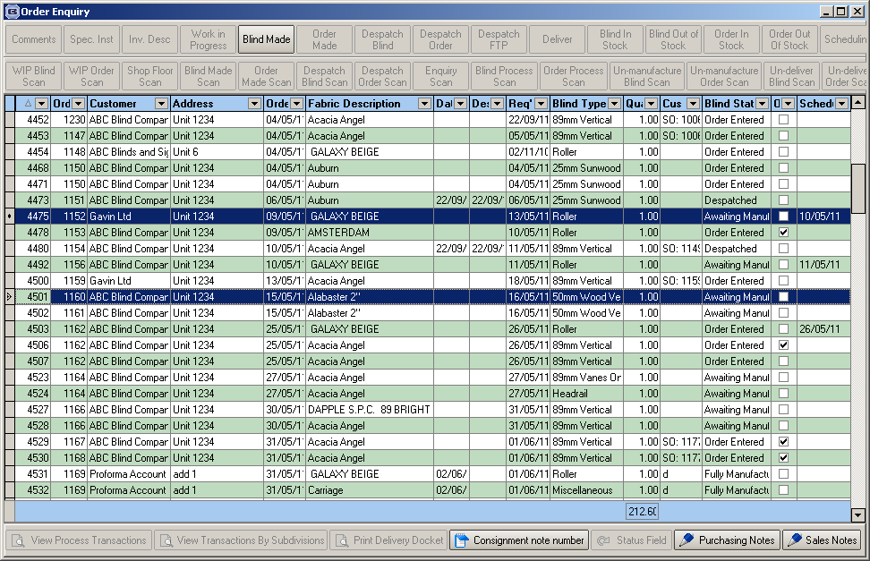

2508. Dashboard

If ‘Full Screen Dashboard’ is switched on, then the dashboard figures are displayed far larger and fill the whole screen. This is required because the dashboard is on a flat screen TV at a customer site and the staff could see the figures on the normal size form.

2513. Quotation – Bespoke 16

Previously the footer address line (from Company Details) printed Company Name, Add Line 1, Add Line 2, Add Line 3, Add Line 4, Postcode.

This has been changed so it only prints Add Line 1, Add Line 2, Add Line 3, Add Line 4, Postcode, and is still centred.

