Blindata Release Note 5.7.0 

19 December 2011

Bug Fixes and Enhancements

3668. Installation Sign Off Sheet

The company name is now the company name from Administration > Company Details, not hard coded text.

3669. Order Processing > Risk Assessment

If ‘Use Risk Assessment Table’ is switched on, the user is now able to see the text properly in this form. We have also adjusted the ‘Risk Assessment Text’ system table so carriage returns can be put in.

3670. Order Processing > Repairs

If you tried to enter a price for a repair, it did not save. Fixed.

3672. Works Order Label 1

If ‘Kanban Item’ is set to true in the fabric record, the word ‘Kanban’ was printing on the label. It no longer does this.

New Work and Customer Requests

2481. Order Processing > Orders

For blind types with blind identifier = vanes only, there is a new parameter to stop the width from being entered in quote/order entry. The parameter is in Blind Details > Blind Types and is called ‘Hide Width Entry’.

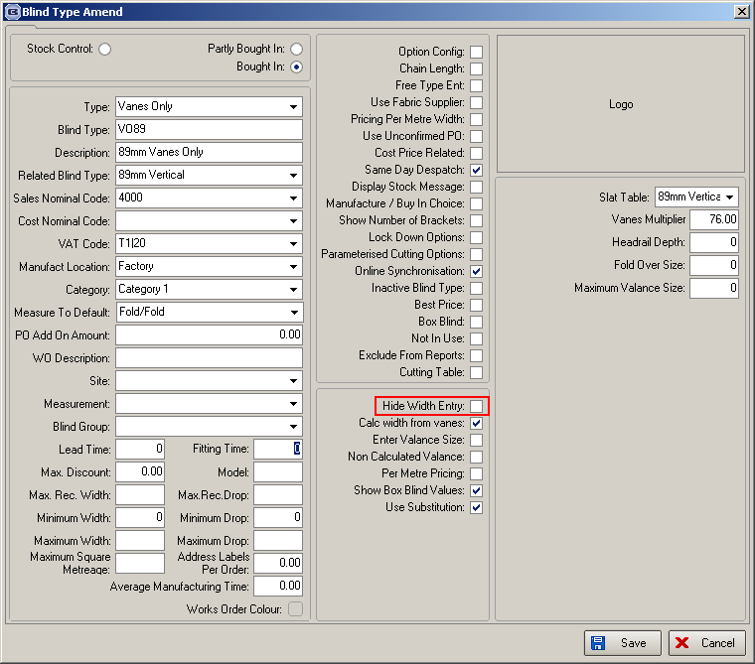

2483. Sales Files > Customers > Preview Labels

In the context menu there is now a choice called ‘Label to Clipboard’ and the following can then be pasted into a spreadsheet in this format:

Customer Company Name
Address 1
Address 2
Address 3
Address 4
Postcode

In the USA the address will be formatted like this:

Customer Company Name
Address 1, Address 2
Address 3, Address 4
Postcode

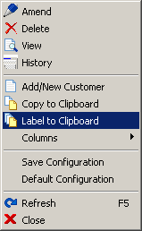

2488. Acknowledgement – Bespoke 40

A number of changes have been made to this report.

Made the detail lines shrinkable
If ‘Location’ or ‘Spec Ins’ is blank, then do not print at all
£ has been right justified on the total
Removed ‘Despatch Date’
Moved ‘Order Acknowledgement’ down 10mm and font 15 and printed it in capitals
All other header font are 10 pitch
Detail line column headings are the same size font as in quotation
Switched thick and thin lines around and removed vertical border
Right justified non address fields in header

2489. Delivery Docket – Bespoke 40

We have created a new delivery docket based on the invoice but without the prices.

2496. Reports > Receipts by Date

There is a new button on this form that will export all orders with receipts in a crosstab format.

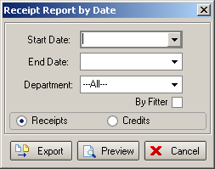

2498. Dashboard

There is a new parameter called ‘Full Screen Dashboard’, which expands the dashboard to the whole screen.

2499. Acknowledgement – Bespoke 17

This report is now a choice in Administration > Parameters > Report Export Parameters > PDF Acknowledgement.

