Blindata Release Note 5.6.9 

12 December 2011

Bug Fixes and Enhancements

3663. Quotation – Bespoke 21

The drop field was showing the width – fixed.

3666. Deposits For Incomplete Orders

This report is now also looks at orders that have been fully archived as well as orders in the live tables.

New Work and Customer Requests

2463. Risk Assessment Report

We have made some improvements to the Risk Assessment functionality.

It is now possible to hold risk assessment records in the same way as we hold ‘Quotation Text’ records.

Therefore there is a new system table called ‘Risk Assessment Descriptions’. There are fields for ‘Nature Of Hazard’, ‘Possible Effect Of Hazard’, ‘Persons At Risk’.

There is also a new flag in Administration > Parameters called ‘Use Risk Assessment’ table which defaults to false. If it is set to true, then when the ‘Risk Assessment’ button is used in ‘Order Amend Enquiry’, the user will be able to add in the ‘Severity’, ‘Probability’ and ‘Assessed Risk’ for each record.

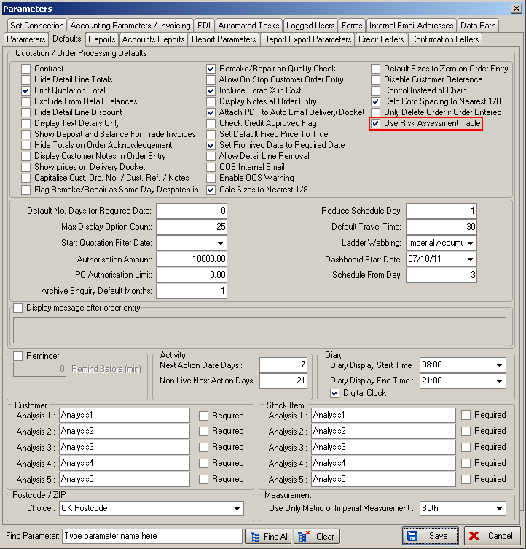

A report for this will be available at a later date.

2465. Installation Sign Off Sheet

There is a new report called ‘Installation Sign Off Sheet’, which is now a choice for ‘Fitter Report’ in Administration > Parameters > Reports.

2469. Diary Improvements

Service visits now to appear on the map and on the route.

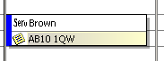

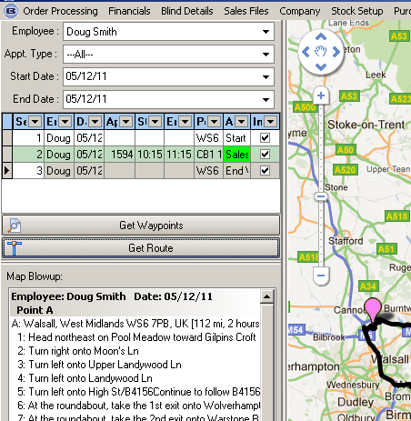

It is now also possible to complete a service visit and a survey appointment. This means we are able to update the status of a service visit and a survey.

Also need to be able to complete a survey in the diary form and be able to save notes. This means we need to be able to update the status of the survey visit.

When you create a service appointment from the contact management, it is also now possible to see the order number it is tied to from the diary.

2471. Diary > General Appointment

We now record a history against a general diary entry. This is displayed in the same way as it is for a sales lead appointment ie right click to show context menu.

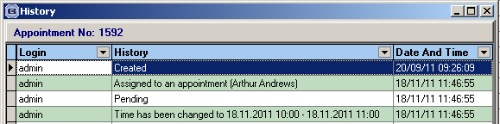

2487. Quotation – Bespoke 40

This report has been redesigned.

2490. Works Order – Bespoke 40

Font for sizes and fabric are now the same size as options.
Fabric description has been centred
Removed vertical border either side of ‘x’.
Removed x heading and now there is one heading ‘Finish Size’ instead of 3 column headings.
Changed headings to be bold and entered fields to not bold.

2492. Invoice – Bespoke 31

Some changes have been made to this report.

- The unit price is now split into 3 – base price, below that option price (discount), below that option price (no discount).
- The figure on the right hand column has been renamed ‘Net price’ instead of ‘List Price’ and the amount is the net total for the detail line.

2494. Reports > System Reports > Customer Listing

There are now options to print the customer list in alphabetical order by account code or by company name. Previously this report only printed in id order.

2495. Label 5161 – Bespoke 35

The control length now prints on this label (if ‘Use Chain Length’ = true in the blind type record).

