Blindata Release Note 5.6.8 

5 December 2011

Bug Fixes and Enhancements

3620. Stock Control

If a quotation is converted to an order, and ‘Use Factory Stock’ is switched on, at the WIP stage the stock is taken from the warehouse (main stock in hand) when it should have been taken from factory stock. Fixed.

3650. Deposits For Incomplete Orders

The criteria for this report is now:
((Invoice date > cut off date and order status is after ‘Despatched’) or (order status is ‘Despatched’ or before)) and (receipt date < cut off date).

3651. Order Processing > Quotations

It is now possible to amend quotations after they have been converted to orders ie if they have a status of ‘Ordered’. Previously it was possible to amend a detail line and add/amend a text line, but it is now possible to add a detail line (both blind and component).

There is a new parameter called ‘Edit Converted Quotation’ in Administration > Parameters. If this is set to true, the user is able to fully edit a quotation with a status of ‘Ordered’, but will not be able to recreate an order from that quotation.

3653. Delivery Docket – Bespoke 17a

The fabric description now prints out – in the same way as it does in ‘Delivery Docket – Bespoke 17b’.

3654. Delivery Docket – Bespoke 17c

The fabric description now prints out – in the same way as it does in ‘Delivery Docket – Bespoke 17b’.

3655. Works Order – A4 Packing Slip

This report was still showing 1/16s – entered size, metric and imperial – even though the parameters for calculating to 1/16s were switched off. Fixed.

3656. Order Processing > Orders

If too much text was entered in the free type field in an option, subsequent detail lines printed out incorrectly. Fixed.

3657. Packing Machine Report

When you select this report, it now defaults to the relevant blind identifier, but has blind type default to ‘All’.

3658. Order Enquiry > Blind Made Scan

There was an issue with a particular user login at one customer site. When the last blind on an order was scanned as made, an error message appeared. Fixed.

3659. Administration > Users

An error message appeared when trying to save a new user that has been added. Fixed.

3660. Stock Setup > Stock Items

When trying to enter a new stock item, the error “multiple step operation generated errors appeared. Fixed.

3661. Purchase Order Enquiry > Generate Regular PO

When entering a new regular purchase order a warning appeared up for a variable supplier. Fixed.

3662. Purchase Order Enquiry > Generate Bought In PO

An error occurred at one customer site when you try to create an EDI file – fixed.

New Work and Customer Requests

2453. Administration > Archiving

There is now an option to archive quotations that have not been converted to orders. Previously it was only possible to archive quotations that have status = ‘Ordered’. There is a new parameter called ‘Archive All Quotations’ in Administration > Parameters to allow this.

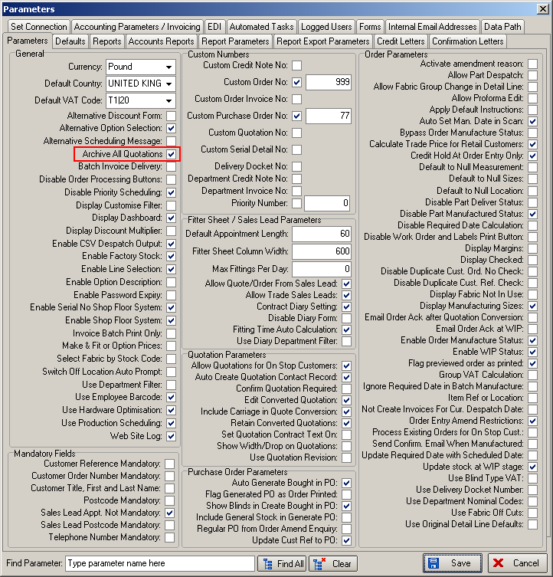

2454. Purchase Order Enquiry

There is now a routine to create all bought in purchase orders that have not already been created. There is a new button on the ‘Purchase Order Enquiry’ form called ‘Create All Bought In POs’. When this is selected, it looks through all existing sales orders to see if there are any sales orders that should have purchase orders created for them, and makes individual bought in purchase orders for each sales order. After the button is selected, a message appears saying ‘You are about to create bought in purchase orders from sales orders. Do you want to proceed?’

There is also an advanced permission for this button in Administration > Users > Advanced Permissions.

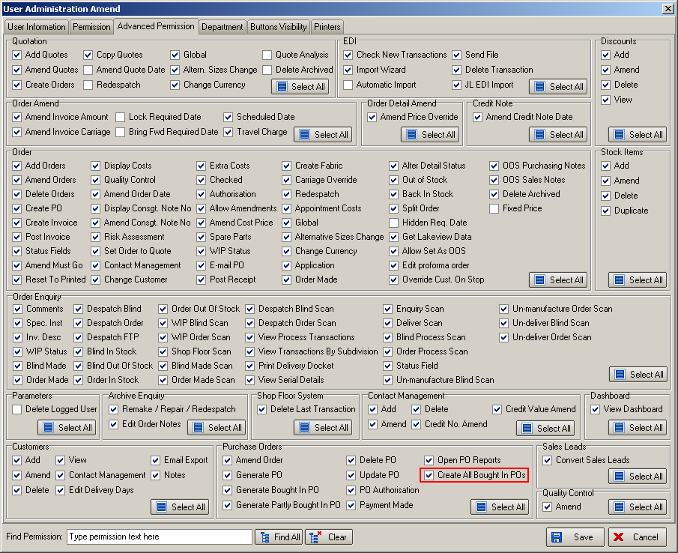

2455. Purchase Order Enquiry > Deliver

There is now an option to print out a label for bought in blinds that are delivered into stock, using a new button on the Purchase Order Enquiry form called ‘Bought In PO Labels’. This button will only be active when the bought in purchase order has a status of ‘Delivered’.

2456. Bill of Materials Report

This report now prints in landscape so there is a lot more room for the stock description. There are two places where this report can be printed – in the order amend enquiry form and also in ‘Window Blind Amend’. Both have been changed.

2457. Stock Setup > Stock Items

There is now a field that shows the cost price less discount on the ‘General’ tab (calculated field only).

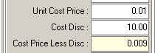

2458. Stock Setup > Stock Items > Stock Transactions tab

- Previously for a sales order transaction, we showed the order number and contact name. We now also show the customer company name (before the contact name with a comma between).

- If a stock transaction has been generated by a stock take entry (manual or spreadsheet import), this is indicated by displaying ‘Stock Take’ and then the date that the transaction was created. The date is taken from the date used in the stock take entry.

2459. Order Processing > Order Enquiry

The ‘Blind Status’ column now has the same functionality as the ‘Order Status’ column in the order amend enquiry form. ie it is now possible to select which blind statuses are displayed on the form, in the same way as the order statuses are selected in ‘Order Amend Enquiry’.

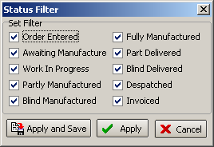

2464. Invoice – Laser Printer (pdf version as well)

Some minor changes have been made to this report.

- If there are any detail lines with negative discount, then the discount column is not printed.
- Settlement discount now prints on this report.
- The totals have been tidied up – ie right justified with £ beside numbers.

2468. Archive Enquiry

There is now a discount field column choice in the archive enquiry form.

2470. Diary

There is now a choice to have a digital clock – as well as a clock face.

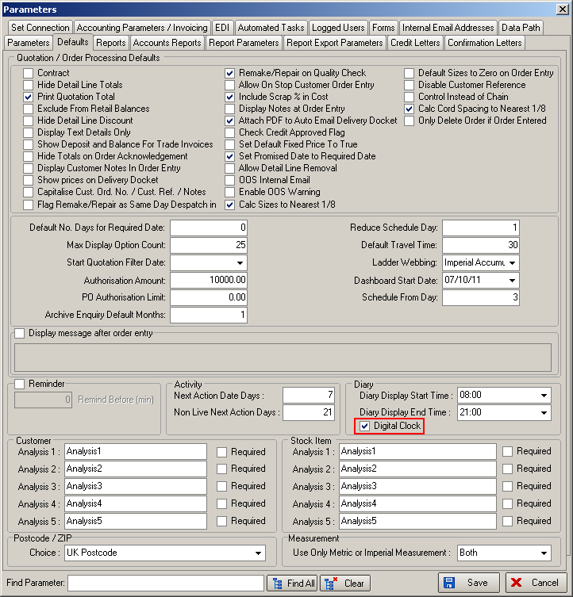

This now means a time can be entered like this:

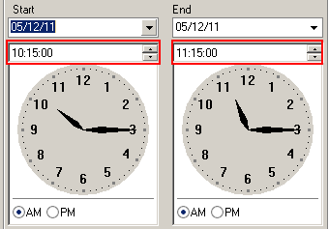

2480. Acknowledgement – Bespoke 17

A new order acknowledgement report has been created, called ‘Acknowledgement – Bespoke 17’, based on ‘Acknowledgement – Schedule Date’.

