Blindata Release Note 5.6.6 

21 November 2011

Bug Fixes and Enhancements

3640. Reports > Financial Reports > Deposits For Incomplete Orders

This report is now correct. The cut off date is used to find orders that have deposits that are for orders that have not yet been invoiced at that date. Here is an example: if an order is entered on 25/08/11 for 400.00 and there is a receipt of 100.00 taken on 25/08/11, but the invoice is not created until 30/09/11, then if you enter a cut off date of 31/08/11, the receipt now appears in the report. If the cut off date was entered as 01/10/11, then the receipt does not appear on the report.

3641. Stock Valuation Report

The total for the stock amount per item was incorrect. Fixed.

3642. Acknowledgement – Bespoke 34

This report now has chain length printed on detail lines (if ‘Chain Length’ = true in the blind type record.

3643. Works Order – Portrait Barcode

This report is now showing 8 options.

3644. Stock Items > Purchase Orders tab

This form also displays the ‘Delivered’ amount.

New Work and Customer Requests

2396. Quotation – Bespoke 40

A new quotation report has been created called ‘Quotation – Bespoke 40’. The font is Avantgarde Md BT.

2429. Order Processing > Orders > ‘Fabric Join/Turn’ Messages

The wording on some of the warning messages for joins and/or turns on roller blinds has been changed.

The first two pop ups are ‘Errors’ we would like to change these to ‘Warnings’ like the third example (third example works correctly). We would also like to change the wording as follows:

‘Both the width and the drop of this blind are greater than the roll width. The blind cannot be made’ has been replaced by ‘Both the width and the drop of this blind are greater than the roll width. The fabric will need a join and a turn. Please contact the customer to ensure this is OK’.

‘The Width of this blind is greater than the roll width. This blind cannot be made’ has been replaced by ‘The Width of this blind is greater than the roll width. The fabric will need a turn. Please contact the customer to ensure this is OK’.

2432. Picking List

There is a new report that can be printed in ‘Order Amend Enquiry’ called ‘Picking List’. This picking list report is similar to bill of materials, but does not have cost or scrap but has two blank columns for signing by an operator. There is a line between each product.

The picking list can be printed by selecting the ‘Picking List’ button on the Order Amend Enquiry form. However, it must first be switched on in Administration > Users > Buttons Visibility.

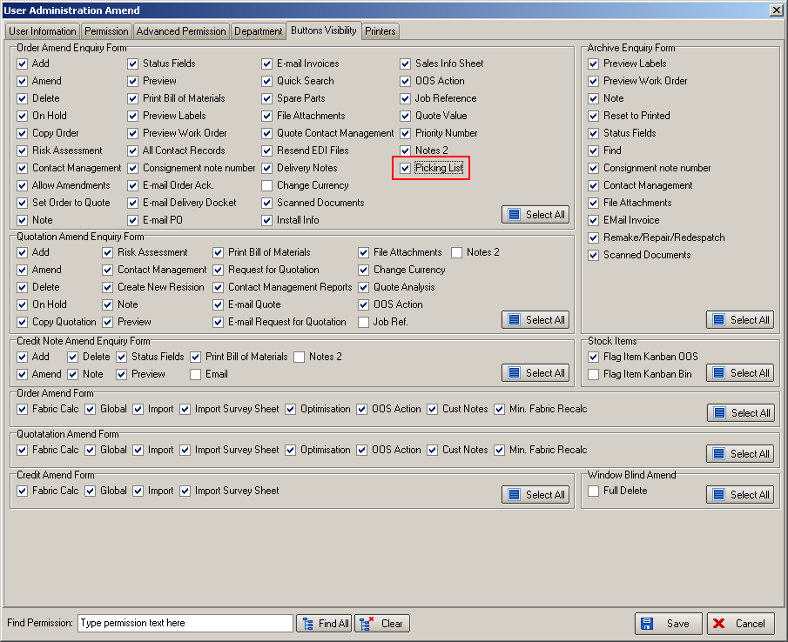

The report is grouped by blind type and has a different page per blind type.

However we do not necessarily want to show all the records from the bill of materials. Therefore there is a new flag in the stock record called ‘Non Picking List’. If this is set to true, then the stock item does not appear on the report.

Process types also appear at the bottom of the report.

2434. Stock Items

There is a new date field in the stock record called ‘Last Updated’ to indicate the last time a stock record was updated. Previously we stored a history record when the stock item was updated – it now updates the date field ‘Last Updated’ as well. This field is also a column choice for the stock enquiry form.

There is also a new field for ‘Stock Update Checked’, which is a true/false flag and which is also a column choice.

2435. Box Blind Slat Table Changes

We changed the way this functionality works a few months ago. However there are some blind types that need to calculate based on the old functionality. To allow for this, there is a new flag in the blind type for box blinds called ‘Use Box Blind Min Table’.
If this is selected, the add/deduct point will be taken from the Box blind minimum width table.
If not selected, the Add/deduct point will be taken from the Box blind slat table.

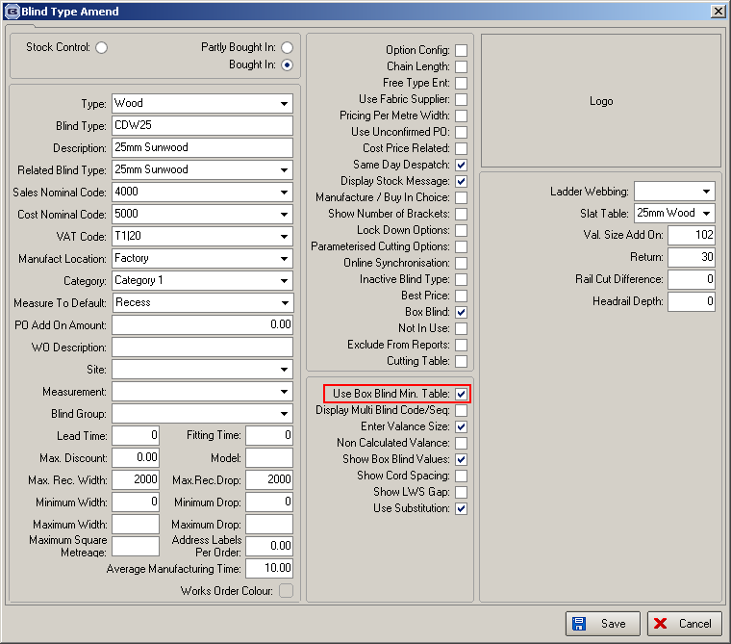

2436. Administration > Parameters > Reports > Tagging Label

There is a new tagging label layout called ‘Tagging Label – Bespoke 2’. It has four labels on an A4 sheet, in landscape. The labels are in a 2 x 2 arrangement, all the same size.

2437. Export Order / Export Invoice

The export paperwork was previously listing everything as Incoterms 2000 when in fact these are no longer valid. It now reads “As per Incoterms 2010”.

2440. Order Processing > Orders

If ‘Use Blind Type Vat’ is set to true, then the VAT code is taken from the blind type record. This is useful for Republic of Ireland customers because VAT can be different for different products. However we have a customer in Ireland that is now selling to the UK and the VAT is always zero.

There is now a new flag in the customer record called ‘Always Use Customer VAT Rate’. If this is set to true, then it will override the ‘Use Blind Type Vat’ flag and use the VAT code that is set up for that customer for all products.

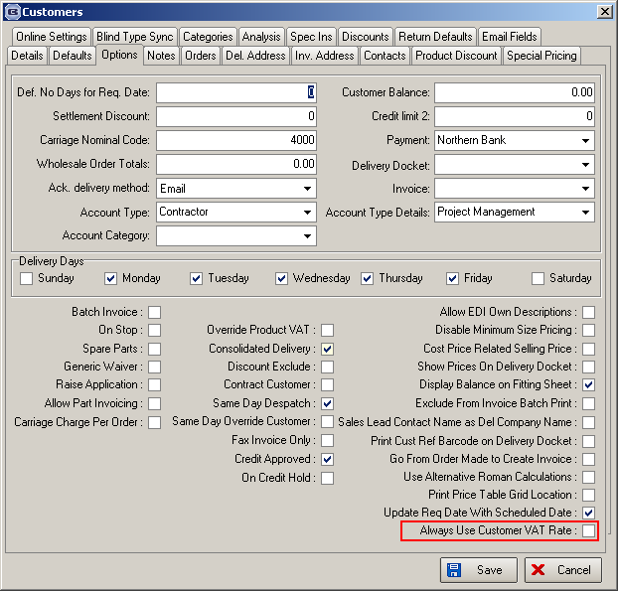

2441. Alternative Bought In PO XML File

There is now a way of not putting certain options into the alternative PO XML file. To exclude these options, use the ‘Export’ flag in Blind Details > Blind Types > Option Setup tab.

2442. Order Processing > Orders

There is a new flag called ‘Activate Amendment Reason’ in the User record (false by default). If either this or ‘Administration -> Parameters -> Activate Amendment Reason’ is set to true, then the ‘Amendment Reason’ form will be displayed.

2443. Option Price Enquiry

There is a new field for ‘Minimum Price Per Metre (Drop), which is then applied in the order detail line entry. The existing field ‘Minimum Price Per Metre’ has been renamed to ‘Minimum Price Per Metre (Width).

W140. Order Entry

There are now only two buttons within ‘View’:
Order Form – ‘Next’ (takes user to Details Form) and ‘Back’ (takes user back to the main order list)
Blind Details Form – ‘Back’ (takes user back to the Order form)

.The Delivery Address tab has been removed and placed as a button beside the actual deliver address fields on the Order form. The forms only have the following buttons:
Order Form – ‘Next’ (takes user to Details Form) and ‘Save’ (saves the order and takes user back to the main order list)
Blind Details Form – ‘Back’ (takes user back to Order form) and ‘Save’ (saves the order and takes user back to the main order list).

W141. Same Day Maximum Validation Online

Currently, the online site validates the Blind Types on an order that is flagged ‘Same Day Despatch’ against the allowed ‘Same Day Despatch’ Blind Types and prompts the user if any exceptions are found. It does this at two stages:
- If you click the ‘Same Day Despatch’ flag while blinds exist on the order, the user is prompted and the flag is unchecked.
- If you add blinds to an order that is flagged as ‘Same Day Despatch’ that are not allowed and save, the user is prompted and the flag is unchecked.
We have kept this functionality, but as well as checking blind types, the online site also checks the quantities as the office version does when it imports the EDIs. These are held against the manufacture location in the ‘Large Quantity’ field.

W142. Sage Pay Duplicate Payment Functionality

The online status of an order is now updated to ’Pending Payment’ once the ‘Pay Order’ button is clicked. This will then be changed to ‘Submitted’ if the payment completes successfully. If the payment fails, or the user cancels, Sage Pay passes back the appropriate result, and the order status is reset to ‘Unsubmitted’.

