Blindata Release Note 5.6.5 

14 November 2011

Bug Fixes and Enhancements

3639. Archive Enquiry > Preview Labels

If an order is fully archived (ie in the AOrder table etc), it is now still possible to print labels for the order.

New Work and Customer Requests

2413. Tuffnells Despatch

We have created a csv file to export to the Tuffnell despatch system when an order is delivered. The relevant despatch record needs to be set up with the carrier field = Tuffnells.

The csv file has the following layout.

B = Courier Code (from Carriage Type record)
C = Order number
D = Delivery Company Name
E = Del Add 1
F = Del add 2
G = Carriage Type description
H = leave as 0 for now
I = “CAR”
K = number of packages
M = delivery address postcode
Q = “001”
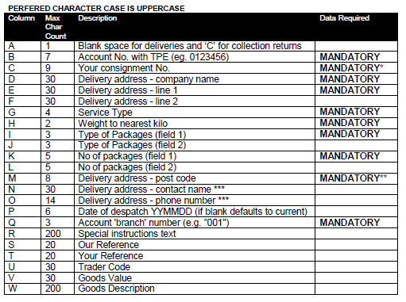
2418. Benthin Spacer Calculation

We have a customer that uses a Benthin vertical headrail system.

There is a calculation for working out the number of louvers and the spacers that apply, depending on the width of the blind. It is a bit like the Impala system, except not as complicated.

The following work has been done.

The ‘Vertical Slats’ import has been adjusted so that four extra fields that contain the spacer data ie Qty1, Link1, Qty2, Link 2 can be imported. It is still possible to import the spreadsheet in it’s existing format.

The ‘Single Bunch Louvre Slats’ and ‘Split Bunch Louvre Slats’ forms have been adjusted so the new fields can be edited.

When a headrail is chosen in the detail line entry, we can then work out the slat table to use by looking at the ‘Headrail Slat Table’ form, and then selecting the number of vanes and spacers from this.

‘Works Order – Bespoke 40’ has also been adjusted so the spacers are shown for vertical blinds.

2423. Order Processing > Orders > OOS Actions

There is a new flag in the OOS Action Outcomes system table called ‘Require Promise Date’. If an outcome is selected in OOS Actions that has this flag ticked, then the user must enter a promised date. If ‘Require Promise Date’ is not ticked, then promised date is not mandatory.

2426. Order Processing > Orders > Original Required Date

A number of changes have been made to the functionality involving the Original Required Date.

If scheduling is switched on, the original required date is not saved for an order until the order has been scheduled.

If an order is copied, or used to generate a remake/repair/redespatch, the new order created does not carry across the Original Required Date - instead this is set the first time the new order is scheduled.

If an order is split, the new order carries across the old Original Required Date and saves it.

A change has been made to how the Same Day Despatch charge is applied during the invoicing routine. Previously the despatch date was compared with the required date to see if the same day despatch charge should apply. This has been changed to check the despatch date against the Original Required date, to ensure customers are not charged incorrectly if an order is manually rescheduled beyond the same day period.

2428. Pricing > Option Price Enquiry

There is a new flag on the ‘Option Price Enquiry’ form called ‘Non Default Price Only’. If this is ticked, then option pricing will only be selected if the option selected is not in the ‘Default Options’ tab of the fabric selected.

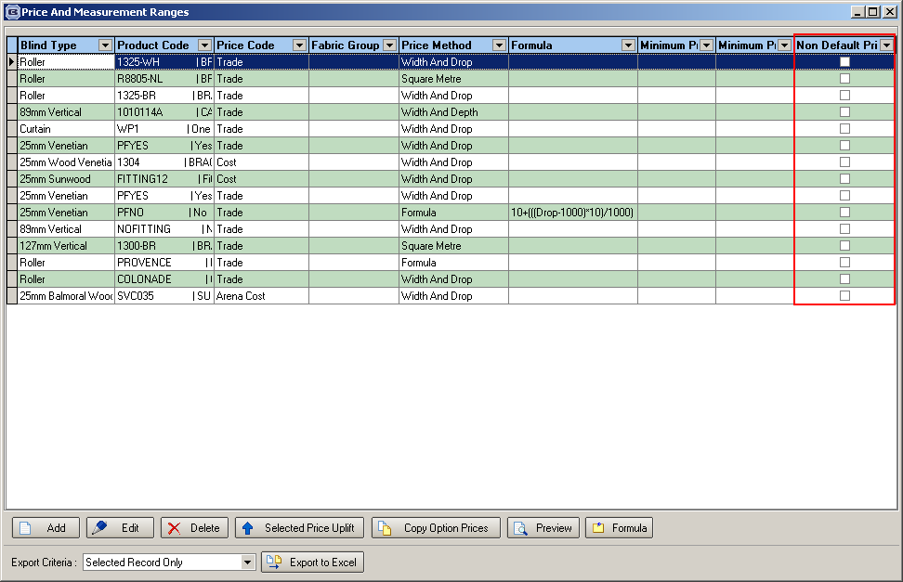

2438. Suppliers > XML File

There is now a choice as to what goes into the ‘PO Number’ field in the PO alternative XML file. It can either be the Po number or the customer reference from the sales order.

There is a new field in the supplier record called ‘Use Cust Ref in PO Number in XML File’. If this is set to true, then the customer reference will be held in ‘PO Number’ in the XML file.

2439. Reports > Financial Reports > Deposits For Incomplete Orders

This report now only shows deposits that were taken before the cut off date entered, and for orders that have not yet been invoiced ie orders with status up to and including ‘Despatched’.

