Blindata Release Note 5.6.4 

31 October 2011

Bug Fixes and Enhancements

3631. Incorrect Slat Add/Deduct for Sunwood

There was a problem when processing manual and EDI orders - the first blind entered calculated the add/deduct amount correctly, but subsequent blinds gave incorrect results. Fixed.

3633. EDI Import

For vanes only orders, the number of vanes = 2 in the imported order, regardless of vane quantity in the EDI file. Fixed.

3635. Order Processing > Orders

If ‘Flag previewed order as printed’ is switched off, then for a miscellaneous order (with no label print) the status of the order now changes to ‘Order Printed’ after the order is actually printed.

3636. Purchase Order Enquiry > Update > Lakeview PI Post

The layout of the pinvoice XML file is now correct. Here is the layout in the Lakeview spec.

<?xml version="1.0" encoding="ISO-8859-1"?>
<pinvoices>
<pinvoice>
<account_code />
<date />
<reference_1 />
<reference_2 />
<items>
<item>
<description />
<quantity />
<unit_price />
<vat_indicator />
<nominal_code />
</item>
.
.
</items>
</pinvoice>
.
.
</pinvoices>

3637. Delivery Docket – Laser Print

The email address now appears on the del docket immediately below the delivery address. It says ‘Email:’ then prints the delivery email. If there is not a delivery email, then it prints the default email in the order.

3638. Invoice – Laser Print

- If there is more than one page on this report, the totals now only appear on the last page.
- The page number no longer overlaps the ‘Balance’. The page number has been moved to the bottom middle.

New Work and Customer Requests

2408. Stock Setup > Stock Items

There is a new tab called ‘Purchase Orders’ so we can see PO transaction relating to the stock item. This shows the expected delivery dates, the quantity on the order and the purchase order number that it relates to.

2409. Reports > System Reports > Order by Operator (Detailed)

There is now a total for orders and blinds after each sub group (order status and operator)

2410. Stock Setup > Stock Items

When the Duplicate button is used, it now also duplicates the data from the ‘Unit of Sale’ and ‘Unit Costs’ tabs.

2411. Purchase Order Enquiry > Purchase Invoice Create

If the unit cost price is changed, then the user is now asked if the unit cost price in the stock record should be updated. The message says ‘Do you want the unit cost price to be updated in the stock record?’

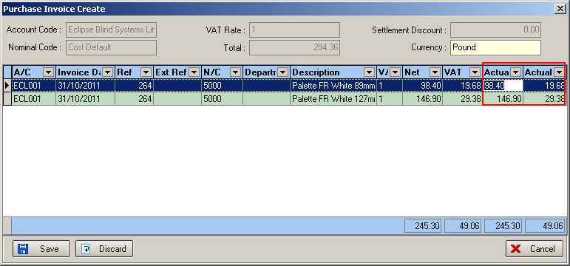

It is now possible to display the VAT amount in ‘Amend’. This has been added to the column choice. There is also a total for the VAT at the bottom of the form.

When updating and editing, if you ESC then the changes that have been made are now saved.

2412. Fabric Group Setup

There is a new option for ‘Roll Length’ so it can be changed for all filtered records.

2414. Packing Machine Report

There is a new report called ‘Packing Machine Report’. This will be printed on the factory floor so there is a new context menu option called ‘Packing Machine Report’. It will select by blind type or blind identifier, then required date (chosen from the record that is currently being pointed at).

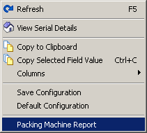

The report heading shows blind type description and required date. The report then shows order no, customer name, blind id, width, drop, then leave room for a barcode

2415. Blind Details > Blind Types

Depending on the drop of the blind, we now hold different criteria for the default length of the control/chain. We can also apply a formula according to drop points. Previously we only held data about the control length here.

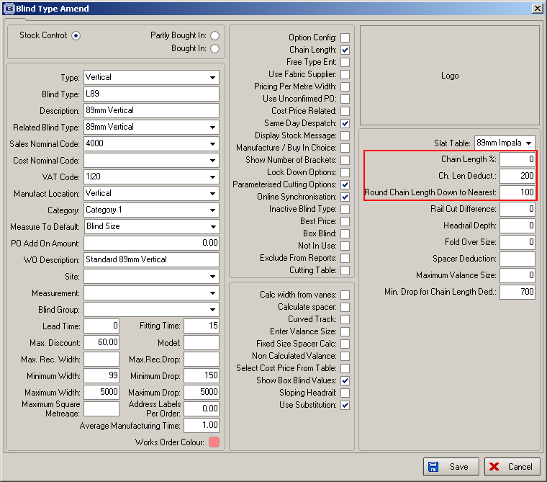

This was fine but the rule applied for all drops of blind. We can now hold this information according to the drop eg up to a drop of 500mm, the ‘chain length deduct’ may be 100mm instead of 200 etc. This data is held in a tab called ‘Chain/Control Length and is picked up from there in the order entry.

2416. Order Processing > Orders > Context Menu

There is now a choice for ‘Chain(Control) Length’ in column choice for ‘View Details’.

2417. Works Order – Bespoke 40

The following changes have been made.

- Print descriptions instead of code in options
- It is now possible to hold trim and certain other options in a line below, also special instructions (notes). There is a new flag called ‘Option Text Line’ against the option in the blind type, and if this is ticked, the option will print out along the new line in the same style as ‘Option List’.
- Print location where ‘notes’ column was.
- Made column headings smaller to fit on more detail lines.

2419. Wood Blind Setup

The functionality for finding slat, bottom bars and valances has been changed to include any combination, including the following.

W10=Slat
W11=Bottom Bar
W12=Valance

2420. Sales Files > Customers > Same Day Despatch

There is a new flag in the Options tab of the Customer form below the existing Same Day Despatch field called ‘Same Day Override Customer’. If this is ticked, then when manually saving an order, or when the EDI import is creating an order, the standard Same Day blind types and Large Quantities for manufacture locations are ignored. This means that any order can be placed as Same Day Despatch.

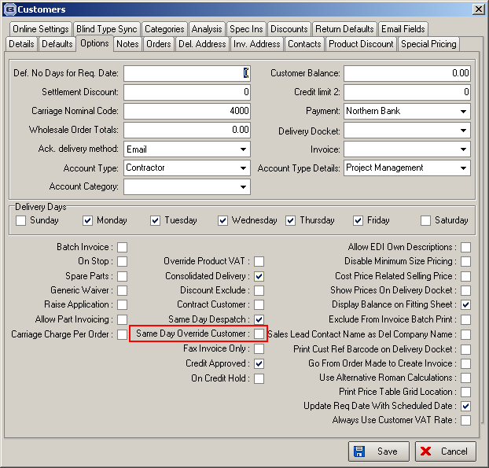

2421. Pricing > EDI/Online Discounts

If you create a discount record, but leave the ‘Customer Name’ blank, the discount will be a global discount and applies to all online orders.

To stop this happening by accident, the following message appears.

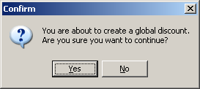

2422. Order Enquiry > View Process Transactions

The ‘View Process Transactions’ and ‘View Process Transactions by Subdivision’ forms in Order Enquiry now have a column for the name of the employee (EmployeeID).

2424. Administration > Parameters

There is a new parameter to set the Quantity, Width and Drop of all new blinds entered on quotes and orders to default to 0 each time. This applies regardless of any other parameters for copying the details of the previous detail line when processing. Validation has also been added to the Add/Edit blind form to prevent a line from saving with a quantity of 0.

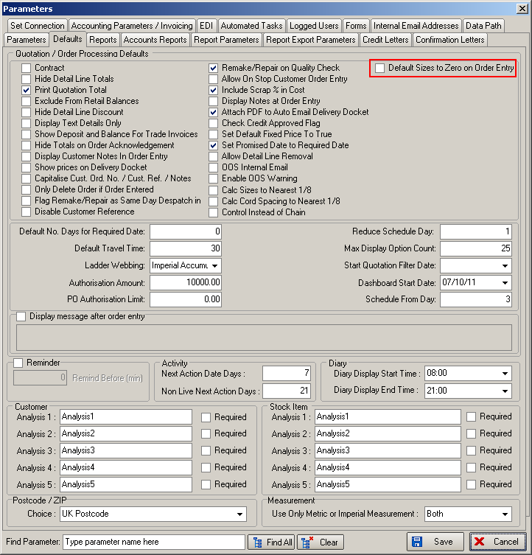

2425. Deliver Order Scan CSV Integration Validation

Several changes have been made to the City Link CSV Integration mainly to do with screen work validation to help reduce errors. When the ‘Enable CSV Integration’ parameter is switched on, the ‘Number of Packages’ appears on the Deliver Order Scan window.

- The number of packages has been moved up to the second row and the scan field moved down to the third row so they flow in sequence.
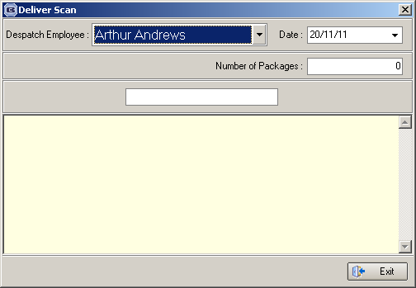

- It is no longer possible to scan without entering a ‘Despatch Employee’ or ‘Number of Packages’. Both fields are now validated.

- The number of packages now defaults to 0. This is also reset to 0 after each scan to force operators to update it for each order they despatch.

There is now validation to restrict the no of packages to a maximum of 99.

2430. Works Order – Label 1

The blind number (eg. 1 of 2) has been moved down to also appear on the line below to the right of the width, drop and order no. It also remains on the top line where it is now.

2431. Order Processing > Global Search

There is now a right click option to the Global Search form to view the Serial Detail Lines for a selected order. This works in the same way as the functionality in Order Amend Enquiry.

