Blindata Release Note 5.6.3 

31 October 2011

Bug Fixes and Enhancements

3624. Archive Enquiry / Orders > Remake/Repair/Redespatch

Options were sometimes incorrect if orders were created using the Remake/Repair/Redespatch method.

3626. Purchase Order Enquiry > Update

When creating a purchase invoice, there is now a prompt to enter the purchase invoice number.

3627. Purchase Order Enquiry > Update > Lakeview Post

The file layout for the Lakeview purchase invoice has been changed.

3628. Purchase Order Enquiry

There is now a button on this form so that the purchase invoice number can be entered against a PO. Previously if you forgot to enter the purchase invoice number, there was no way of going back into the PO to enter it.

3629. Purchase Order Enquiry > Update > Carriage

The message ‘Purchase Order is 0’, now says ‘Purchase Order is equals 0’.

3630. Order Processing > WIP

If a stock transaction is updated at WIP stage, the ‘Factory Stock’ flag is now ticked in the stock transaction.

3634. Remake/Repair/Redespatch & Copy

Previously, when you copied an order, or when you generated a remake/repair/redespatch from the archive, the new order created had the same promised date as the original order. This is now blank as the new order created will not have a promised date in these situations. The promised date is only copied across to a new order if the original is split as the promised date will apply to both orders.

New Work and Customer Requests

2376. Email Invoice Summary

It is now possible to send a spreadsheet of invoiced orders to a customer.

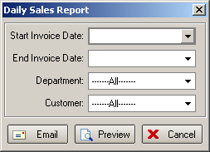

The email address for the invoice summary is held in Sales Files > Customers > Email Fields.

2382. Quotations

It is now possible to create a revision to an original quotation (which will have a status of ‘Ordered’) so it can then be printed/emailed. It is not be possible to create another order from this quotation.

2387. Alternative Supplier

It is now possible to access the alternative supplier for stock items when creating a regular purchase order (but not in the auto generate routine).

At the moment we hold an ‘Alternative supplier’ against a stock record. When a purchase order is entered, the stock code / stock description looks at stock records where the supplier is held in the main record. It also now looks at the ‘Alternative Supplier’ as well.

If the alternative supplier is selected, then the ‘Part Number’ and ‘Cost price’ are taken from there. It will not be able to look at ‘Unit Costs’ if the alternative supplier is used.

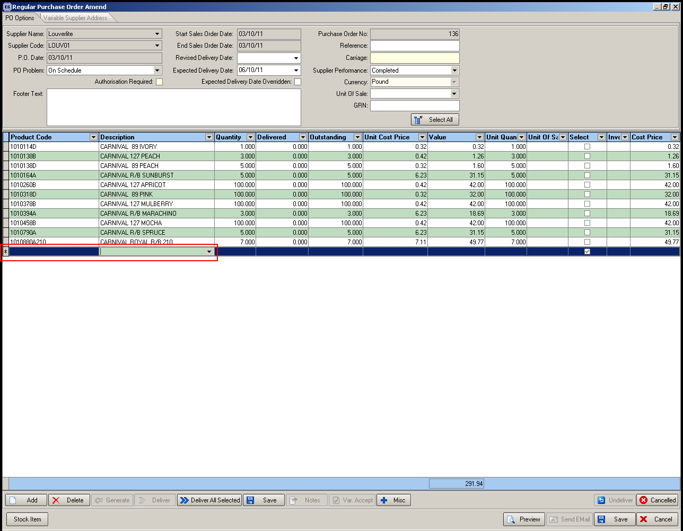

2388. Purchase Discounts

We can now hold a % discount against cost price by quantity, and also be able to import these. The % discount is taken off the cost price that is held in the ‘General’ tab of the stock item.

The cost price by quantity will either have a cost price or a quantity in it.

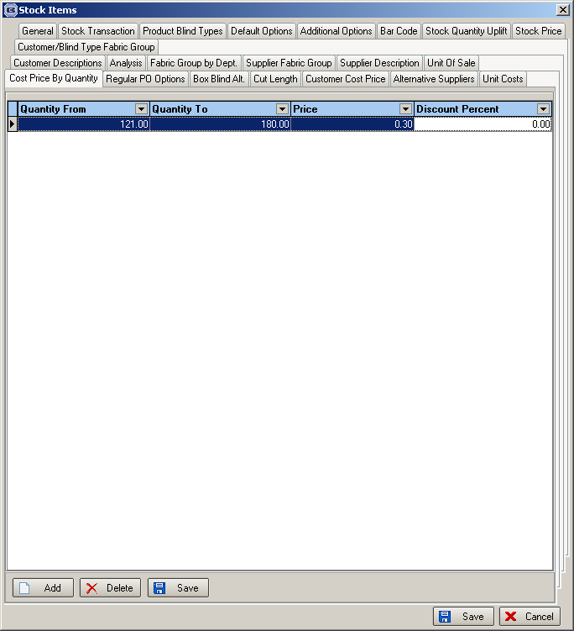

We have also amended the ‘Unit Cost Stock Prices’ spreadsheet so we can also import cost price by quantity (and also %). The two blue rows are the ‘Cost price by Quantity’ rows.

Fabric Code | Unit Of Sale | Price Type | Price | Qty From | Qty To
RF1 | Metre | Trade | 10.2
RF1 | Metre | Trade | 8
RF1 | Metre |  | 30
RF1 | Unit |  | 10
BL-BROWN | Unit |  | 1.23
BL-BROWN | Length |  | 4.65
AMCOF195 | Qty Price Discount |  | 7.89 | 20 | 50
AMCOF200 | Qty % Discount |  | 20 | 20 | 100

2390. Stock Setup > Stock Items

There are now fields displayed for ‘Available Stock’ and ‘Future Free Stock’ in the bottom right of the ‘General’ tab.

‘Available Stock’ = ‘Stock In Hand’ – ‘On Sales Order’
‘Future Free Stock’ = ‘Stock In Hand’ – ‘On Sales Order’ + ‘On Purchase Order’.

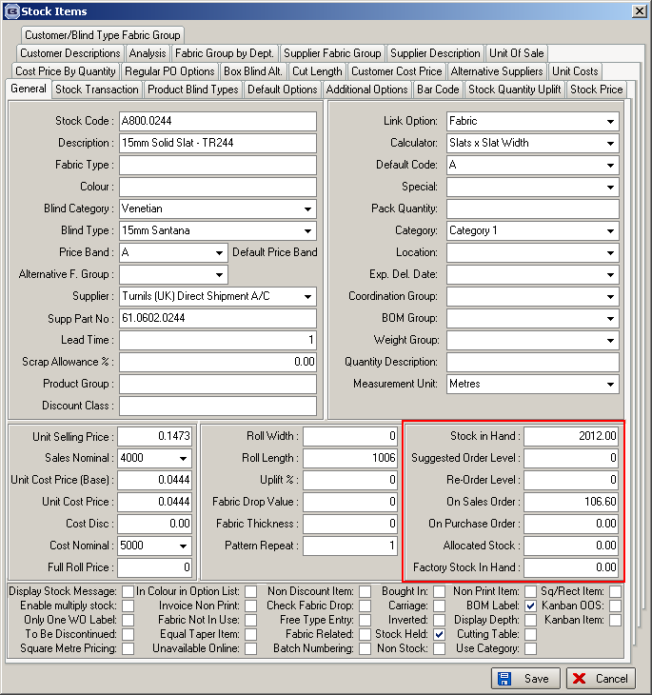

2401. Order Processing > Orders

A while ago we made a change so that 1/16s could be entered in the system and cord spacing would be displayed with 1/16s in them. This has been only partially successful, because whilst the cord spacing is fine, we were getting complaints from customers that the exact blind size was coming out with 1/16s which they do not want.

We still allow blinds to be entered with fractions to 1/16, but we now have two new parameters that stop the manufacturing blind sizes and cord spacing sizes being calculated to the nearest 1/16. The parameters are called ‘Calc Sizes to Nearest 1/8’ and ‘Calc Cord Spacing to Nearest 1/8’. If these are set to true, then manufacturing sizes and cord spacing sizes will be calculated to the nearest 1/8 inch.

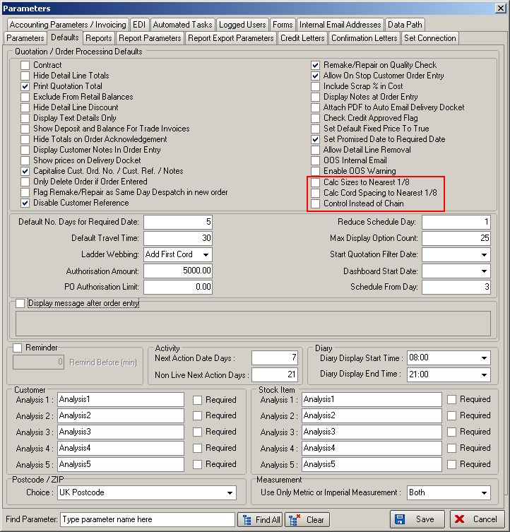

2402. Order Processing > Orders

There is a parameter to determine whether the program displays/prints ‘Chain Length’ or ‘Control Length’. Previously everything was defined as ‘Chain Length’. The parameter is called ‘Control Instead of Chain’ and is in Administration > Parameters (see screenshot above).

2404. Administration > Archiving

It is now possible to archive quotations and cancelled orders as well as orders. There are now tabs for ‘Orders’ and ‘Quotations’ on the form. It is only possible to archive a quotation if it has a status of ‘Ordered’.

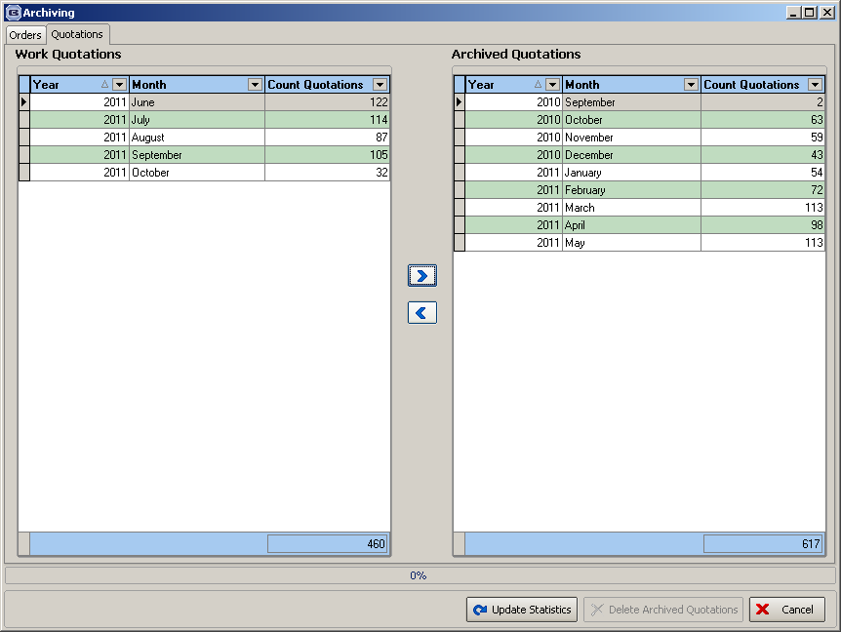

2405. Order Processing > Orders / Archive Enquiry

There is now a column choice for ‘Account Code’ in both ‘Order Amend Enquiry’ and also ‘Archive Enquiry’.

