Blindata Release Note 5.6.2 

21 October 2011

Bug Fixes and Enhancements

3600. Order Processing > Orders

There was a problem with customer default options. These are now only selected when the blind type is chosen in the order detail line.

3611. EDI Import

There was a problem if the system was set to send out order acknowledgements as soon as an order was received and Microsoft Outlook was not open. Orders were being imported but not creating an order number. This has been resolved by writing an error message to the EDI log that the acknowledgement has not been sent.

There was one other issue where an ‘out of memory’ error occurred. This is still being investigated.

3612. Reports > Financial Reports > Sales Cash Flow Report

This report was including cancelled orders and orders with the status Invoice Posted – these have been removed.

Also we have added a filter by Department and the choice to run by Inv Date or Order Date.

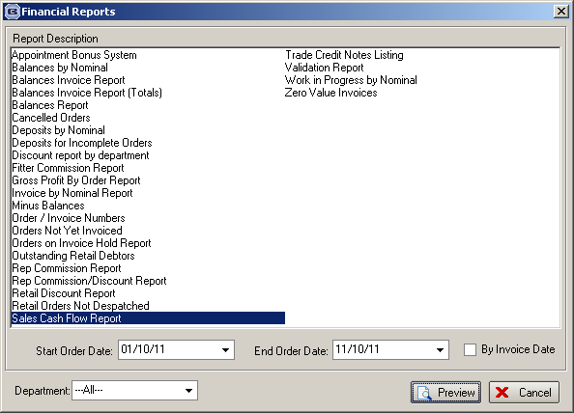

3615. Purchase Order Enquiry > Regular PO Entry

When entering a purchase order detail line, we had an issue before where every time a new detail line was entered, the curser went back to the first item entered. This was changed so that it would stay in the same line but it had reverted back to how it used to be. Fixed again.

3616. Blind Details > Blind Types

The tabbing through the fields on this form has been tidied up.

3617. Transfer File 2

When an XML record is created for a bought in blind from a supplier with ‘Transfer File 2’ = true, and the blind identifier = Venetian or Wood, there is no longer a segment for COLOURWAY.

3618. Order Processing > Orders

If a detail line is flagged as ‘Out Of Stock’ and the ‘Send OOS Message to Customer’ is switched on, then the email is sent to the customer and not to the ‘internal’ Customer Services Email address.

In Parameters ‘OOS Email to Customer’ has been changed to ‘OOS Internal Email’ to avoid any confusion. If this is true, then an internal OOS email is sent.

3622. Blind Details > Blind Types > Option Setup / Option Selections

If you leave either of these forms open, and go into order entry, when you went back to these forms, the field names were not displaying (same in Option Selections). Fixed.

New Work and Customer Requests

2251. Scheduling (Part 2)

We have now included the ‘Breakdown of Units’ spreadsheet export in Order Processing > Total Of orders Outstanding.

2373. Order Processing > Orders

There is a new parameter called ‘Enable OOS Warning’, which is required to differentiate between the ‘out of stock’ functionality and the ‘out of stock warning’ functionality. The new parameter defaults to false.

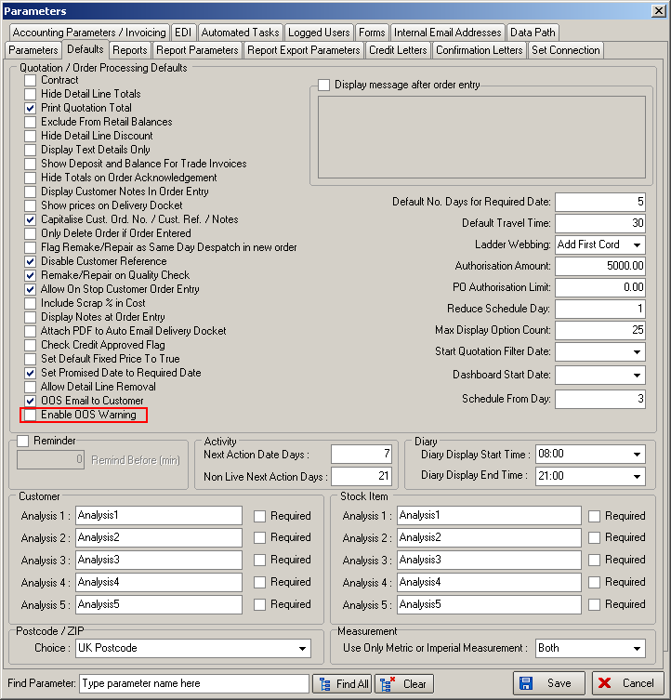

If this parameter is switched on, then all the OOS Warning functionality works as it does currently.

If this new parameter is switched off, then the OOS functionality works as it did before dev 2149 was introduced i.e.

The OOS button in the order detail line updates the ‘Out Of Stock’ flag in the detail line and in the Order table.

The BIS button updates the ‘Out Of Stock’ flag in the detail line and also the ‘Previously Out Of Stock’ flag. If there are no other detail lines with ‘Out Of Stock’ = true, then the order is flagged as ‘Out Of Stock’ = false.

It is now also possible to make an order OOS even if it is WIP.

2375. Sales Files > Customers

There is now a ‘Priority Scheduling’ flag in the customer record. If this is set to true, a priority scheduling time is applied when an order is entered. This means that it checks to see if it can be fitted into the first available priority scheduled time (according to ‘Schedule From Day’).

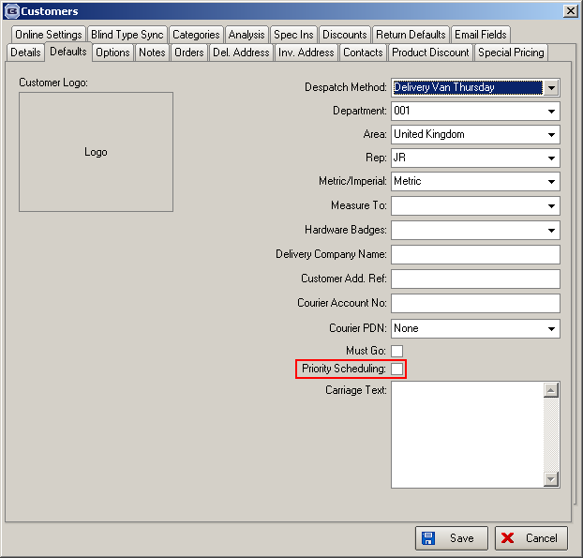

2380. Order Processing > Orders

There is now a column choice for ‘View Detail Lines’ in the ‘Order Amend Enquiry’ context menu. There are extra column choices for ‘Measure To’, ‘Location’, ‘Option List’ and ‘Special Instructions’.

2385. Batch Fabrics

When fabrics are ordered, they are often ordered in batches eg 10 rolls of roller fabric (all the same stock code). When this arrives, it often carries a batch number. We have developed functionality to record batch numbers against stock transactions.

Stock Setup > Stock Items

We have created a new table to hold the batch number, unit of sale and the quantity. The table is called StockTransactionBatch.

There is a new flag in the stock record called ‘Enable Batch Numbering’, which defaults to false. If this is switched on, then there is a new tab visible called ‘Batches’.

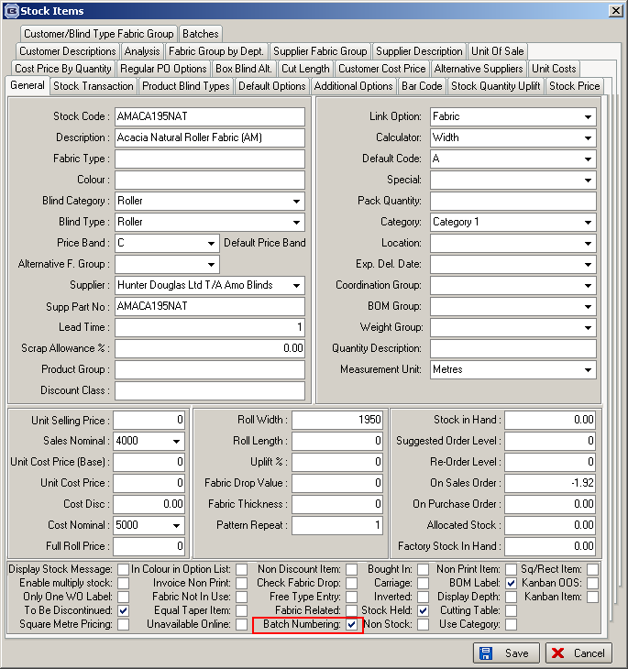

Purchase Ordering

When a regular purchase order is delivered into stock, if ‘Enable Batch Numbering’ is true for the stock item, the user is now able to enter a batch number as well as the quantity (if not delivering all), but only if it is going into warehouse stock. There is no functionality for holding batch numbers against factory stock.

The batch number will be manually entered by the operator – it could be numerical or alphanumerical.

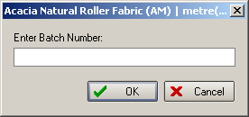

Stock Setup > Stock Transaction Entry

If a stock record has ‘Enable Batch Numbering’ switched on, then the batch number can be entered for a stock receipt or stock issue, and also if a warehouse > factory relocation is done.

When stock is transferred, and there are batches held for that stock item, it is also possible to specify the batch number.

Order Processing > Orders

If ‘Use Factory Stock’ = true, then batch numbering does not apply – the factory stock in hand figure will just be updated as now. If ‘Use Factory Stock’ = false, then batch numbering is not applied.

Stock Valuation

This now shows the batch numbers and quantities as a subset of the stock item.

2391. Archive Enquiry

There are now column choices for ‘Required Date’ and ‘Despatch Date’ in this form.

2394. Purchase Order Enquiry

Previously a purchase order (regular or bought in) could have it’s cost price changed if it had a status of ‘Sent’. It is now possible to change the unit cost price (as can currently be done if the PO is entered but not flagged as ‘Sent’).

2395. Works Order – Bespoke 40

We have allowed for 7 cutting sizes, and made the option columns a bit narrower.

We now hold number of brackets for order in footer (sum of brackets from blind type)

Instead of the company logo, it is now possible to show a picture of blind type on the header – this means we now hold an image against the blind type record.

For each different blind type (ie page), we now start the blind number at 1

Also in top right we have included the ‘7 L89, 3R’ style field.

2397. Order Processing > Orders

There is now a smarter way of finding accounts in the order entry program. It is possible to search by name and first two address lines for anything, and not involve wildcards eg ors would find Gorse – which could be Mr Gorse, or 1 Gorse Road or Gorse Land Ind Est etc.

This has also been applied to the ‘Find’ in the diary.

2399. Order Processing > Orders

Remake/Repair/Redespatch now has an option to copy an old order but not flag any of the detail lines as being included.

2403. Stock Setup > Fabric Group Update

There is a new choice to update ‘Batch Numbering’ to true/false here.

