Blindata Release Note 5.6.1 

14 October 2011

Bug Fixes and Enhancements

3591. Financials > Invoice Batch Print > Invoice – Bespoke 34

The page numbering is still wrong on these invoices (only if emailed and ‘Email By Order’ was switched off in ‘Invoice Batch Print’.

3598. Order Processing > Orders

We have made some amendments to the logic when printing/emailing order acknowledgements.

There are two criteria to consider in Sales Files > Customers.

‘Receive Order Ack’ true/false
‘Ack Delivery Method’ fax/email/post/other

If ‘Receive Order Ack’ = false, then a message appears if the user clicks ‘E-Mail Order Ack’ or ‘Print Order’. The message reads ‘The customer has requested not to receive order acknowledgements. Are you sure you want to proceed?’. There is then a Yes/No box so they have the choice to override and send anyway.

If ‘Receive Order Ack’ = true and the user clicks ‘Print Order’, the system checks to see what ‘Ack. Delivery Method’ is set to on the Options tab of the Customer form. If this is ‘Email’ then a message appears stating ‘This customer has requested to receive acknowledgement via Email. Are you sure you want to proceed?’. Again, there is a Yes/No option. If the Delivery Method is not email, the print preview proceeds uninterrupted.

If ‘Receive Order Ack’ = true and the user clicks ‘Email Order Ack’, the system checks to see what the ‘Ack. Delivery Method’ is set to on the Options tab of the Customer form. If this is ‘Fax’ then a message appears stating ‘This customer has requested to receive acknowledgement via Fax. Are you sure you want to proceed?’. Again, the Yes/No option will appear. If the Delivery Method is not fax, then the email proceeds uninterrupted.

3599. Order Processing > Order Enquiry

The Blind Process Scan window was looking up the User list and not the Employee list again in this release. It now looks up the Employee list and stores the employee_id in the ProcessTransaction table.

3601. Works Order Label 1

For vertical blinds, the Chain drop was overlapping the vanes number. Fixed.

3602. Invoice – Bespoke 34

If there is no discount on an invoice, then the discount column does not appear for emailed invoices. This was working properly in the printed version.

3603. Purchase Order Enquiry

If a regular PO has been created and there is no unit of sale held against the detail line, it could not be delivered into stock. To resolve this, we have added a ‘Unit Cost’ record for each stock item where one did not exist.

3604. Order Processing > Archive Enquiry

The column choices are now in alphabetical order.

3605. Order Processing > Total Of Orders Outstanding

This no longer shows so many decimal places for miscellaneous blind types.

3606. Order Processing > Orders

A message appears when an order is saved and the customer record is set up as ‘Receive Order Ack’ = true and ‘Ack Delivery Method’ = Email. But if we also have ‘Email Order Ack At WIP’ set to true, the order acknowledgement should only be sent out at the WIP stage. Therefore the message does not appear if ‘Email Order Ack At WIP’ is set to true.

3609. Order Processing > Orders > Work In Progress

If ‘Use Factory Stock’ = true, ‘Taken From Factory’ is set to true in the component detail line.

New Work and Customer Requests

2251. Scheduling Report

There is a new option on this form to export data to Excel

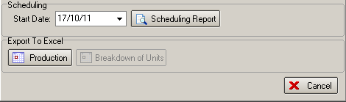

We need to be able to replicate information that is on spreadsheets that have been sent to us by Yewdale.

If Production is selected, then a spreadsheet is produced that contains the following data

Columns

The ‘Job No’ is the order no.
‘Customer’
‘Customer Ref’
‘Order Typed’ is the ‘Order Date’
‘Delivery Date’ is the ‘Required Date’
‘Despatched Date’ is the ‘Delivery Date’
‘Products’ is the category and detail lines are grouped by category.
‘Quantity’ is the detail line quantity
‘Process’ is the ‘Order Status’.
‘Goods In’ to ‘Despatch’ are all manufacturing processes set up against the blind types. Values are the minutes it will likely take to complete within each department.
‘Transport’ is ‘Despatch method’
‘Priority’ is the priority in the order
‘Total Units’ = Quantity + total of processes
‘Con No’ is ‘Consignment Note No’
‘Notes’ is notes from the order

There is also a colouring system in the exported spreadsheet.

Green signifies a job which is complete across the whole factory, ready for despatch.
Pink signifies jobs which are late.
Pale blue indicates jobs which are due to leave today – on time.
Pale grey indicates future work.

2367. Stock Take Import

There are now options to be able to import either warehouse stock or factory stock or both. Previously it was only possible to import both. There are two new flags in this form, called ‘Import Warehouse Stock’ and ‘Import Factory Stock’, which both default to true. ‘Import Factory Stock’ only displays if factory stock is switched on in Parameters.

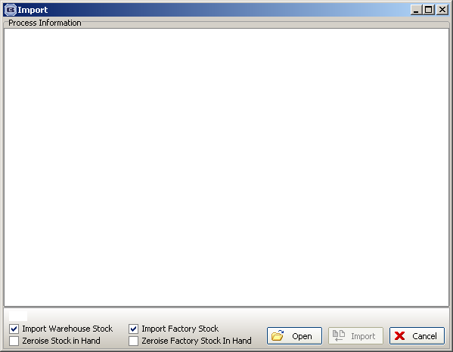

2368. Reports > Stock Valuation

It is now possible to choose records by ‘Link Option’ as well as by ‘Blind Type’ and ‘Supplier’.

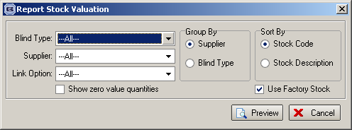

We have also tidied up the stock descriptions in the ‘non factory stock’ report. They were sometimes overlapping into the ‘Unit Of Sale’ field, which has been moved right a bit.

The ‘Factory stock’ report columns have been changed to say ‘Warehouse Stock In Hand’ instead of Quantity. ‘Quantity Value’ now says ‘Warehouse Value’. Also tidied up stock description (stopped overlapping).

2369. Stock Take Report

If ‘Both’ is chosen, there are now two columns for writing amounts, one for entering warehouse and one for factory stock figures.

There are also lines across the report between stock records for easier reading.

2370. Quotation – Bespoke 31

The total quantity of blinds is now printed at the end of the quotation (in the footer).

2372. Purchase Order – Update

There is now a column for total in the invoice form.

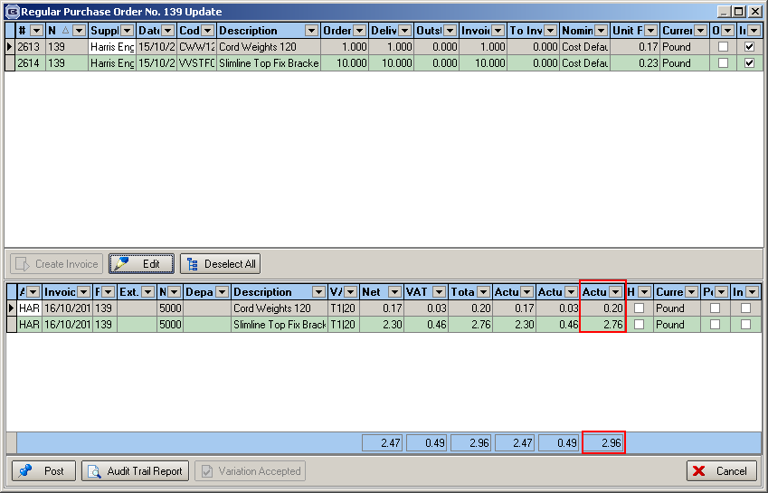

2374. Archive Enquiry

There is now a column choice for ‘Products’.

There is now a ‘View Scanned Order’ option in the context menu.

2383. Sage 2012

It is now possible to integrate to the latest version of Sage 50.

2393. Order Processing > Orders > Create PO

There is now an option so the reference in the PO is updated with the ‘Customer Reference’ from the sales order. To do this we have added a new parameter in Administration > Parameters called ‘Update Cust Ref to PO’, which defaults to false. If this is set to true, then the ‘Customer Reference’ from the sales order is updated to the ‘Reference’ field in the bought in PO.
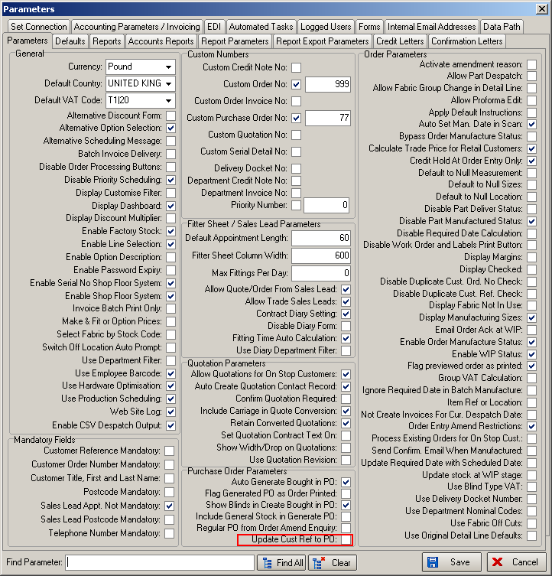

Also, in EDI Enquiry, the PO ‘Reference’ field is now displayed as a column in this form.

