Blindata Release Note 5.6.0 

7 October 2011

Bug Fixes and Enhancements

3581. Customers > Reports > Statements

The ‘Ref’ number was incorrect. It is now printing the ‘Ref’ field from the activity form.

3584. Works Order – Bespoke 34

If the detail line is a miscellaneous type (but not carriage), the quantity and ‘Unit Of Sale’ both now print on the works order – like it does in the order acknowledgement.

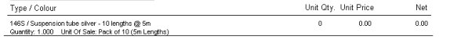
3587. Stock Items > Stock Price

If you entered a record in this tab it could not be deleted. Fixed.

3588. Sales Files > Reports > Statements > A4 Statement

The company and customer have been moved across to the right by 20mm as when placed in window envelope it was not all visible unless placed tight to 1 side of envelope.

Also the £ signs are now beside the numbers.

3589. Sales Files > Reports > Statements

If you try to print out statements for all customers, it did not work. Fixed.

3590. Works Order – Label 7

This is what is required for this label

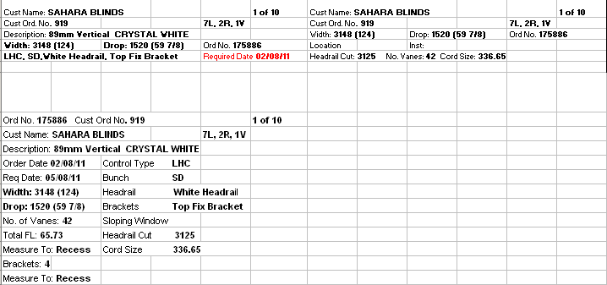

‘Required Date’ now prints instead of ‘Order Date’ in top left label
Cutting sizes now print on top right label (if ‘On Small Label’ switched on in Cutting Sizes).

3595. Reports > Financial Reports > Deposits For Incomplete Orders

This report no longer shows orders which have a deposit but have not yet been invoiced (ie status before ‘Invoice Created’.

New Work and Customer Requests

2377. Works Order – Bespoke 40

A new works order report has been created called ‘Works Order – Bespoke 40’.

The report prints by order and is then grouped by blind type ie one page per blind type.

2389. Purchase Order Regular – Bespoke 31

The fabrics are now grouped together by blind indicator. Also they have been into alphabetical order within these groups by stock description.

A lot of paper was being wasted when the PO is printed, so we have made the following changes.

- Removed headings from second and subsequent pages.
- Moved the supplier address up to the top middle of the header, which would allow for more detail lines.
- Have more detail lines towards the bottom of the report.

2392. Label Print – 3 ½ x 1 Standard

If the blind identifier = Wood and Show Cord Spacing = true, then the cord spacing now prints out.

