Blindata Release Note 5.5.9 

30 September 2011

Bug Fixes and Enhancements

3569. Order Processing > Quality Control

Records could no longer be viewed in here for orders that were entered before the upgrade to 5.5.8. Fixed.

3570. Archive Enquiry

If you tried to print an invoice for an order that has already been completely archived, an error message appeared. This has been fixed.

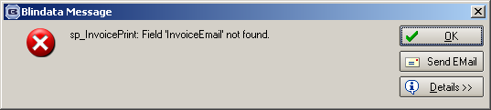

3571. Reports > System Reports > Orders by Operator Report

This report now looks at the order history date instead of the order date. The reason for this is as follows. Let’s say someone entered an order this morning, but changed the order date to yesterday. The order history records will still be dated today, but would not have shown on the report for today’s orders because the order date was yesterday.

3572. Regular Purchase Order Entry

‘Overriden’ is now spelt ‘Overridden’.

If you delivered detail lines and then clicked ‘Cancel’, the lines stay delivered and the overall PO status did not get changed. It is now changed.

3573. Purchase Order Regular – Bespoke 31

If ‘Use Supplier Part No’ is set to true on supplier record, it now prints the supplier part no on the report instead of the stock code.

If the report goes onto a second page, it printed a blank page. Fixed.
If default ‘unit of sale’ has been selected, ‘Unit Quantity’ should not print.
Removed ‘unit of sale cost price’.
Moved ‘Unit Of Sale’ to ‘Unit Of Sale Quantity’.

3574. Dashboard

Value of Today’s Orders

‘Order Manufactured’ now looks at the order manufactured date, ‘Despatched’ looks at the despatch date and ‘Invoice Created’ looks at the invoice date.

The purpose of showing these values is to show what has been done on the current day (in value terms).

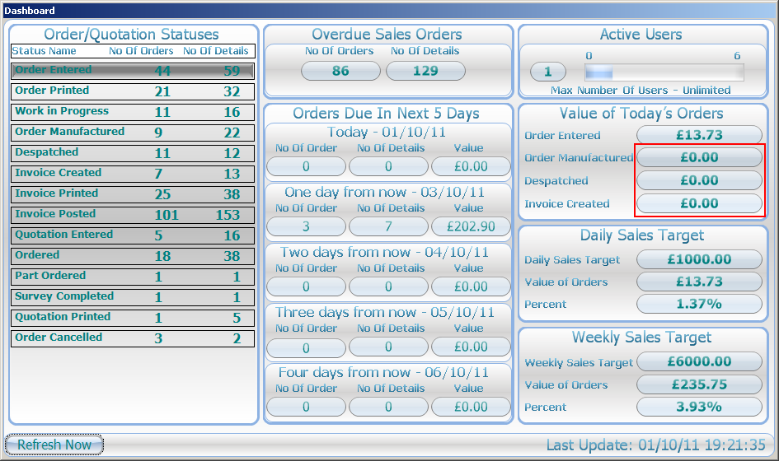

3575. Invoice – Bespoke 35

The ‘Account Code’ has been replaced by ‘Cust Ord No’.

3576. Financials > Complete Posting Of Invoices

The text on this form has been changed slightly, to emphasise that it is the invoice date that should be entered.

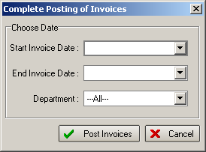

New Work and Customer Requests

2242. Order Processing > Orders

There is a new field called ‘Notes 2’ which is a button like Notes and also a column choice in Order Amend Enquiry’ form.

2253. Dashboard

- The ‘Order Cancelled’ row is now shown at the bottom of the status list.
- Value of Today’s orders – this now has ‘Order Entered’, ‘Order Manufactured’, ‘Despatched’ and ‘Invoiced’, with the values of each of them shown.
- The ‘speedometer’ graphical image has been replaced with the % of orders against target for the day and also for the week. We hold a ‘Daily Sales Target’ in Administration > Company Details.

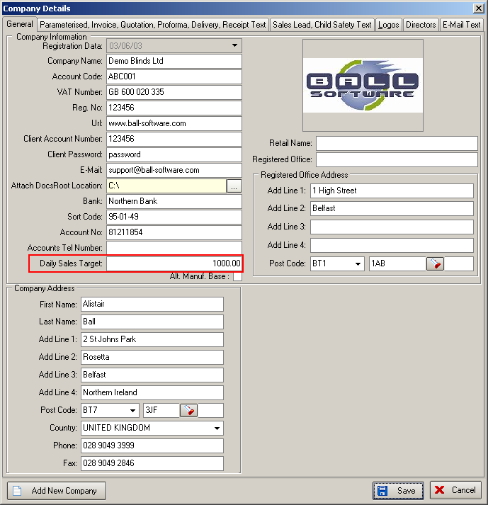

The weekly sales target is calculated by the number of working days in the week multiplied by the ‘Daily Sales Target’. The number of working days in the week can be altered in Administration > Holidays/Weekend.

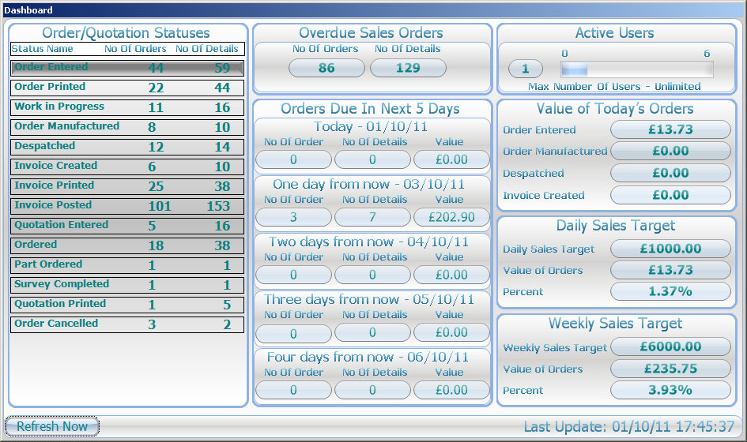

2322. Administration > System Tables > Nominal Codes

There is a new button on the ‘Nominal Codes’ form called ‘Budgets’. This will then display budget records. These records will have start date, end date, value. They will normally be held by month. There is functionality to create the records quickly – a bit like the way the scheduling records are created. If you enter a start date, an end date and a budget amount, then the budget records will be created automatically.

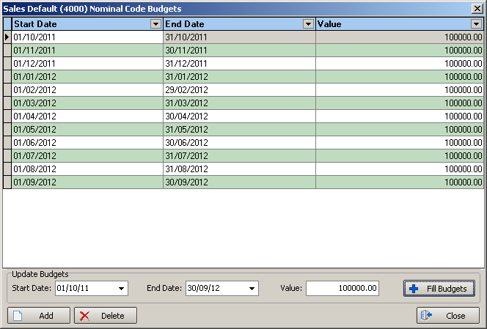

2360. Stock Setup > Stock Items

It is now possible to hold alternative fabric group by customer and blind type.

A change has been made to the form in the tab for ‘Customer Fabric Group’ in Stock Setup > Stock Items. ‘Blind Type’ has been added so fabrics can be set up to have different fabric groups, dependent on blind type and customer.

The order processing fabric group lookup has been amended to take this into account.

