Blindata Release Note 5.5.8 

23 September 2011

Firstly, we’ve made a change to the way the version numbers are displayed. The program displays the incremental number (the fourth digit), and also any discrepancy between the database version and the application version. If this does happen, please call.

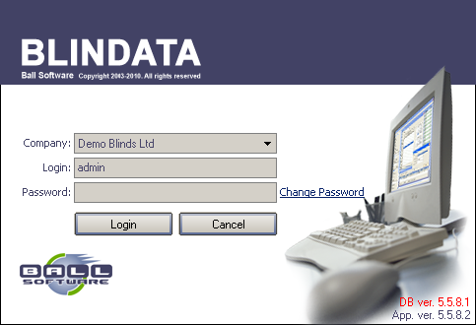

Bug Fixes and Enhancements

3562. Emailing Order Acknowledgements

The logic for this form has been tidied up. We have the following flags in the customer record:

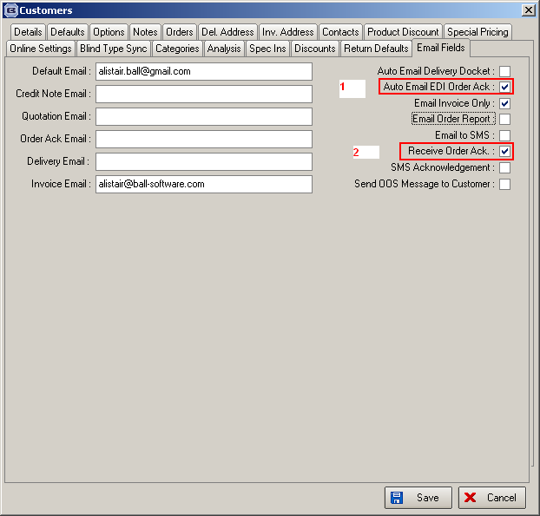

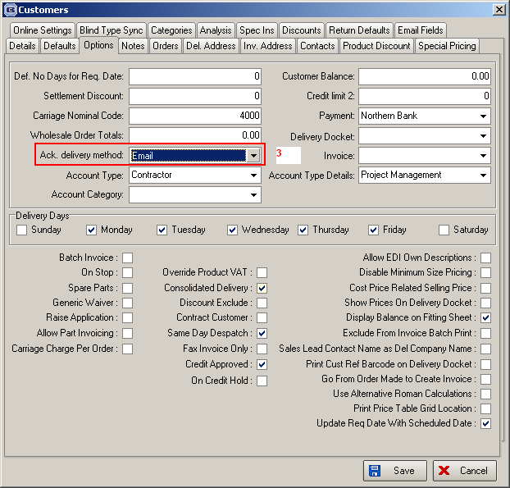

If 1 is flagged, then if an EDI order is received, then an order acknowledgement email is sent to the ‘Order Ack Email’ address that is in the customer record.

If 2 is flagged, then 3 is set to ‘Email’. If 2 is not flagged, then it is not be possible to send an order acknowledgement email for this customer.

If 3 is set to something other than ‘Email’, then 2 is unflagged.

3565. Acknowledgement – Laser Print 8.5 x 11

- The ‘Bill To’ and all fields are now lined up vertically with the company address and the detail lines.
- The boxes do not overlap the column headings.
- The totals box has been tidied up.

3566. Invoice – Bespoke 35

‘HRT’ now says ‘HST’.

3567. Financials > Post Invoices to Sage

There is a problem at a customer that has proved difficult to resolve. They have all customers set to ‘Batch Invoice’. When the invoices are posted to Sage using ‘Post Invoices to Sage’, it nearly always hangs half way through.

We have added a progress bar to this routine and also improved the optimisation.

New Work and Customer Requests

2096. Sales Enquiry Form

It is now possible to print a cover sheet for a sales lead. This can be done by right clicking on the sales lead and selecting ‘Print Report’. Currently this is only a mock up for one customer and will have to be refined.

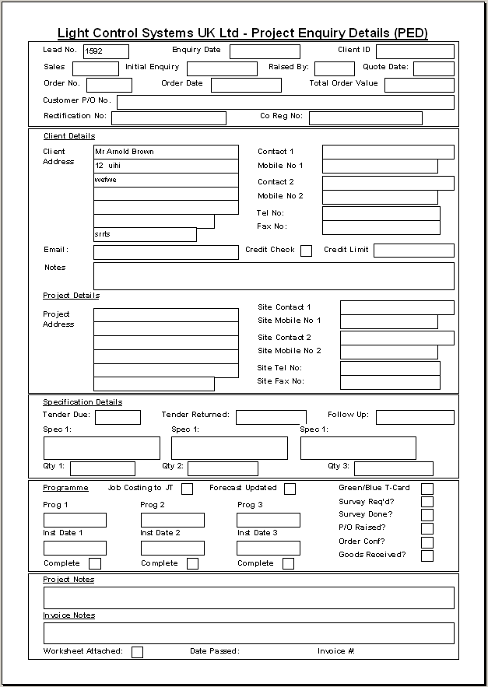

2338. City Link Integration 2

The Un-Despatch scan now works correctly. Previously, when used, it left the order header at a different status from the order lines.

The No of Packages field on the Despatch Scan window is now mandatory when the ‘Enable CSV Despatch Output’ field is checked on the Parameters form. Previously, it was possible to complete a despatch scan without this field being completed.
The PDN field is now working properly. It now passes the actual email address, mobile number or blank depending on the way the customer record is set up.

The system now checks the Start Cut Off Time and End Cut Off Time correctly for the CSV functionality. The alternative despatch method is only used if the current time is outside the cut-off time period. Previously the system did this the other way around and only generated a CSV file inside the cut-off period.

2341. Order Processing > Orders

We now record in the history if the required date has been changed at order entry, and also record if it gets set back to the calculated required date. Previously, we could only record a change in ‘Required Date’ if the order has already been saved and was being amended.

2343. Order Processing > Orders

For vanes only, we have stopped stupidly large number being entered. The program now multiplies the number of vanes entered by the vanes multiplier to check if it is lower than the ‘Maximum Width’ in the blind type record. If it is larger, then the message about the blind being too wide appears. If ‘Maximum Width’ = 0, then this does not apply.

2355. Reports > System Reports > Quotations by Operator

A new report has been created called ‘Quotations by Operator’. This is the same as the ‘Orders by Operator’ report except it is for quotations.

2357. Purchase Order Regular – Bespoke 28

This report now shows both the product code and the supplier product code.

2358. Order Processing > Archive Enquiry

There is now a total for the “Net Total” column in the archive enquiry form.

2359. All Discounts Report

This now includes alternative fabric groups.

2361. Archive Enquiry

There is a new column choice for ‘Same Day Despatch’.

2362. Global Search

There is a new column choice for ‘Same Day Despatch’.

2363. Remakes / Repairs

Remakes/Repairs can now be flagged as ‘Quality Required’. There is a parameter flag called ‘Remake/Repair Quality Check Required’ to enable this. This works for remakes and repairs created manually via ‘Add New’ and via the Archive Enquiry Remake/Repair/Redespatch button.

2364. Archive Enquiry

There is now a ‘View’ button here so a user can look at the detail line.

