Blindata Release Note 5.5.6 

9 September 2011

Bug Fixes and Enhancements

3540. Purchase Order Enquiry > Regular PO

- The value now only display to 2 decimal places.
- The cost price is now shown if there are no ‘Unit Costs’ records held against the stock item.
- The cost price is now shown if a miscellaneous entry is made.
- When a detail line is added, it should open below the other detail lines.
- The cost price column now defaults to be placed to the right of the ‘Unit Cost Price’.
- It was not possible to amend the text in a miscellaneous line. Fixed.

3541. Purchase Order Regular – Bespoke 31

- The detail lines now print in the same order as they are on the entry form.
- There are now quantities and prices showing for miscellaneous lines.
- There is a new column called ‘Unit Of Sale Cost Price’.
- The fax number now prints on the line below the telephone number.

3543. Purchase Order Regular – Standard

- The fax number now prints in the line below the telephone number.
- The quantity and price now print for a miscellaneous item.

3546. Reports > Stock Valuation

When ‘Use Factory Stock’ is false it was still showing the factory stock on the printout and using the value. Fixed.

3548. Purchase Order Enquiry > Send Email

When an email is sent for a regular PO, a history record is now created

3549. Purchase Order Enquiry > Send Email

When an email is sent for a regular PO, the incorrect text was being used.

It now uses the text from Administration > Company Details > Email Text > Email Purchase Order Text.

3550. Purchase Order Entry (Regular)

The system now checks the ‘Cost Price By Quantity’, after the quantity has been entered, because this may affect the cost price. The ‘Cost Price by Quantity’ overrides the other prices.

3551. Invoice – Bespoke 5

When you printed this invoice from ‘Invoice Batch Print’, the totals printed too high up the page on a single page invoice. The same problem was happening with ‘Invoice – Bespoke 34’. Both fixed.

New Work and Customer Requests

2292. Label – Bespoke 33A

For verticals, copied Impala spacers to top left label (right of vanes).
Removed ‘Customer Name’, ‘Desc’, and changed ‘Num of Vanes’ to ‘Vanes’, ‘Control Length’ to ‘C/L’.
Removed order date and put required date on first line.
Removed ‘Order No’ – ord num is now in bold and can be identified by this.

There are now options for ‘On Small Label 1’ and ‘On Small Label 2’ for cutting options.

Cutting options now appear on right hand side of the small labels, from second line to fourth line (3 max).

2318. Acknowledgement – Bespoke 35

The customer’s phone number now prints on the order acknowledgement, packing slip and invoice.

2345. Order Processing > Orders

Previously we made a change to the customer record so we could hold the following email addresses.

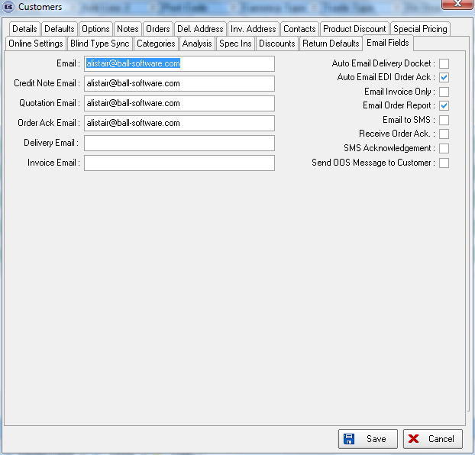

We have made sure that the emails are being picked up from the correct place when acknowledgements, delivery dockets and invoices are sent. For invoices this has been done for Financials > Invoice Batch Print as well as emailing an invoice from Order Processing.

When an order is created, we now hold all the email addresses against the order, which are taken from the customer record. They are now held in the ‘On Site Contacts’ tab, which has been changed to say ‘Other Contacts’. We have also allowed for the fact that a lot of customers will not have these emails set up, so the default email address (‘Email’ in the customer record, which should be changed to ‘Default Email’) can still be used.

Order Acknowledgement Email

This is sent to the ‘Order Ack Email’ address in the order. If this is null, then the email is sent to the default email address in the order. It uses the email address in the order, because it may have been entered there specifically for that order.

Delivery Docket Email

This is sent to the ‘Delivery Email’ address in the order. If this is null, then the email is sent to the default email address in the order. It uses the email address in the order, because it may have been entered there specifically for that order.

Invoice Email

This is sent to the ‘Invoice Email’ address in the order. If this is null, then the email is sent to the default email address in the order. It uses the email address in the order, because it may have been entered there specifically for that order. This is also be done for ‘Email Invoice’ in ‘Archive Enquiry’.

Financials > Invoice Batch Print

This is sent to the ‘Invoice Email’ address in the order. If this is null, then the email is sent to the default email address in the order. It uses the email address in the order, because it may have been entered there specifically for that order.

2348. Purchase Order Entry (Regular)

We now hold the ‘Expected Delivery Date’ that is inputted. Previously this was automatically changing to a lead time held within the system. If the ‘Expected Delivery Date’ is changed manually, then it stays as that date.

2351. Reports > Stock Valuation

This is now group by Supplier/Blind Type and also printed alphabetically by either Stock Code or Stock Description.

2353. Order Processing > Order Enquiry

There are new column choices for ‘Customer Reference’ and ‘Email Address’ (default held against order).

