Blindata Release Note 5.5.5 

5 September 2011

Bug Fixes and Enhancements

3445. Administration > System Tables > Postcodes

Mobile numbers were not coming up in the mobile field when an order was entered. This happened for customers that had contact records set up. Fixed.

3446. Order Processing > Orders

If a customer default option was imported incorrectly, it caused a problem with the option display when a second blind was entered. Fixed.

3531. Order Processing > Orders

If the ‘Allow Amendment’ advanced permission was not switched on, it was still possible to add an ‘Auto’ detail line. After this had been added and saved, the add new ‘Blind’ button was re-enabled. This no longer happens.

3532. Works Order Label 7

- The cord spacing was missing for Venetians and wood blinds.
- The ‘Man Process’ fields were not printing.

Both items have been fixed.

3533. Order Processing > Orders

If the control length was overridden, ‘Label Print – Bespoke 33A’ was still making the calculation to reduce the control/chain length to the nearest 100mm. Fixed.

3534. Administration > System Tables > Postcodes

If a new first part of a postcode was added, it was not available in the lookup in customers or order entry until the user logged out and back in. This has been fixed, and the postcode can now been seen immediately.

3535. Order Processing > Orders / Quotes

Large orders/quotes were taking a long time to add if a lot of detail lines. This has been improved slightly.

3536. Purchase Order Enquiry (Regular)

If a purchase order detail line is fully delivered, it now has ‘On Back Order’ defaulted to false.

When a non unit amount is selected, when you created the purchase invoice, the unit price was incorrect. It was picking up the unit price - it now picks up the non unit price.

3537. Administration > Import From Excel

When you imported a ‘Unit Cost Stock Price’ from a spreadsheet, the ‘Unit Cost’ was not being calculated properly. Fixed.

3538. Orders by Operator

The report now looks at the order history status and not the order status.

3539. EDI Import

There was a problem with EDI defaults being selected for imported EDI files instead of the actual option in the XML file. Fixed.

3542. Purchase Order Regular – Bespoke 31

If you ‘Generate’ a regular PO, the quantities now appear properly on this report, without too many decimal places.

3544. Purchase Order Regular – Bespoke 28

The fax number is now on the line below the telephone number.

New Work and Customer Requests

2185. Cord Spacing / Multi Blinds

Blindata now has functionality for multi blinds. Here is an example.

In the picture the valance goes right across the top of all three blinds. The 3 blinds are also connected to only one headrail. This is quite a common occurrence in the USA and Canada so we have incorporated it in the system. There are two main changes.

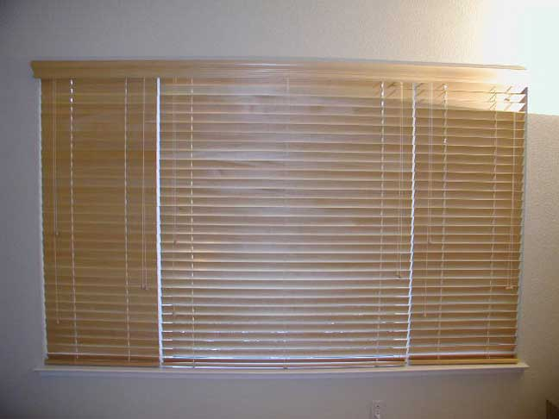

- It is now possible to calculate rout holes (cord spacing) for 2 on 1 and 3 on 1 headrails.
- We can cater for one valance across 2 or 3 blinds.

Blind Types

There is a new blind identifier called ‘Multi Blind’. If this is selected, the blind type form shows the same fields as blind identifier ‘Wood’, but there is a new field called ‘Gap Between Blinds’. The measurement in this field is held in millimetres.

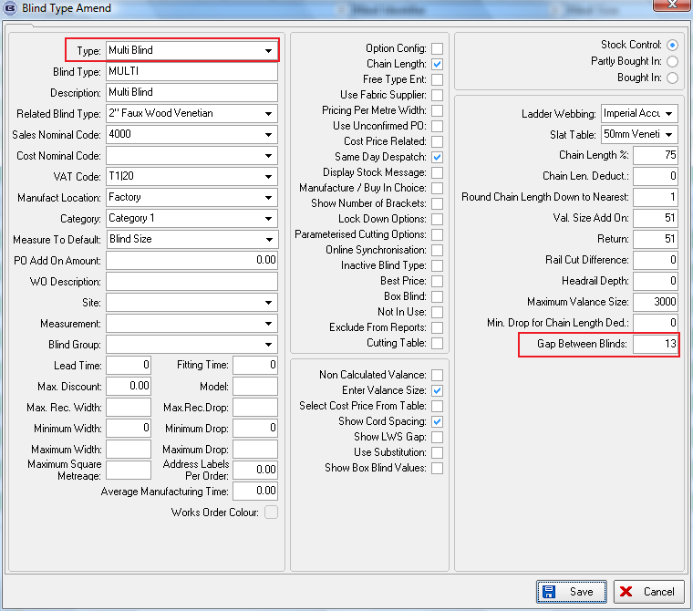

For a venetian or wood blind, the following field has been added:

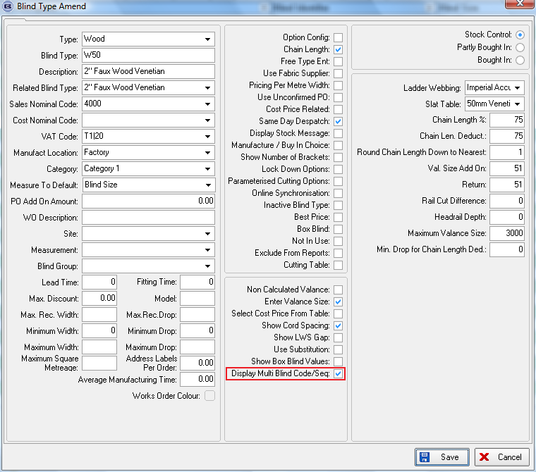

Order Processing > Orders

Example

If we were entering the detail lines for the blind above, we would need to enter 4 detail lines, 3 for the blinds and 1 for the valance. But we could have a more complicated order, where there are, for example, 3 different sets of blinds to be entered – a 3 in 1, a 2 in 1 and then a 3 in 1.

When an order detail line is added for a blind identifier = ‘Multi Blind’, the ‘Gap Between Blinds’ field is displayed with the default from the ‘Blind Type’ form. It is also possible to enter the ‘Multi Blind Code’ eg M1, M2, M3.

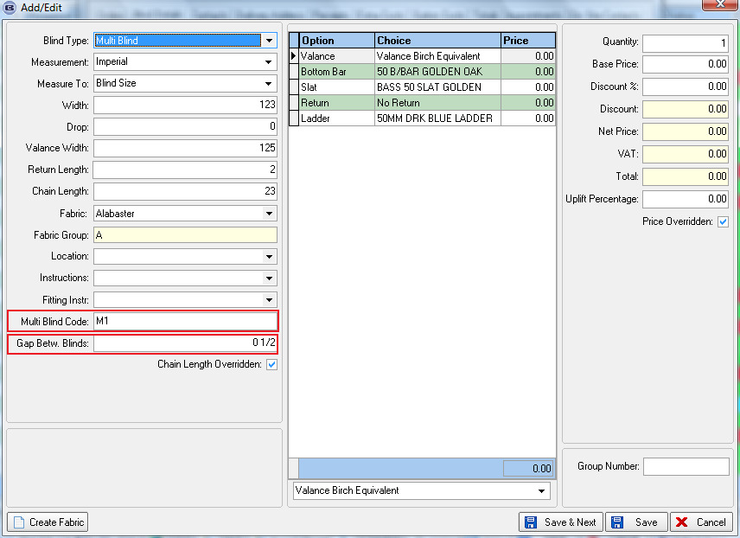

When the related blinds are entered, the following needs to be entered.

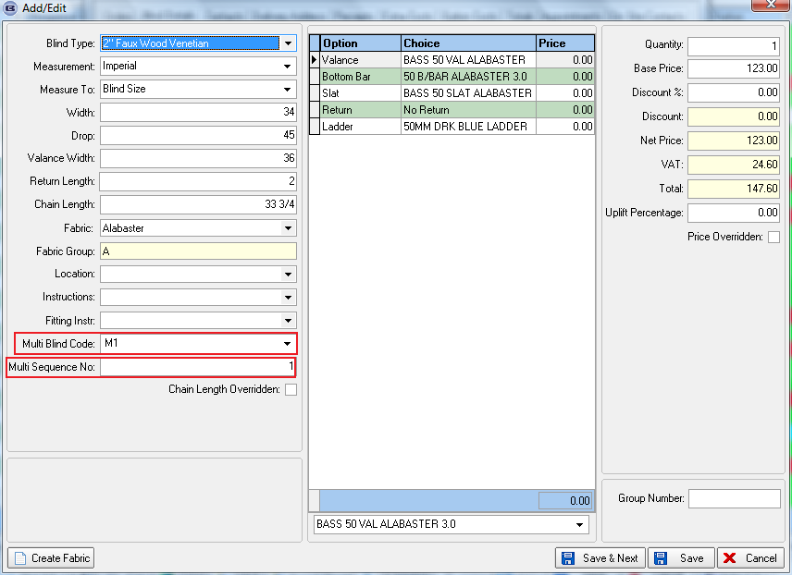

When this detail line is saved, there is enough information to work out the cord spacing (punch holes) on the headrail. We can work out the headrail size form the width entered, and then do the calculations in the way determined by the ‘Ladder Webbing’ set up in the blind type record.

We do not need to enter ‘2 in 1’ or ‘3 in 1’ because we can work that out by the number of blind detail lines tied to the ‘Multi Blind’ detail line.

Reports

We now have this information on some works orders and labels. We still show the normal fields (order no, customer etc) but the only production data we need is valance width, headrail width, cord spacing (according the parameter criteria ie Imperial Sequential etc), Gap Between Blinds, and ‘Multi Blind Code’.

To start with, the multi blind data is on:
Works Order Portrait 8.5 x 11
Label – 5161
Label – 5161 Bespoke 35

2327. Credit Note – Bespoke 35

There is a new credit note report called ‘Credit Note – Bespoke 35’. This has a similar layout to ‘Invoice – Bespoke 35’ but is a credit note. There is also a PDF version of this report.

2329. Order Processing > Orders

It is now possible to enter notes for order whilst in the order. Previously you have to save the order then click on the ‘Note’ button on the ‘Order Amend Enquiry’ form. There is now a ‘Note’ option on the Context Menu in ‘Window Blind Amend’.

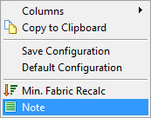

2331. Label Print – 3 ½ x 2A

- Account code now prints to the right of ‘FACTORY’.
- Special instructions now also print on labels, in place of the lower WIDTH and DROP.

2334. Administration > Company Details

‘HST Number’ has replaced ‘VAT Number’ if Canada.

2335. Reports > System Reports > All Discounts Report

There is a new customer discount report that shows all discounts for a customer, both blinds and components. Previously there were only two separate reports, ‘Customer Discount Report’ and ‘Customer Product Discount. We have retained these reports, but also have a report that combines both, by customer, called ‘All Discounts Report’.

The user should be able to select a customer for this report or choose all customers. The product discount should take account of the product, category and fabric class discounts.

2336. Sales Cash Flow Report

There is a new report in Reports > Financial Reports called ‘Sales Cash Flow Report’. The user can choose the start and end order date. There are totals at the bottom of the report and it prints in order number order. If trade type = ‘Trade’, then the company customer name prints, if trade type = ‘Retail’, then the customer contact name prints out.

The format is:

Order Order Invoice Deposit Balance
Number Date Value Date Value Date Value Date Value
Customer Name 37469 02/05/11 £2,348 07/07/11 £2,348 02/05/11 £1,500 07/07/11 £848

2337. Delivery Docket – Laser Print 8.5 x 11

- If the detail line is a component line, then the stock code now prints on the left hand side.
- If the detail line is a component, the columns are headed ‘Stock Code’, then ‘Description’. There will not be a mix of blinds and components on these delivery dockets.

2342. Order Processing > Orders

There is now a column choice for a list of the blind type codes in the order, called ‘Products’.

2344. Order Processing > Orders

Blindata has functionality to store scanned documents in an assigned folder, which can be determined in Administration > Parameters. If the scanned pdf documents are named according to the convention 99999.pdf (where 99999 is the order number), there is now a context menu option to view these documents.

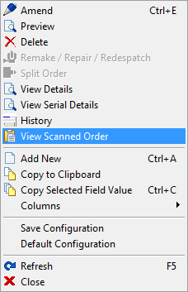

2346. Purchase Order Enquiry

In the regular PO amend form, there are changes to some of the columns.

- ‘Ordered’ has been removed.
- ‘Cost Price’ has been changed to ‘Unit Cost Price’.
- There is a new column called ‘Cost Price’ which is the cost price of the ‘unit cost’ selected.
- The columns now default to product code, description, quantity, unit quantity, delivered, outstanding, cost price, unit cost price, unit of sale, free text, select.

2347. Stock Setup > Fabric Group Setup

There is a new field in this form for ‘Discount Class’. There is a column for this field and also a choice at the bottom of the form to update the ‘Discount Class’ field for the records selected.

