Blindata Release Note 5.5.4 

26 August 2011

Bug Fixes and Enhancements

3516. Order Processing > Orders

When you enter an order and the customer has a ‘Return Default’ set up, this had temporarily stopped working. Fixed.

This had not worked because of the changes made in dev 2063.

If the code for an option name is set to ‘Valance Calc’, it looks at the ‘Return Valance Size Add On’ form. This option code is now also used for the ‘Return Defaults’ form.

3525. EDI Enquiry / Purchase Order Enquiry

If a sales order is entered for a bought in blind, and ‘Auto Generate Bought In PO’ is true and ‘Automatically Send File’ = false, there were two things wrong:

- When you went to EDI Enquiry > Send File, and sent the file, it did not flag the PO as being sent in ‘Purchase Order Enquiry’.
- After this, in ‘Purchase Order Enquiry’, you could re-send the file.

Both of these issues are fixed.

3526. Works Order Portrait 8.5 x 11

If you enter a detail line with a valance that had imperial fractions, it did not print out properly on the works order. We have made sure the full size now prints out.

3527. Order Processing > Orders

If you entered a component detail line, saved the order, then went back into amend the component line, if you then changed the stock code, the ‘Comment’ field did not get updated, and so the wrong description was printed out. Fixed.

3528. Sales Files > Customers

If you saved something in the ‘Measure To’ field, it could not be removed. It is now possible to remove the entry from here because it has an impact on the default ‘Measure To’ choice in order detail line entry.

3529. Fitter Worksheet

- Sometimes this report split blinds up into different pages. Fixed.
- Customer contact name was missing from the header – now printing.
- Fitting instructions now print on the report.

3530. Works Order Label Blind Size

It is now possible to print up to 15 options on the large label (1). We have altered the special instructions to allow for this (2).

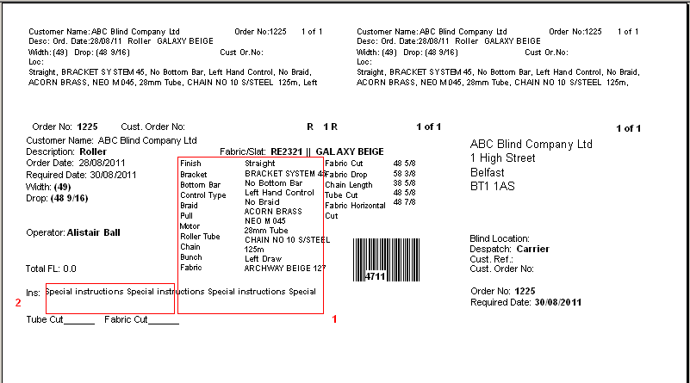

New Work and Customer Requests

2299. Lakeview PO Update

We have created the Lakeview update when posting a purchase invoice. This works in exactly the same way as the sales invoices work, except it is for purchase invoices. We therefore have created an XML file for export to Lakeview after a purchase invoice is created.

The following data locations have been set up in Parameters. They are the same as for sales, except ‘Customers’ will be ‘Suppliers’ and ‘Invoices’ will be ‘Purchase Invoices’.

2307. Order Processing > Quotations / Orders

If a blind type is set to ‘Cost Related Price’, when the quote/order is entered, the fabric cost price is calculated on the amount of fabric required. However if the fabric has to be bought for this specific quote/order, then a minimum amount may have to be purchased.

Therefore we have added a new context menu option in the ‘Window Blind Amend’ form called ‘Min. Fabric Recalc’.

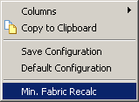

There is also flag for this in ‘Buttons Visibility’ (both for quotation and order).

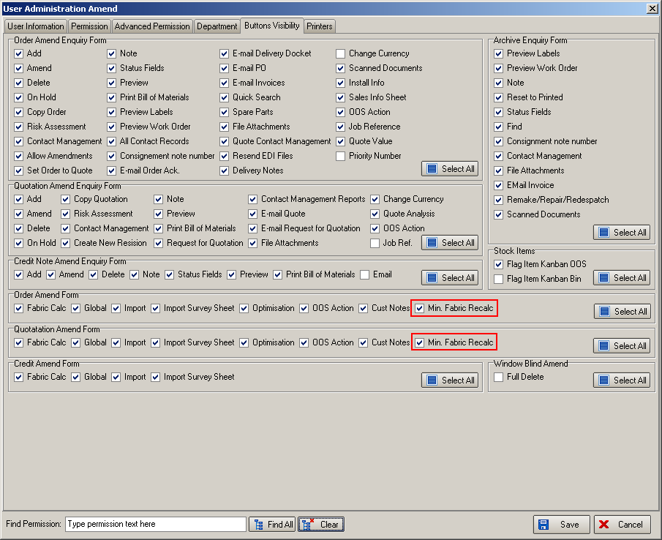

When this button is selected a message says ‘Do you want to recalculate the cost price based on a minimum fabric order quantity?’. If yes is selected, then the following happens.

The program groups the blinds by fabric, totalling the fabric quantity (from the bill of materials). If this quantity is lower than the ‘Minimum Order Quantity’ for the fabric, then the minimum order quantity is put into the first detail line for that fabric and the others zeroised. The blind detail line(s) is then flagged as having been recalculated and the cost price of the detail line and hence quote/order is recalculated. This is similar to the optimisation process except we are not doing the optimising, but we are replacing the quantity.

We have also added ‘Min Fabric Recalculated’ as a column choice in the Order Edit > Details grid.

2311. Works Order – Label 7

There is a new report, called ‘Works Order – Label 7’. This is based on ‘Works Order – Label Blind Size’. The top two small labels should look like this if blind identifier = Vertical.

For roller blinds we have removed "fit" and replace with "inst" (instruction)
Please note all small labels for all blind types now print the total blind order eg- 7L, 2R, 1V.

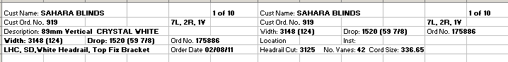

2316. PO Regular Reports

Unit of measure now prints on all regular PO reports.

2319. Customers > Product Discounts

Previously we could only have customer stock item discount held by category and by stock item.

We now also have discount held by ‘Discount Class’ (Discount Class in the stock record). There is an extra column in this tab form for entering this field If a record is created for ‘Discount Class’, then either a price or a percentage can be entered. This is then selected when an order detail line is entered for the relevant component.

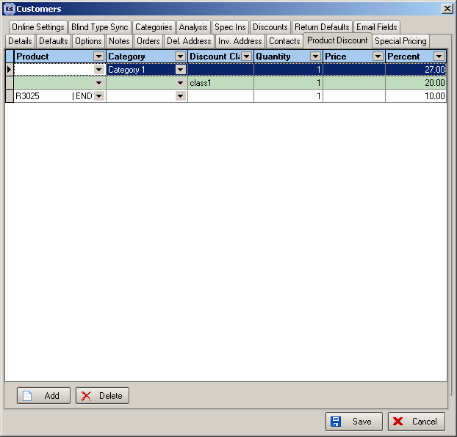

When a component order detail line is entered, this new discount should be taken into account.

2320. Sales Files > Customers

There are new system tables called ‘Account Type’ and ‘Account Type Details’. The latter is a sub group of the former.

These fields are held against the customer record and are also available as column choices in the customer enquiry form.

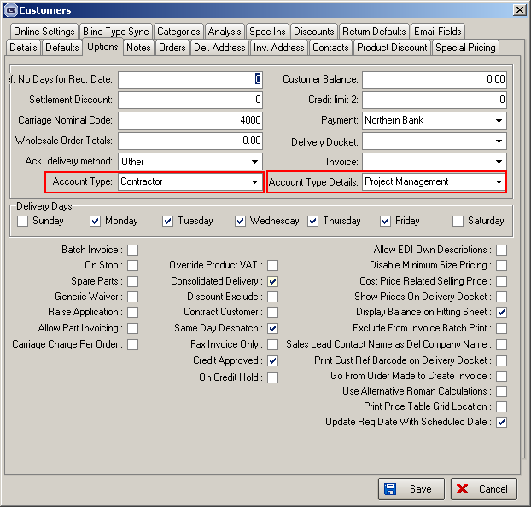

2333. Invoice – Bespoke 35

We have added the HST tax number to this invoice. This is the Canadian equivalent of ‘VAT Number’ and prints under the invoice total box, as ‘HRT Number: ‘.

2337. Delivery Docket – Laser Print 8.5 x 11

- If the detail line is a component line, then the stock code now prints on the left hand side.
- Also, if the detail line is a component, the column headings become ‘Stock Code’, then ‘Description’. There will not be a mix of blinds and components on these delivery dockets.

