Blindata Release Note 5.5.3 

19 August 2011

Bug Fixes and Enhancements

3517. Wholesale EDI File (re-release of 5.4.9)

The ‘Unit Of Measure’ is now being stored in the XML file.

3518. Works Order Portrait 8.5 x 11

A number of small amendments have been made to this report.

- The customer name has been moved down a line and made wider
- The works order number has been moved left so it is in line with customer, but a line above
- The salesman (rep) has been moved down a line (same line as customer) and right justified.
- The blind identifier codes field has been made this a lot wider so it can hold lots of possible combinations eg 12R, 13W, 7V
- The fabric description field has been moved down a line so a longer description will print.
- The option names were getting wrapped round – this meant the option names and choices are possibly not on the same line, so we have cut off the option name.

3519. Invoice – Bespoke 35

- There is now a space between the postal code and the phone number.
- Dispatch method print on the invoice. It has replaced ‘Cust Ord No’.

3520. Purchase Order Enquiry > Generate Regular PO

The amount calculated for a regular PO was incorrect if a non unit is entered. Fixed.

3521. Invoice – Bespoke 34

If no lines have discount, then the words ‘Disc Amount’ do not print in the column heading.

3523. Purchase Order Enquiry > Generate Regular PO

When we display the ‘Related Sales Orders’ form, the total quantity now prints at the bottom of the form (total of viewed transactions on this form).

New Work and Customer Requests

2295. Reports > Stock Valuation

If ‘Use Factory Stock’ is switched on this report is now in landscape, and also print totals for quantity and value, also print fields for quantity and value for factory and warehouse.

2301. Acknowledgement – Bespoke 37

We have created a new order acknowledgement report called ‘Acknowledgement – Bespoke 37’.

2304. Administration > Users > Advanced Permissions

There are now advanced permissions add, delete, amend, view for stock items.

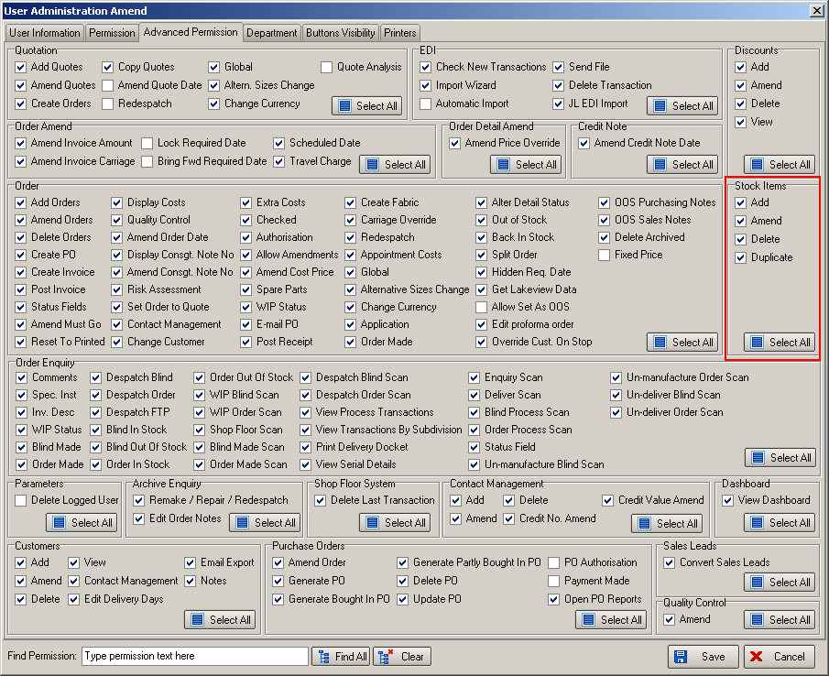

2305. Regular PO Reports

There is a new button on the ‘Purchase Order Enquiry’ form called ‘GRN’. If this is selected, the user will be able to update the ‘Delivery Note No’ field.

2306. Administration > Export Data > Stock Transaction

It is now possible to export stock transactions (in the Sage layout below) in Export Data > Stock Transactions, selected by start and end sales order date and also by supplier and by transactions type ie ‘on sales order (order date)’, ‘on purchase order (PO date)’, received date, issued date.

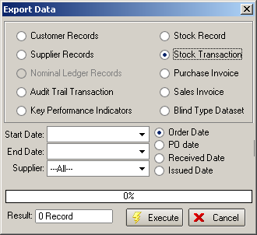

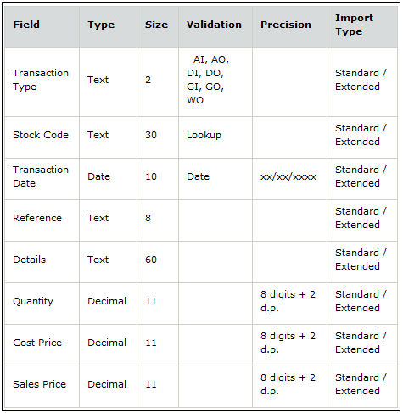

2308. Out Of Stock Messages

We made a big change in development item 2149 so the out of stock messages were sent according to stock warnings, but it was still necessary for it the way it was emailing previously (ie before 2149). There is now an option for this.

There is a new parameter flag for this called ‘OOS Email to Customer’. If this is set to true, then the OOS email will be sent to the customer as it previously was. If it is set to false then it will be unchanged from the version 5.5.2.

2310. Invoice – Bespoke 38

There is a new invoice layout based on ‘Invoice – Bespoke 12’.

The margins have adjusted on the left side (moved in 45mm).
Text has also been moved up 50mm.

2312. Sales Lead Bespoke 39

In Parameters > Report Parameters > Sales Lead / Fitter Sheet Individual, there is a new report layout called ‘Sales Lead Bespoke 39’.

2313. Quotation – Bespoke 38

A new quotation report has been created called ‘Quotation – Bespoke 38’.

2314. Invoice – Bespoke 39

A new invoice report has been created called ‘Invoice – Bespoke 39’.

2315. Cord Spacing Calculation

The cord spacing calculation now calculates to 1/16 of an inch if cord spacing settings are imperial.

This is because the spacing was too far off with the conversion from metric to fractions. A sample would be 77 1/4” spacing with a 5” space at each end gives us 67 ¼” but the spacing on the works order shows 11 ¼” but this was too big. In decimals it works out to 11.208. This will now calculate as 11 3/16.

2317. Order Processing > Orders

Previously if ‘Enter Valance Size’ is switched on, when an option is changed, the ‘Valance Width’ and ‘Return Length’ were always recalculated. There is a new parameter called ‘Non Calculated Valance’so this will not happen. It is held in the blind type record and is only shown if ‘Enter Valance Size’ is switched on. If this is set to true, then the ‘Valance Width’ and ‘Return Length’ can be entered manually and will not be changed. Also they will not look at ‘Return Valance Size Add On’ or the ‘Return Defaults’ for customers.

