Blindata Release Note 5.5.2 

12 August 2011

Bug Fixes and Enhancements

3504. Online Proforma Import / Credit Control Email

The totals tab for proforma online orders and the credit control email generated for them are incorrect. They did not take the same day despatch charges into consideration.

3509. Order Processing > Orders

If you entered a detail line after a curved headrail detail line had been entered, the blind did not price properly. It took the width from the previous detail line. Fixed.

3510. Works Order Portrait 8.5 x 11

If imperial sizes are printed with fractions in them, they were sometimes being cut off. Fixed.

3511. Invoice – Bespoke 20 (Regular and Batched)

This customer has changed their preprinted stationery. We therefore have moved ‘INVOICE’ and ‘Customer Copy’ (1) and ‘Page 1 of 1’ (2) to the top left of the page (3).

This has also been done for ‘Acknowledgement – Bespoke 20’, ‘Credit Note – Bespoke 20’, ‘Delivery Docket – Bespoke 20’ and ‘Quotation – Bespoke 20’.

3512. Acknowledgement – Laser Print 8.5 x 11

- Department has been removed.
- If Canada, ‘Cust Ref’ says ‘Tag:’.
- If USA or Canada, ‘Despatch’ is spelt ‘Dispatch’.

3513. Invoice – Bespoke 35

The page length for this is now 11 inches, not A4 length.

- Telephone number for the customer now prints.
- If USA or Canada, ‘VAT’ says ‘Sales Tax’.
- The currency sign is now beside numbers.

3514. Delivery Docket – Laser Print 8.5 x 11

- Tel number from the order now prints.
- Salesman (Rep) now prints.

3515. Works Order Portrait 8.5 x 11

- If ‘Enter Valance Size’ is switched on in the blind type record, the entered sizes now print out.
- If the works order is set to print in imperial, the chain length size prints in imperial.
- If options wrap around, they do not line up properly with the option names. They no longer wrap around.

New Work and Customer Requests

2288. Purchase Order Enquiry

When entering free text, it is now possible to see all the sales orders with bill of materials that relate to the stock code being entered. There is a new choice on the context menu (right click on record) called ‘View Related Sales Orders’ where you can see all the sales orders for that stock code between the start and end date. This in effect looks at the same records as the ‘Generate’ button but does not actually generate the amount required. Instead a window will just show the individual transactions.

2293. Order Processing > Orders

It is now possible to overwrite the ‘Control Length’ and flag it as amended so it does not get rounded on the label. We now hold a flag to say that the ‘Control Length’ has been manually altered.

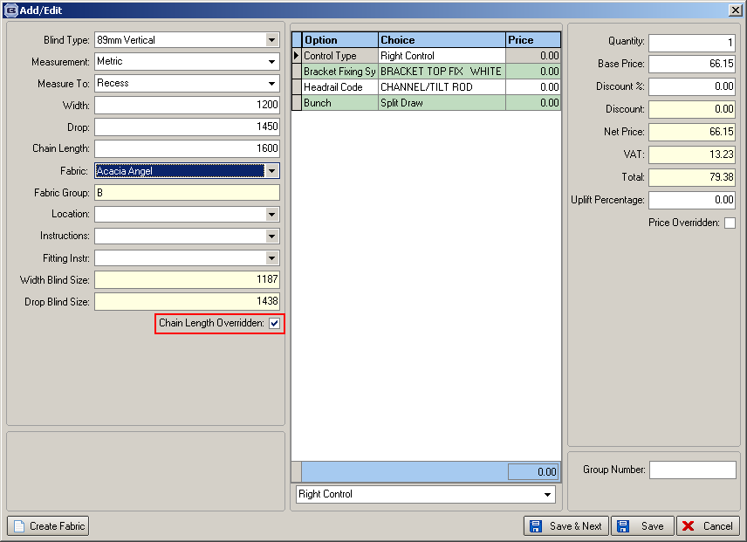

2294. Orders by Operator Report

We have improved this report so we can select the ‘status’ that is to be printed, including all. This means it will be possible to see how much work each person is actually doing.

2296. Purchase Order Enquiry

If a PO email is sent, the PO is automatically flagged as sent.

We can now calculate the ‘Expected Delivery Date’ for regular purchase orders. It calculates this as the longest ‘Lead Time’ held against a stock item that has been ordered.

If ‘Factory Stock’ is enabled, at PO entry, the user now has the choice of whether the item is for factory or warehouse. This has the same default rules as described in 2297.

When PO is updated, stock transaction now state whether it is factory or warehouse

2297. Stock Setup > Stock Take Entry

There is now a choice here for whether factory stock is updated or not. There is a flag called ‘Factory Stock’, which defaults to false if ‘Stock Held In House’ = true, and true if this field is false. This flag only displays if ‘Enable Factory Stock’ is switched on in Parameters.

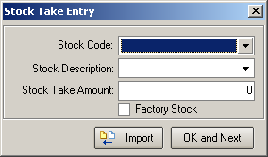

2302. Order Processing > Orders / Quotes

When entering sizes in Imperial, it is now possible to cater for 1/16 of inches. Therefore the order/quote entry accepts entries with the extra following fractions: 1/16, 3/16, 5/16, 7/16, 9/16, 11/16, 13/16, 15/16 and converts them to millimetres (if required).

2303. Acknowledgement – Bespoke 35 / Invoice – Bespoke 35

The Salesman (rep) name now appears on each document that is printed from Order Acknowledgement to invoicing stage.

2309. Purchase Order Enquiry

When a purchase order EDI record is created, the PO is now flagged as sent.

If ‘Transfer File’ is switched on for a supplier, then it is no longer possible to email a purchase order. The ‘Send Email’ button is disabled in the ‘Purchase Order Enquiry’ form and in the ‘Regular Purchase Order Amend’ and ‘Bought In Purchase Order Amend’ forms.

