Blindata Release Note 5.5.1 

5 August 2011

Bug Fixes and Enhancements

3502. Stock Setup > Stock Take Entry > Import

There was a problem with importing the stock take spreadsheet. It would not import any records until it has checked that all the records are ok. This was not satisfactory if there were over 6000 records and it could not do the import because it kept stopping with error messages. As well as taking a long time, it was slowing the whole system down as well.

We have changed the import routine to be the same as the ‘Fabrics’ import in Administration > Import From Excel, so it will import records whilst also saying which records won’t import.

3503. Works Order Label 1

Removed the ‘Must Go’ text from Same Day works orders so only ‘Same Day’ appears beside the main barcode. This stops the text from wrapping onto a second line.

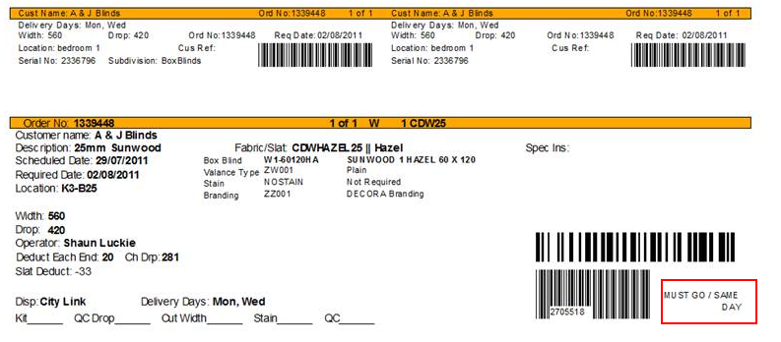

3505. Order Processing > Orders

If a user does not have ‘Allow Amendments’ permission, they cannot add lines to orders above order entered status. Also, users without this permission previously could not split orders at all. They can now split orders, but only at ‘Order Entered’ status..

3506. Works Order Portrait

If a quantity with decimal places is entered, it noe only displays the relevant number of decimal places.

3508. Purchase Order Enquiry > Generate Regular PO

If you enter text in the ‘Variable Supplier Address’ before a detail line is entered, it did not retain the fields. Fixed.

New Work and Customer Requests

2285. Administration > Import From Excel

There are now import options for sales ledger transactions, purchase ledger transactions and nominal ledger transactions. We have used the same import files that are used for importing transactions to Sage. This is the same file layout as is exported in Financials > Post Invoices to Sage > Line 50 Export File.

2287. Contact Management

There is a new field for ‘Disclaimer Text’ in Company Details > Email Text. This appears as a default and then can be changed in the contact management record, if ‘Send Email’ is selected. This text appears at the end of the email.

2289. Contact Management Report

We now show the operator name on this report (for each record).

2290. Customer Discount Report

We now print the account code to the right of customer name

2291. Works Order – Bespoke 31

For blind identifier = miscellaneous, we now print the product code and unit of sale to the right of description. Also the detail lines now print in detail line order.

2298. Detail Line Removal

There is a new feature to completely remove a detail line and all the history records associated with it. We need a new field in Administration > Parameters called ‘Allow Detail Line Removal’ and a ‘Buttons Visibility’ flag also called this.

If both of these are switched on, then a user will be able to remove a detail line completely from an order, using a button called ‘Full Delete’. This can be done on the ‘Window Blind Amend’ form at any stage up to, but not including. ‘Create Invoice’. If either of these parameters are switched off, then the button will not be visible and the detail line can not be fully deleted.

2300. Purchase Order Enquiry

We added the +Misc button recently, but only for suppliers where ‘Variable Supplier’ = true. This has now been implemented for all suppliers.

