Blindata Release Note 5.4.9 

25 July 2011

Bug Fixes and Enhancements

3455. Invoice Laser Print (Letterhead Logo) 8 ½ X 11

There is now a ‘Report Export Parameter’ version of this report.

3478. Order Processing

There was an issue where sometimes required dates didn’t calculate correctly. This seemed to happen during the scheduling routine when the order was checked, resulting in the required date being before the schedule date. This is fixed - was to do with the scheduling routine for proforma customers with a set delivery day.

3479. Acknowledgement – Bespoke 35

Fitting Instructions from the detail lines now print on the report, but only if not null.

3480. Delivery Docket – Laser Print 8.5 x 11

- Despatch is now spelt ‘Dispatch’ if Canada or USA.
- The date format is now correct – if system and Windows setup is mm/dd/yyyy.
- Fitting Instructions from the detail lines now print on this report, but only if not null.

3481. Invoice – Laser Print (Letterhead Logo) 8.5 x 11

If there are 9 detail lines for blinds or more for component lines, the total prints at the top of the next page. Fixed.

3482. Works Order Portrait 8.5 x 11

‘Location’ now prints on this works order, above ‘Special Instructions’.

3483. Customer Label – 4” x 2”

The font size was set to 20 point a while ago, but the customer name no longer fits, so we have made the customer name as wide as the label and also make the font a bit smaller.

3485. Administration > Parameters

This form has been tidied up.

3486. Order Processing > Quotations

This ‘Fixed Price’ flag has to be tidied up.

3487. Works Order – Bespoke 34

If ‘Print Measure To in Works Order Print’ is set to false, then it does not print on this report.

New Work and Customer Requests

2267. City Link Software Integration

See separate documents – Blindata City Link Integration Specification.doc and City Link Test Import.csv.

2205. Process / Employee Barcoding

A customer has come up with a good idea of how to record when processes are done in the factory and who has done them.

The idea is to have a barcode for a process, and one for an employee. Then in the factory, the employee will scan their own barcode, scan the process (on a sheet on wall) then scan the label. After the last process is done, the blind status should be ‘Blind Made’.

This has an impact on ‘Blind Process Scan’ and ‘Order Process Scan’ in Order Processing > Order Enquiry.

The following work has been done.

Blind Details > Blind Types > Man Process Types

We can now hold an integer in here which can be used as a barcode. It should therefore be a unique number that cannot ever be an order detail or serial number.

Administration > Employees

We can now hold an integer in here which can be used as a barcode. It should therefore be a unique number that cannot ever be an order detail or serial number.

These barcodes can be printed onto reports in Reports > System Reports. The ‘Man Process Types’ barcodes will print by blind type, and the employee barcodes will print onto an A4 page, with employee name and barcode, 2 across the way, 6 or 8 down.

The employee barcode report will then be cut up, and each factory employee given a laminated card which will have their barcode on it.

Administration > Parameters

There is a new parameter called ‘Use Employee Barcode’. If this is set to true (it defaults to false), then in ‘Blind Process Scan’ and ‘Order Process Scan’, the employee is able to scan their barcode and scan the process instead of selecting both.

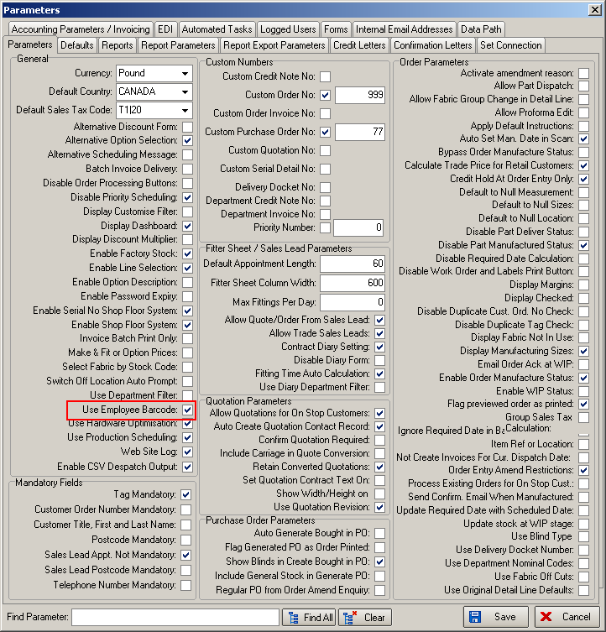

2276. Wholesale EDI Functionality

We have amended the wholesale XML file layout to match the following layout.

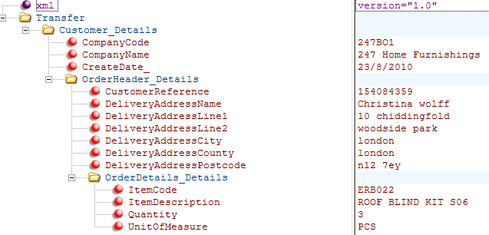

2280. Create Invoices

Occasionally we get complaints from customers that invoices do not add up properly. The detail lines are always correct, but the total is sometimes wrong. It does not happen very often, but we have made a change in ‘Create Invoices’ to check that the detail line total matches the overall total.

This has be done in Financials > Create Invoices and in Order Amend Enquiry > Create Invoices.

2281. Works Order – Bespoke 28

The special instructions now print in red.

2282. Purchase Order Improvements

If a regular PO is created for a variable supplier, then we need to be able to enter a free text line. We have done this in the same way as a component detail line is entered in a sales order.

There is a new button called ‘Misc’ in the ‘Generate Regular Purchase Order’ form. If this is selected, then the stock code will default to stock code M (which will be set up as Miscellaneous) and the user will be able to enter a description in a ‘Description’ field.

We have altered all the regular PO reports to allow for this new field. It now prints instead of the stock code and stock description.

It is also possible to enter the invoice number as well as the GRN number (at the delivery stage). We have also added both the invoice number and del note number columns to the main p/o enquiry form.

2283. Works Order – Label 1

The following changes have been made to this report layout (colour and non-colour versions).

- The ‘Order No’ in the top two labels has been moved down.
- ‘SAME DAY DESPATCH’ has been shortened to say ‘SAME DAY’ to see if this stops the layout from slipping down.

