Blindata Release Note 5.4.8 

15 July 2011

Bug Fixes and Enhancements

3449. Label Print – Bespoke 33A

For blackout blinds, the barcode is now displaying properly.

3466. Same Day Large Quantity Scheduling Bug

The ‘Large Quantity’ field used to limit the maximum number of blinds per manufacturing location on a Same Day Despatch order was not working properly. The ‘Maximum Scheduling Number’ was being checked instead, but this has been replaced by ‘Large Quantity’.

3471. Purchase Order Enquiry

When you click ‘Recreate EDI Transaction’, you got the following error. Fixed.

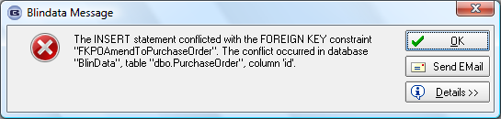

3473. Delivery Docket – Laser Print Non Itemised

- ‘Width’ and ‘Drop’ no longer appear if the order only contains miscellaneous items.
- Quantities now print to a maximum of 2 decimal places.

3474. Works Order Portrait 8.5 x 11

‘Despatch’ now prints as ‘Dispatch’.

3475. Picking List

‘Despatch’ now prints as ‘Dispatch’.

Also, the customer company name and address now print out beneath the company details name and address.

3476. Invoice – Laser Print (Letterhead Logo) 8.5 x 11

- Company name (from Company Details) now prints below the logo.
- If country is Canada, ‘Sidemark’ now says ‘Tag’.
- Also we have made sure that an invoice with prices that go up to 99999.99 print properly in all places where prices are printed.

3477. Quotation – Laser Print by Option

- If country is Canada or USA, ‘VAT No’ has been removed.
- If country is Canada or USA, ‘Despatch’ now prints as ‘Dispatch’.
- Country has been removed.
- If country is Canada or USA, ‘VAT’ now says ‘Sales Tax’.

New Work and Customer Requests

2250. Priority Number

It is now possible for each order to have a priority number assigned to it. There is a new field in the Orders Table called ‘Priority’, which is an integer. There is a ‘Priority’ button on the ‘Order Amend Enquiry’ form so a number can be entered. This is only visible if switched on in Administration > Users > Button Visibility.

There is a default ‘Priority Number’ in Administration > Parameters.

2255. Stock Setup > Stock Items

There is a new tab in the stock record for ‘Customer Fabric Group’. This means it is now possible to assign a fabric group to a fabric by individual customer. When an order/quotation is entered, if there is a record set up in the fabric for ‘Customer Fabric Group’, then this fabric group is used instead of the one in the main stock record.

2256. Sales Files > Customers > On Credit Hold Flag

There is a new flag on the customer record called ‘On Credit Hold’, which defaults to false. If this is set to true, then when an order is entered, the order will be placed on credit hold, regardless of the credit limit and/or outstanding balance result.

There is also an ‘On Credit Hold’ column choice in customer enquiry.

2258. Order Processing > Orders

There is now a column choice for stock code in ‘Window Blind Amend’.

2260. Contact Management Reports

It is now possible to see a report of all contact records between dates, by customer, by blind type and by type. Also the value.

This report choice is in Reports > System Reports. We need to enter start and end order date, select customer (default to ‘All’), select blind type (default to ‘All’), and select Type (default to ‘All’). There is also a choice to sort and group by any combination of these fields, then print them along with the net value.

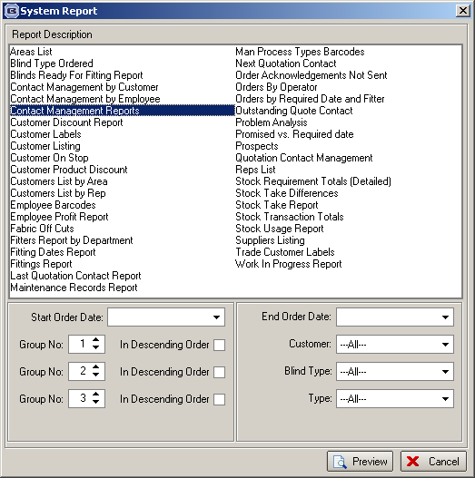

2261. Stock Setup > Stock Items

In the ‘Unit Costs’ tab, it is now possible to enter the price for a box (for example) as well as the unit price, and the system will then work out the unit price and vice versa.

This means we have added a new field to be displayed here. The ‘Cost’ column has been renamed to ‘Unit Cost’ and another column added called ‘Cost’. ‘Unit Cost’ is the unit cost, ‘Cost’ is the cost of a ‘Length’ etc. For example, if there are 5m in one length and the ‘Unit Cost’ is 0.09, then the ‘Cost’ for a Length will be 0.45.

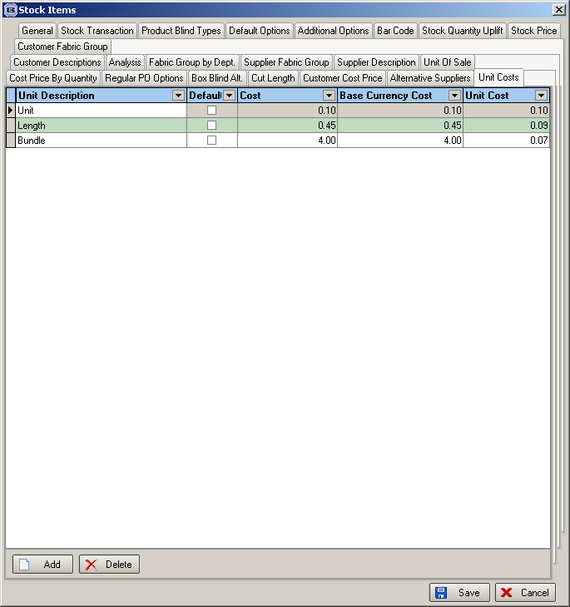

2262. PO Enquiry

It is now possible to flag in the PO detail line whether the stock is for warehouse or factory when creating the PO. This flag is only available if ‘Enable Factory Stock’ is switched on.

2265. Works Order – Bespoke 31

The total price for an order now prints on this works order.

2266. Order Processing > Archive Enquiry

If orders have been moved into the ‘AOrders’ tables (ie fully archived), it is now still possible to use the following buttons (which were previously greyed out)

View
Remake/Repair/Redespatch
Reset To Printed

2269. Order Processing > Orders > Scheduling

It is now possible to set the required date for orders on the ‘Scheduling Update’ form. There is a new button on this form called ‘Set Required Date’. When the required date is selected, the delivery days held against the customer is checked to make sure it is a relevant day. If not, a warning message appears.

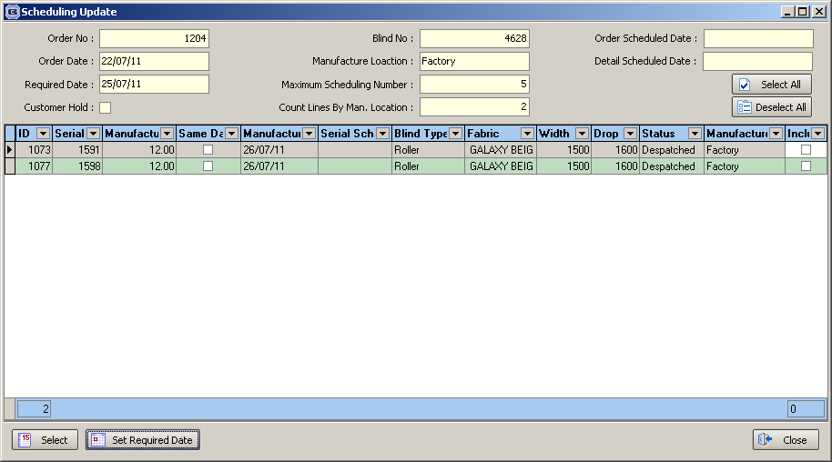

2270. Order Processing > Orders

Promised Date to Default to Blank Parameter

There is a new parameter in Administration > Parameters called ‘Set Promised Date to Required Date’, which defaults to true. If set to false, the ‘Promised Date’ in order entry is left blank.

Previously, when an order was created either manually, or via the EDI import, the promised date got assigned to the original required date.

2271. Sales Files > Customers / Customer Delivery Days

We have changed the functionality of the ‘Consolidated Delivery’ field on the Options tab if the customer form. This field has no impact on despatching, required dates or scheduling and is for information only. It is set to false if a customer has all of its delivery days selected. If they only have certain delivery days selected, then it is set to true. This is updated automatically as delivery days are changed, either on the Options tab of the customer form, or in Sales Files > Customer Delivery Days.

Also, ‘Consolidated Delivery’ has been added as a column to the Order Amend Enquiry form.

2272. Works Order Label 1

We recently made a change to Works Order Label 1 (colour and non colour) to allow space for parameterised cutting options for Roller blind types. We have now done the same for blind identifier = Vanes Only and Vertical.

2273. Sales Files > Customer Delivery Days

Any changes made to customer delivery days in the Sales Files > Customer Delivery Days form are now recorded in the customer history, as they currently are in Sales Files > Customers.

2274. EDI Import

Authorisation Hold Alert Email at EDI Import
There was an issue with the Authorisation Hold functionality where on EDI orders, an order over the Authorisation Amount could go on hold, but no-one is informed of it and the order gets overlooked. To resolve this, an automated email is now generated by the EDI import routine that is sent to credit control. The email contains the Order No and that it is an EDI/Online order that has been placed on Authorisation Hold. The email is sent to the Credit Control Email set up in Administration > Parameters > ‘Internal Email Addresses’ tab.

2277. Blind Types > Link Options

A change was made recently to recalculate options after other options were changed. This caused a problem that was partially rectified by making the sequence numbers = 0. We have improved this further by allowing negative sequence numbers to be entered. If these are used, then the option is not refreshed and the sequence can still be retained.

2278. Allow Amendment Permission

If a users does not have the ‘Allow Amendments’ advanced permission, then they are unable to make any amendments to order detail lines once the order has passed the ‘Order Entered’ status.

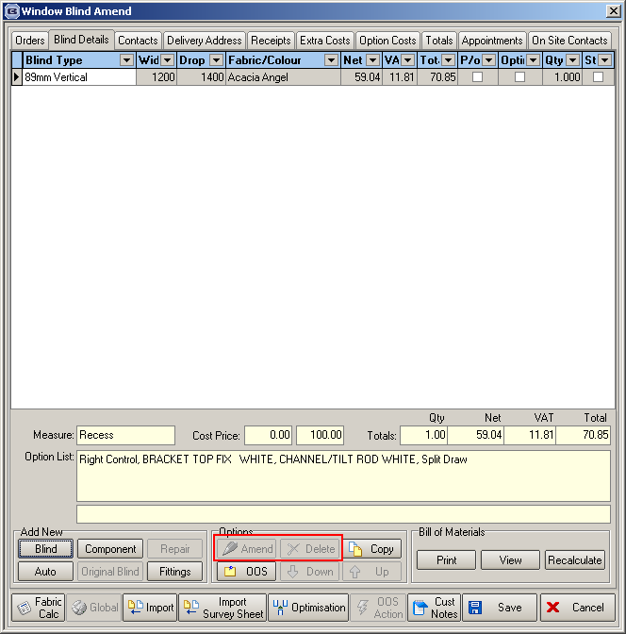

2279. Works Order – Bespoke 17

- There is now room to print up to 11 option details here.

- There is also more space for category print.

W138. Join/Turn Warnings for Rollers Online

If an order is entered for a roller blind and a join is required, a warning message now appears to tell the customer this.

