Blindata Release Note 5.4.6 

27 June 2011

Bug Fixes and Enhancements

3437. PO Reports

If you enter a purchase order for a supplier that has ‘Variable Supplier’ = true, the company name and address that appears is the company name and address that has been entered in the ‘Variable Supplier Address’ tab.

3450. Order Processing

If you change from metric to imperial for a vertical blind, the number of vanes does not get recalculated. It does get recalculated if you change the ‘Bunch’ option.

3452. Label – 5161 Bespoke 35

- Removed ‘Measure To’ and replaced with ‘Tag’.
- The cord spacing is now in fractions, not decimals.
- The label print/reprint now functions correctly

3453. Works Order Portrait 8.5 x 11

Cord spacing has been moved left and also spaced out better, with ‘—‘ between each figure.
Valance Width and Return have been removed.

3456. Invoice – Bespoke 36

- The miscellaneous line entry showed 0 x 0. Fixed.
- The £ sign is now right justified beside the figures.

3457. Quotation – Bespoke 34

- Total now only appears on the last page.
- Header only appears on the first page.
- The picture has been lined up with right hand margin and stretched a bit. The word ‘PROPOSAL’ is centred above the picture.
- Quotation text has been extended left to hold all text.
- Date is now in format ’16 June 2011’
- Date and ‘Proposal’ are right justified with margin.

New Work and Customer Requests

2124. Order Processing > Orders > Appointments Tab

When entering a survey date in the ‘Appointments’ tab of the order form, this updates a new field in the Orders table called ‘Survey Date’. There is a column choice in ‘Order Amend Enquiry’ for this new field. This works in the same way as the fitting date appointments i.e. you see the first one in the ‘Order Amend Enquiry’ column.

2207. Stock Setup > Stock Items

We now hold the ‘Calculator’ and ‘Default Code’ fields against the ‘Product Blind Type’ tab record in the ‘Stock Items’ form. This is required because some fabrics are used for different blind types, and they have different calculators.

The BOM calculation in the order entry has been changed to check to see if there are calculator and default codes set up in the ‘Product Blind Type’ tab. If not, the program looks at the calculator and default code in the header record (as it previously did).

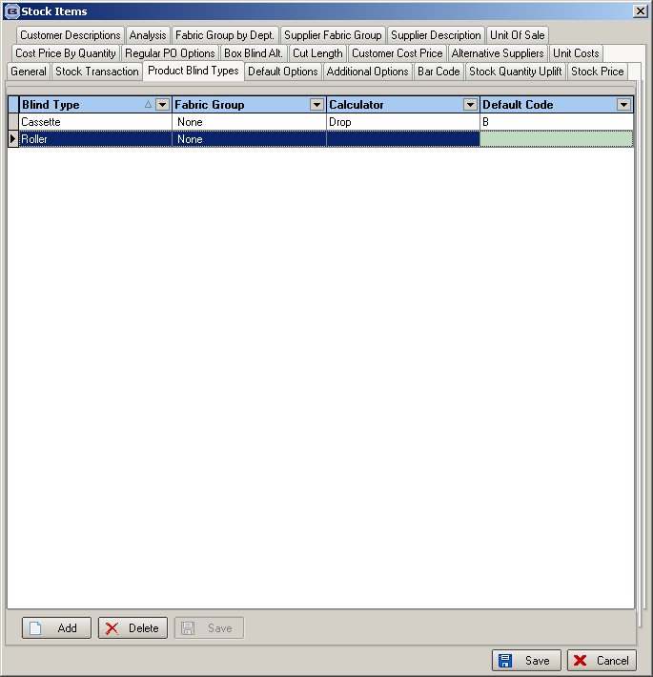

2208. Order Processing > Orders

If the ‘Status Field’ button is used to change an order to status ‘Order Cancelled’, a warning message now appears first ie ‘Are you sure you want to cancel this order?’.

2243. Order Processing > Orders

It is now possible to amend the job reference number in the order form. Previously it could only be entered or changed in the quotation form. There was no room for it in the ‘Order’ form, so there is a new button called ‘Job Reference’. This has a ‘Button Visibility’ flag in Users.

2244. Order Processing > Orders

‘Job Reference’ is now a column choice in ‘Order Amend Enquiry’.

There is also a hyperlink for job reference number so a user can access the folder with all the job reference files in it. This can be accessed by the ‘Job Reference’ button outlined in dev 2243.

2245. Order Processing > Orders

The Quote Total no longer includes VAT.

There is now also a facility to change the quotation value that is held against the order. There is now a button called ‘Quote Value’ in the ‘Order Amend Enquiry’ form. There is a ‘Button Visibility’ flag for this is in Administration > Users.

2246. Order Processing > Quotations

- For contract jobs, there will be quotations that have fixed prices ie when a survey is done and entered into the order, the price for the job remains the same regardless. So we have introduced a way to lock the price of that order. We therefore have a new flag in the quotation/order called ‘Fixed Price’. There is a new parameter in Parameters called ‘Set Default Fixed Price To True’. It defaults to false in Parameters. Also there is an advanced permission to only allow certain users to unlock the order pricing.

- If the blind type ‘Cost Related Price’ = true, then when the ‘% uplift’ is entered in the detail line, ‘Price Overridden’ is not set to true. This means an overall discount % can be entered in the Totals tab.

2247. Fitters Sheet / Sales Lead

There is a new parameter in Administration > Parameters called ‘Contract Diary Setting’. Instead of contact name surname, this means the diary will display job reference, customer reference, postcode.

2248. Sales Info Sheet

Order No has been replaced by job reference no

Manu Sizes: if manufacturing survey is done, print yes. If not, print no.

Delivery date agreed / quoted is the ‘Install Date’ and has been moved to the first page.

If a free type blind has been entered, the fabric entered is printed, and not ‘Free Type’.

