Blindata Release Note 5.4.4 

10 June 2011

Bug Fixes and Enhancements

3423. Administration > System Tables > Sales Tax

If the country is set up as Canada or Usa, the ‘VAT rates’ table is shown as ‘Sales Tax Table’, and is now displayed properly.

3425. OOS Auto Email to Customer

Recently we were asked to be able to set this functionality on a per customer basis. When the new ‘Send OOS Message to Customer’ option was flagged, the OOS email did not send to the customer when their order is scanned out of stock. Fixed.

3426. Chain Length not appearing on EDI Works Orders

The Chain Drop field was not appearing on works orders for orders generated by the EDI import. Fixed.

3427. EDI Generated Sage Pay Email – Total Incorrect

There was a bug with the email generated by the EDI import when it imported a Sage Pay proforma order. The field detailing the value of the order was incorrect. Fixed.

3428. Works Order Label 1

We added parameterised cutting options to Roller works orders recently. The figures are now in bold.

3429. Delivery Docket – Laser Print 8.5 x 11

If ‘Postcode / ZIP Code’ = Canada, ‘Cust Ref’ now says ‘Tag’. If USA, it says ‘Sidemark’.

3430. Picking List

- ‘Picking List’ is now in a bigger font.
- If ‘Postcode / ZIP Code’ = Canada, ‘Cust Ref’ says ‘Tag’. If USA, it says ‘Sidemark’.
- ‘Stock Code’has been inserted in the left hand column.

3431. Order Processing > Quotations > Create Orders

Quotes that were converted to an order that had an actioned stock warning caused an issue as the new fields below did not copy across to the order. Fixed.
isOOSWarning
isPreviousOOSWarning
OOSActionedBy
OOSActionedDate
OOSActionOutcomeID

3432. Order Processing > Out Of Stock Management

The OOS Management Form now works with the ‘Stock Warning List’ filter. This displays only orders where the isOOSWarning field is ticked in the header. Previously it was not displaying stock warning records at all.

3433. Order Processing > Orders

If you amend a line that has an actioned warning and save again without making changes, it flagged the stock warning as active again. This was not correct. If the detail line has an existing stock warning, the header is now only re-flagged as a warning if the blind type or fabric is changed.

3434. Order Processing > Orders

Previously only Kanban pop-ups were flagging the stock warnings. The ‘Not Enough Stock’ warnings were not. These are now flagged for manually entered and EDI imported orders the same way the Kanban pop-ups do.

3435. Works Order Label 1

There was an issue with the colour stripes on this report. The stripes for must gos etc all work fine. However, the orange stripe for consolidated delivery day customers was not working properly. It printed fine if you selected the ‘Consolidated Delivery Day’ option on the ‘Production Documentation’ form, however if you ran a standard print for all tickets, the orange consolidated stripes did not appear. This was being decided by the option on the Production Documentation form rather than actually checking the customer’s delivery days. It now interrogates the latter.

New Work and Customer Requests

2219. Label Print – Bespoke 33A

- On the small label, it now prints ‘Reqd Date’ instead of ‘Del Date’.
- If the label is to be printed in metric, ‘Control Length’ is also in metric.
- The ‘On Small Label’ flag in Blind Details > Blind Types > now works so certain option choices can be switched off and won’t print.

2220. Sales Analysis by Blind Type by Fabric by Order

There is a new report based on Sales Analysis by Blind Type by Fabric, which also shows each individual order number and customer.

2221. Administration > Import From Excel

It is now possible to import ‘Unit Cost’ records as well as ‘Unit Of Sale’. This was the previous layout for the ‘Unit Of Sale’ import.

Stock Code | Unit Of Sale | Price Type | Price
R8172 | Box of 12 | Trade | 2.45
R8172 | Box of 24 | Trade | 2.09
R3006 | Pair | Trade | 1.94

The ‘Unit Cost’ only needs to have three columns, but we have combined these in the same import. If the ‘Price Type’ column is blank, then we import these records into the ‘Unit Cost’.

Stock Code | Unit Of Sale | Price Type | Price
R8172 | Box of 12 |  | 2.45
R8172 | Box of 24 |  | 2.09
R3006 | Pair |  | 1.94

2222. Purchase Order Enquiry > Generate Regular PO

It is now possible to enter free text against a detail line (10 characters) when manually entering a PO detail line.

2223. Purchase Order Regular – Bespoke 31

We have created a new report called ‘Purchase Order – Bespoke 31’. This is based on ‘Purchase Order Regular – Standard’.

In the detail section we also show the supplier part no (parameter), unit description, quantity, free type as well as the existing details. We have made the orientation landscape.

2224. Purchase Order Enquiry > Deliver Regular PO

We have made some alterations to the ‘Deliver’ and ‘Deliver All’ buttons.

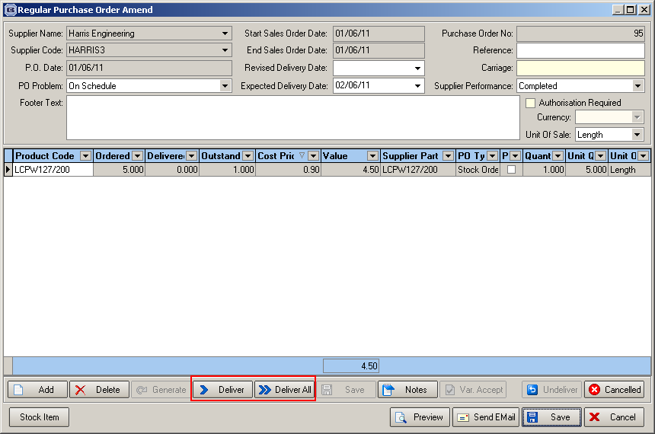

Deliver All

It is now possible to select individual lines that are incorrect eg if an order has 100 detail lines on it, but only 2 are incorrect, it is possible to deliver all the others (like ‘Deliver All’), and then adjust the two lines that are incorrect. Previously the only way to do this was to deliver each detail line manually.

There is now an alternative way of doing this. We have a ‘Select’ flag for each detail line with a ‘Select All’ choice. The ‘Deliver All’ button has been changed to ‘Deliver All Selected’ and will then fully deliver all the selected lines. The user can then select individual lines using the ‘Deliver’ button.

Deliver

Previously when the ‘Deliver’ button was used, the user could only enter a delivered amount. But the following scenario could happen eg 3 boxes are ordered, but only 2 boxes and 4 lengths arrive. Let’s say there are 24 lengths per box and each length is 4 metres. The unit quantity for the detail line is therefore 288 metres (3 boxes x 24 lengths x 4 metres). If the delivery is for 2 boxes and 4 lengths, the user has to work out that this is (2 boxes x 24 lengths x 4 metres) + ( 4 lengths x 4 metres) = 208 metres, and then enter 208 as the amount delivered.

Instead of having to manually calculate the amount delivered, the user is able to enter 2 boxes and 4 lengths. We therefore display the units of sale for that product and are able to enter the amount in each, display the unit quantity total and then save it. Here is how we do this – we can look up the ‘Unit Costs’ tab when we are creating the PO detail line.

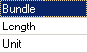

When the goods are delivered into stock, previously we could only enter a quantity. We have changed this so we can enter the ‘Unit Description’, then the amount. We have allowed for possibly more than one type of unit to be entered. So in the example above, where 2 boxes and 4 lengths are delivered, we now have another window where we display each unit description and enter the amounts eg

Unit Quantity Unit Quantity
Box 2 192
Length 4 16

This then totals 208 and is what updates ‘Stock In Hand’.

2225. PO Invoice

When creating the PO invoice, it is now possible to select individual lines for invoicing. The flag for selecting lines to be invoiced is on the PO Update form.

We can also define a line as being on back order or not. This means we can tell in it is still an outstanding purchase order or not. If it is on back order, then it is outstanding. If not, then there will be no more delivered for that detail line.

Here is an example. A purchase order was created with a detail line with a quantity of 5, but only 4 were delivered. An invoice is sent for 4.

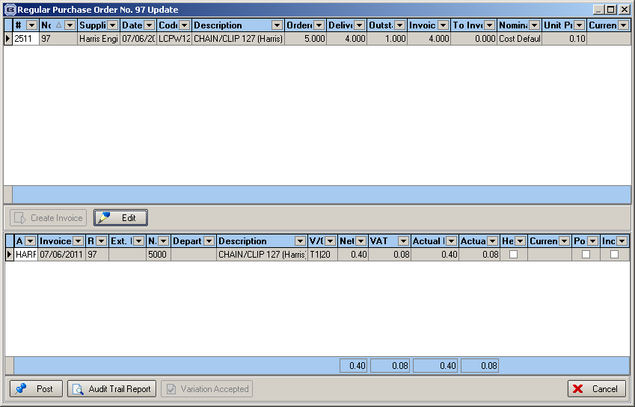

There is now a flag on the PO Update line to say if the outstanding amount is ‘on Back Order’. This defaults to true. If it is switched off, then the outstanding amount is ignored. If all PO detail lines are either outstanding amount = 0 or ‘On Back Order’ = false, then the purchase order status is set to ‘Delivered’.

2226. Stock Take Entry

It is now possible to record what is warehouse stock and what is factory stock. This has been done on the form (if ‘Enable Factory Stock’ = true). There is also an extra column in the import spreadsheet.

2227. Stock Setup > Stock Items

There is now a column for ‘Factory Stock In Hand’

2228. Reports > System Reports > Stock Take Report

There is now a choice for printing ‘Stock in Hand’, ‘Factory Stock In Hand’, ‘Both’.

2229. Wood Slat PO Delivery

We have a particular type of purchase order that we need to deal with. When this customer orders wood, they will order, for example, 100,000 feet of Golden Oak (slat/fabric colour). They do not specify that they want 100 3 foot slats, 20,000 4 foot lengths etc – they just order a total quantity.

When the 100,000 feet of Golden Oak slat is delivered, the customer has to record what they have actually received. So they may want to deliver into stock x feet of 3 foot slat, x feet of 3’ 6” slat etc.

We have therefore done two things. We have a dummy stock code for entering the PO detail lines. This can be defined in the ‘Regular PO Options’ tab in the stock record, either by defining the stock record as a ‘dummy’ item or tieing the dummy record to a real stock item.

2232. Order Processing > Order Enquiry

A change was made recently to include a warning at the blind/order manufactured stage to highlight if a blind needs to be Quality Checked. This works, however the warning appears in the text of the scan window which is hard for the operator to notice. This has been changed to a pop up message that will force the user to click ‘Ok’ to proceed.

2233. Order Processing > Global Search

There is a new column in the Global Search form for ‘Net Total Inc. VAT’. Also, there should be a summary field at the bottom of the screen with a sum total for this field for all orders on the form.

2234. Order Processing > Paid Proforma

There should be a new column in the Paid Proforma form (both Quote and Online tabs) for ‘Net Total Inc. VAT’. Also, there is a summary field at the bottom of the screen with a sum total for this field for all orders on the forms.

