Blindata Release Note 5.4.3 

2 June 2011

Bug Fixes and Enhancements

3410. Sales Analysis by Blind Type (Weekly)

If the quantity per day was too large, numbers were not printed. Fixed.

3413. Order Processing > Orders

There was a problem when splitting an Online/EDI order. The 5% online discount was removed from the new order. The discount now remains the same as the original.

3414. Order Processing > Quotations

There was a problem when splitting quotations. The Totals tab of the two orders did not recalculate correctly. Fixed.

3415. EDI Import

The EDI Enquiry was slow when importing proforma orders from Blindata Online.

3416. EDI Import

The Sage pay transaction number is being passed into EDI file, but when it imported to Blindata, it was not updating into the order. This could not be replicated – please test.

3417. EDI Import

When a proforma order is imported with a carriage charge into Blindata, the carriage charge was duplicated and the order contained two carriage charges in the office system.

3418. Dashboard

The ‘Overdue Sales Orders’ figure has been changed. It is now the total of ‘Order Entered’, Order printed’, ‘Work In Progress’, ‘Part Manufactured’ and ‘Order Manufactured’.

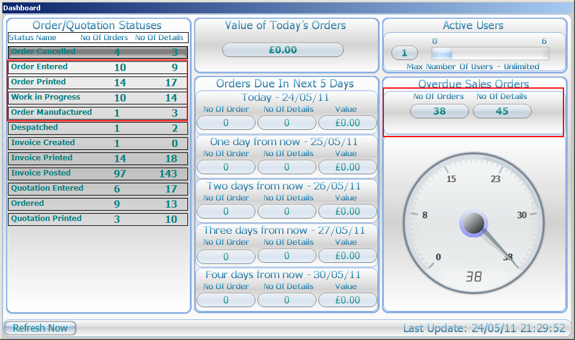

3420. EDI Invoice Export

We made a change to the EDI invoice export in 5.4.2, but it created a further problem. The quantity on the detail line should always be 1, so we have hardcoded it to 1 and make the amounts both be the net price for the detail line.

3421. Works Order Label Blind Size

- The word ‘Drop’ was missing from the top labels.

3422. Label Print – 200 x 24mm

If the blind identifier = ‘Vertical’ or ‘Track’ or ‘Headrail’ or ‘Vanes Only’, the number of vanes now prints on the label.

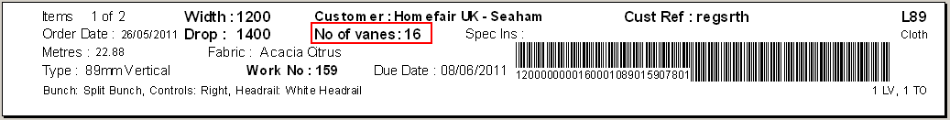

3411. Label Print – 33A

Labels – the barcode on the first set of labels was slightly too low.

3412. Order Acknowledgement – Scheduled Date

The layout has been ameneded according to instructions.

3414. Blind/Order Manufactured – Quality Control

We made a change here so that the quality check was done at the manufactured stage rather than at despatch stage (dev 2215). This was incorrect – the quality check should still be done at the despatched stage, but a warning message should appear at the manufactured stage to say ‘This blind needs to be quality checked’. If it has not been quality checked by despatch, then it should not be possible to despatch it. Fixed.

3416. Order Processing > Orders

The Sage Pay reference number is now a column choice on the ‘Order Amend Enquiry’ form.

New Work and Customer Requests

2114. Sales Lead Individual Normal

We can now fit extra text into the cooling off box and chils safety box on this report.
2115. Sales Lead Individual Normal
We can now get a different field to appear in the company name. This is because some companies have a different name for their business for retail sales. There is a new field in Administration > Company Details called ‘Retail Name’. If this is blank, then the company name is used, otherwise the retail name is used.

2119. Order Processing > Quotations

When an uplift is done on a quotation, there is now an option to exclude component lines from the uplift in the Totals tab. This flag is called ‘Exclude Misc Lines from Uplift’ and is in the Totals tab.

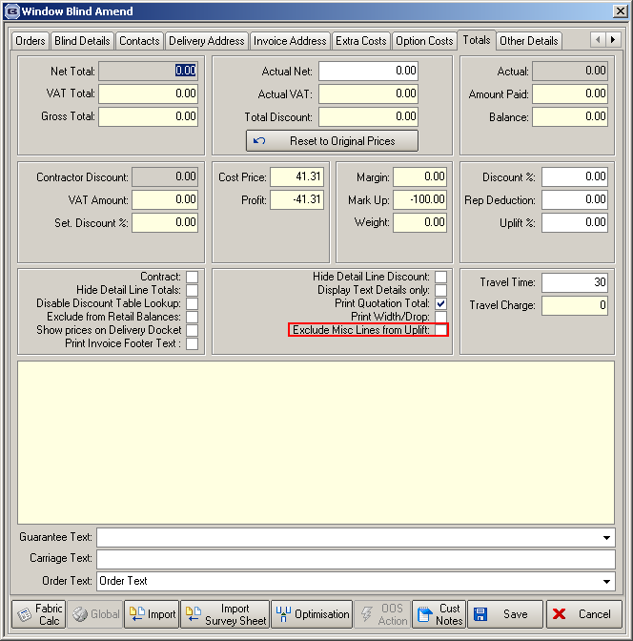

2123. Quotations

When an order is created from a quotation, it is now possible to copy across the quote total and save it in the order in a new field called ‘Quote Total’, and have an option to not copy across the quotation detail lines. This option is called ‘Ignore Detail Lines’. This is required because the order detail lines may be created from the ‘Import Survey Sheet’ after the quotation has been turned into an order.

2126. Login

We have split the flags for displaying quotation and order contact records at the login stage. Previously there was only a flag for ‘Display Current Contact Info on Login’. It has been renamed ‘Display Order Contact Records on Login’ and there is a new flag called ‘Display Quote Contact Records on Login’.

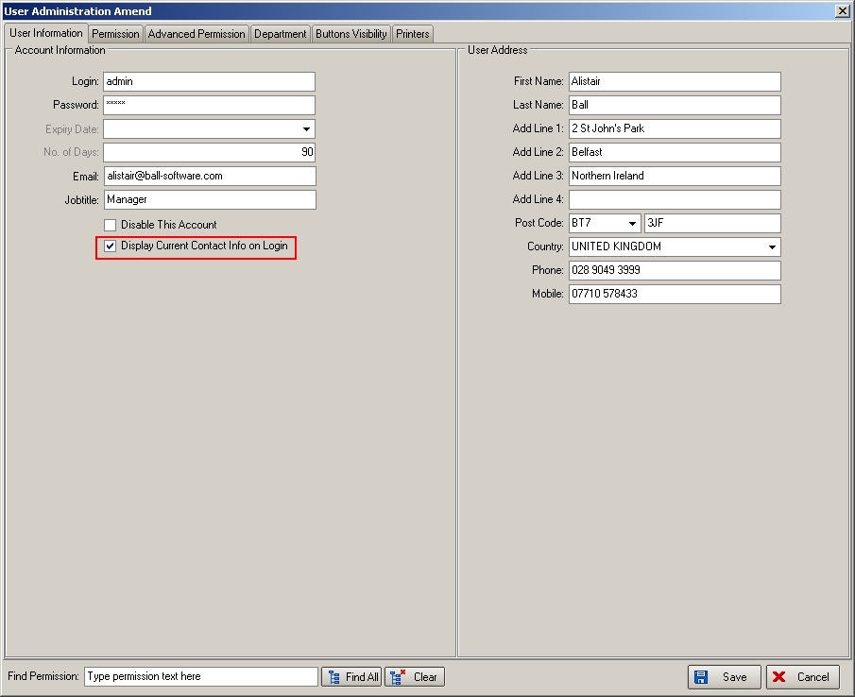

2127. Sales Info Sheet

Financial info now appears on the last page on it’s own. Therefore there is more room to fit details on. Notes still appear at the bottom of the first page.

The ‘On Site Contacts’ data is now filled from the ‘Site Contacts’ tab in the order.

2128. Order Processing > Orders

There is a new tab to hold ‘On Site Contacts’ on the quotation and sales order. The information from here then prints on the ‘Sales Info Sheet’. There are fields in this tab for:
Project Manager
Contact No
Site Contact
Mobile No
Quantity Surveyor
Mobile No
Site Tel
Email

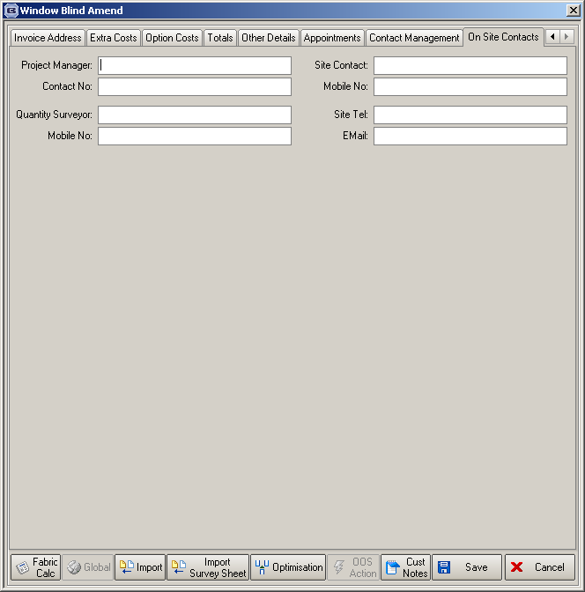

2139. Quotation Email

When a quotation is emailed, it now says ‘Proposal’ on email subject, and also save pdf as ‘Proposal.xxx’, not ‘Quotation.xxx’. This is only done for ‘Quotation – Bespoke 34’.

2200. Purchase Order Improvements

We have made improvements to the regular PO generation for handling units of sale and multi currency.

We have added the unit of sale because items are sometimes bought in rolls or coils or boxes or something else. We calculate fabric usage in metres, and a unit is always 1 metre, but a roll of fabric may well be bought in a 100m roll. We therefore need to be able to enter the unit and get it to calculate the unit quantity that is being purchased.

We need the multi currency because our customers often buy stock from a EU country and it is priced in Euros (In Canada, they often buy from the USA). We therefore need to be able to have the prices in the supplier currency.

Therefore, when a regular PO is created, we now take into account the unit and the currency. There are extra fields in the detail line entry for ‘Unit of Sale’ and ‘Currency’. The unit of sale defaults to the one in Stock Setup > Unit Costs’ and the currency defaults to the one held against the supplier.

The ‘On Purchase Order’ figure is updated properly (by unit).

When the PO is saved, we now save the cost amount entered, and the currency.

The regular PO reports have also been changed.

When the regular PO is delivered into stock, we now make sure that the unit of sale is taken into consideration when the ‘Stock In Hand’ is updated.

When the purchase invoice is updated to the Blindata purchase ledger, the currency is checked, and the correct fields are updated. If the currency in the purchase invoice is not equal to the base currency, then the foreign currency field is updated, then amount multiplied by the currency rate and the normal transaction amount field updated as well.

Batch numbers for PO deliveries – when goods are delivered into stock, there is now functionality to record a batch number against the individual detail lines.

2201. Valance Calculation

In order detail entry, when a valance size is calculated, we have made an adjustment to the way it is calculated. Previously it added/deducted the amount held in Blind Type > Blind Type Setup > Width Add On before doing the other calculations.

If ‘Enter Valance Size’ = true in the blind type record, there is now a new column in the ‘Blind Type Setup’ tab ‘Measure To’ section called ‘Valance Add On’. This means we can potentially have a different add on amount depending on the ‘Measure To’ that is entered.

2202. Valance/Return Calculations

We have made an amendment to the way the valance and return calculations are done. At the moment we have. There are now two extra columns in the system table ‘Return Valance Add On’ - one for choosing a valance option and the second for holding a ‘Return Add On’ size.

      - The ‘Return Size Add On’ column has been renamed ‘Valance Add On Size’.
      - There is a new column for valance option called ‘Valance. This only show options where option code = ‘Valance Calc’. It may be left blank, but if filled, will be used when valance size add on and return size add on (see 3 immediately below) are calculated.
      - There is a new column called ‘Return Add On Size’. When an order is entered and the blind type has ‘Enter Valance Size’ = true, this figure is added to the return size.

2204. Scheduling

We now hold a minimum number of days for first available scheduling day. Previously, blind detail lines were scheduled as soon as there was time available. However we have a customer that did not want that, and wanted to specify when is the minimum starting point for scheduling.

There is a new field in Administration > Parameters called ‘Schedule From Day’. It defaults to zero, so current users will be unaffected, but if it is set to > 0, then scheduling can only be done from current date + ‘schedule from day’.

Also, if we switch on ‘Update Scheduled Date to Required Date’, there is a new parameter against the customer record to ignore this (because it will not be applicable for some customers).

2214. Order Processing > Orders > Works Order Print

It is now possible to have one works order print for blinds and one for components.

There is a new parameter in Administration > Parameters > Report Parameters called ‘Utilise Picking List’. If this is set to true, then a new report called ‘Picking List’ will print out if any order detail lines have blind identifier = M.

The picking list is based on the layout for ‘Delivery Docket – Laser Print 8.5 x 11’).

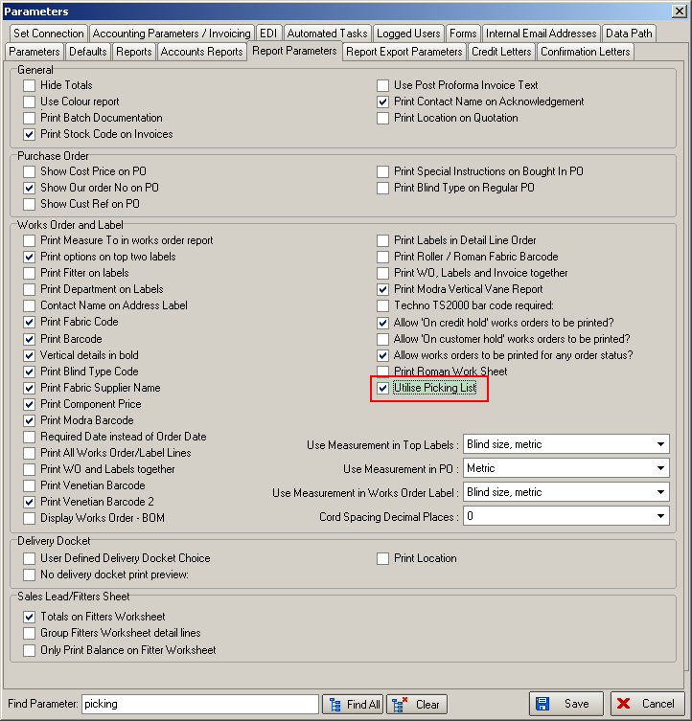

2215. Order Processing > Orders

The ‘Quality Control Required’ warning now appears at Blind/Order manufactured stage instead of at the ‘Despatched’ stage.

2217. Financials > Create Invoices

There is a new parameter called ‘Disable Carriage at Create Invoice Process’ in Administration > Parameters. This defaults to false. If it is set to true, then carriage will not be calculated at all at Financials > Create Invoices’ or at the ‘Create Invoice’ button.

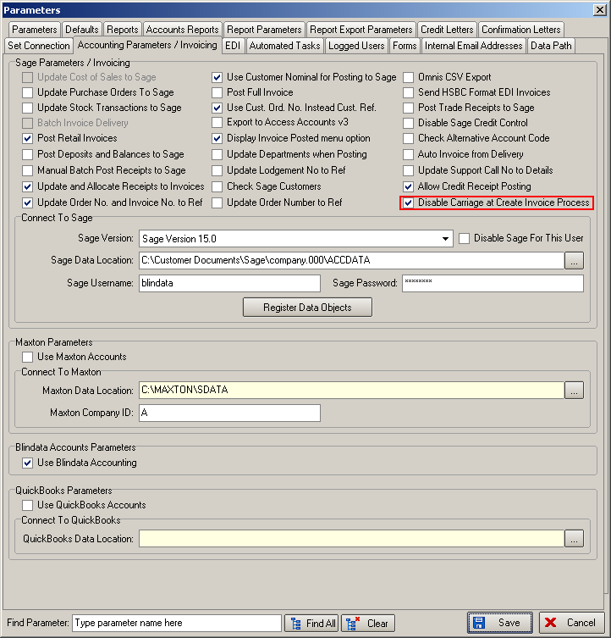

Blindata Online

W129. Sage Pay

When a proforma order is entered for a Euro customer, the currency passed into Sage Pay was in Sterling. Fixed.

W131. Order Entry

It was possible to avoid carriage charges by clicking ‘cancel’ on the order instead of save after you have added blinds. We have removed the cancel button.

W133. Order Entry

The post code fields on the sage pay delivery and invoice address page are no longer mandatory. This is to accommodate ROI customers.

W134. Synchronisation

The Sage Pay Vendors table and the CarriageByAreaAndTotal tables now sync up correctly from Blindata.

W135. Order Entry

There is now a pop up when you add a non-same day blind to a same day order. However users were unable to de-select the same day flag when this happens as the check box is disabled. This is now possible.

W136. Sage Pay Description

Decora now want to just have the ‘Online Order ID’ and ‘Customer Order No’ fields in the ‘Sage Pay Description’ field and nothing else.
Eg
“Online ID: 12345, Cust Ord No: ABC123”

Change of plan by Decora – they now want this instead:
“Online ID: 12345, Cust Account No: BLIN01”

