Blindata Release Note 5.4.1 

16 May 2011

Bug Fixes and Enhancements

3395. Financials > Invoice Batch Print

When an invoice was sent out by batch email, temporarily it was writing a history record for each detail line in the order. It now only writes one history record for the order.

3396. Quotations

If ‘Use Quotation Revision’ is switched on, and a quotation is revised, it was not possible to then see it. Fixed.

3397. Quotations > Contact Management

If ‘Use Quotation Revision’ is switched on, the ‘Contact Management’ button did not work. Fixed.

New Work and Customer Requests

2190. Quotation – Bespoke 36

There is a new quotation report called ‘Quotation – Bespoke 36’.

2191. Pricing > Price Table Enquiry

The functionality is export price tables to a spreadsheet has been improved, and now allows the user to export any combination by using the ‘Print Criteria’ filter. They can then be sent to a customer for importing to another Blindata system.

2192. Pricing > Option Price Enquiry

The functionality is export option price tables to a spreadsheet has been improved, and now allows the user to export any combination by using the ‘Export Criteria’ filter. Any combination of these choices may be selected.



They can then be sent to a customer for importing to another Blindata system.

2193. Curved Track

If blind identifier = ‘Headrail Only’ or ‘Track’, then the ‘Curved Track’ option is available. This then affects the order detail entry as well (ie the depth can be entered).

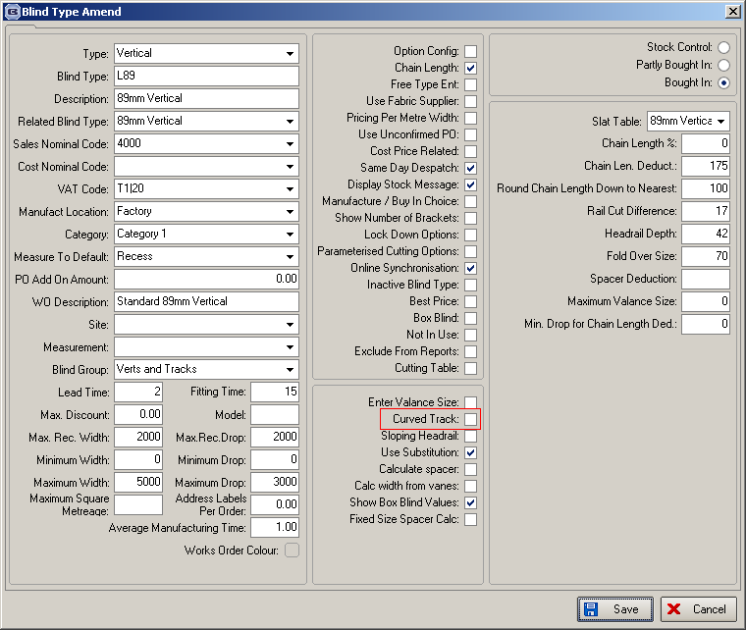

We’ve modified (displaying Depth) the following reports:
- Works Order – Label 1
- Works Order – Label 2
- Works Order – Label 3
- Works Order – Label 4
- Works Order – Label 5
- Works Order – Label 6
- Works Order Portrait
- Works Order - Portrait Barcode
- Works Order A4 Individual
- Works Order A4 Individual 2
- Works Order – CB
- Works Order – Label Blind Size

2195. Invoice – Bespoke 36

A new invoice layout has been created called ‘Invoice – Bespoke 36’. It is based on ‘Invoice – Bespoke 8’.

W110. Order Enquiry Form

We have renamed the ‘Delivery Information’ button to ‘Terms and Conditions’.

W111. Order Entry > Submit

It is now possible to pass a different Merchant Account through to Sage Pay depending on the customer’s currency. We now hold the merchant account code against the currency type record.

W122. Order Enquiry

‘Number of lines’ now says ‘Number of Lines to Display’ and the number is right justified.

