Blindata Release Note 5.3.9 

29 April 2011

Bug Fixes and Enhancements

3381. Invoice – Bespoke 35

- The ‘VAT Number’ has been removed from here.
- If USA, ‘Cust Ref’ now says ‘Sidemark’. For Canada, ‘Tag’.

3382. Works Order – BOM

- The sizes printed were previously entered sizes – they are now what is in ‘Report Parameters’.
- If ‘Chain Length’ and/or ‘Enter Valance Size’ are true, they now print.
- Now prints fractions, not decimals, if ‘Imperial’ print.

3383. Order Processing > Orders

If you clicked ‘Cancel’ in this form, you did not have to enter an amendment reason. Fixed.

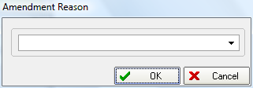
3384. Daily Sales Invoice Report

- The date format was incorrect for the USA – date on Windows is set to mm/dd/yy.
- ‘VAT’ is now Sales Tax for USA and Canada.

3385. Sales Analysis Reports (All)

Date format now matches the Windows date format.

3386. Purchase Order – Bought In Reports

- In USA and Canada, VAT number is not required.
- The date format was incorrect for USA.
- If imperial print, these now print fractions, not decimal places.

3387. Acknowledgement – Laser Print 8.5 x 11

Drop now print Height for USA and Canada.

3388. Label – 5161

The cord spacings were too close together and difficult to read. There are now two spaces before and after each spacing.

3389. Production List > Order Control Report (Landscape)

This is a new report in Landscape. ‘Sidemark’ instead of ‘Cust Ref’ if USA, ‘Tag’ if Canada is now printed. Also show a column for number of blinds.

New Work and Customer Requests

2171. Dashboard

It is now possible to display a dashboard on the main Blindata screen. This can be switched on by ticking Administration > Parameters > Display Dashboard. This is updated automatically every 30 seconds.

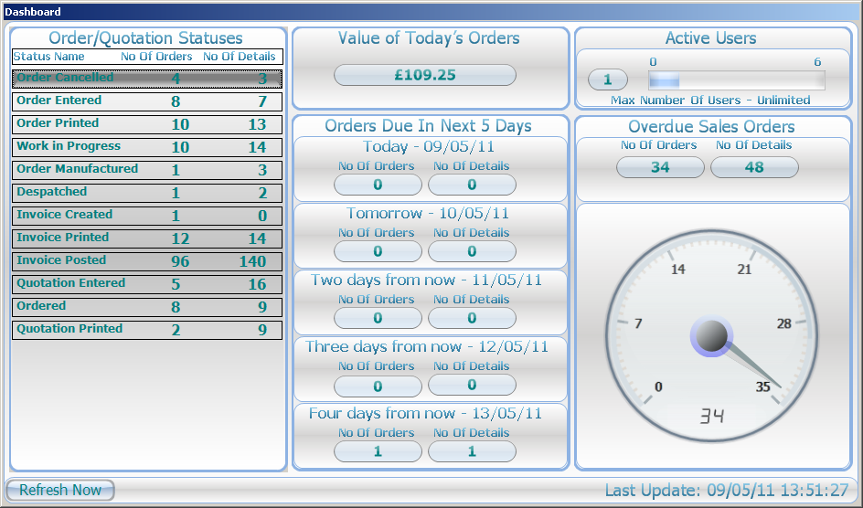

2183. Carriage

It is now possible to have a more complicated carriage calculation.

We have created a new system table called ‘Carriage By Area And Tota’” and held all the data here. This table has the following fields: ID, AreaID, CurrencyID, FromAmount, ToAmount, CarriageAmount. A carriage line is created at the ‘Create Invoices’ stage by looking at this table and if Order > Total greater then max ToAmount carriage will not be applied. Also, we have written update scripts which create all records for existing Areas, Currency and Carriage free over values.

