Blindata Release Note 5.3.8 

22 April 2011

Bug Fixes and Enhancements

3371. Sales Analysis by Blind Type by Fabric

The fabrics are now grouped – previously individual lines were being printed out.

3372. Administration > Import Data > Blind Type Dataset

There is a problem importing ‘Link Option’ lines if there are only widths and drops and no stock item in the second level. Please try importing 25mm Balmoral Wood.xls (attached to email).

3373. Quotation – Bespoke 31

There were two problems here:

- If an order were entered in imperial, the sizes printed as fractions, not decimal places. They now print as fractions.
- For a blind identifier = ‘Headrail Only’, the imperial sizes printed incorrectly. This has been fixed.

3374. Invoice – Bespoke 34

The option prices now print beneath the base price – previously this line was not making a lot of sense because the unit price was only showing the base price and the net amount included the base price and option price.

3375. Acknowledgement – Bespoke 34

Zero amounts should no longer appear in the ‘Measurement’ line.

3376. Bespoke Works Order 8.5 x 11

If this was printed from Order Processing > Production Documentation, it was putting detail lines for different orders on the same works order. These now print on separate works orders.

New Work and Customer Requests

2149. Out Of Stock Functionality

We have made a number of improvements to the ‘Out Of Stock’ process.

There is a new system table for ‘OOS Action Outcomes’.

There is a new ‘Stock Warning Action’ form. The ‘Action Outcome’ defaults to blank and looks up the new ‘OOS Action Outcomes’ system table. Users are unable to submit the form until the Action Outcome is completed. The BOM button performs the same function as the existing BOM button on the ‘Out of Stock Management’ form. This allows users to flag the relevant BOM item as they complete the action form.
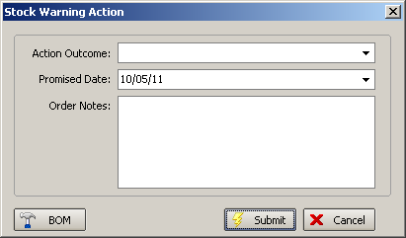

The ‘OOS Action’ button has been added to the following forms:
Order Processing > Orders > Order Amend Enquiry. Button Visibility must be switched on.
Order Processing > Quotations > Quotation Amend Enquiry. Button Visibility must be switched on.
Order Processing > Orders > Window Blind Amend). Located beside ‘Optimisation’, for both Orders and Quotations. Advanced permission must be switched on.
Orders > Out of Stock Management.

Window Blind Amend – Orders Tab.

A check box has been added at the bottom right section for OOS Warning’. This field is for display purposes only and is not editable.

Window Blind Amend – Blind Details Tab.

A new column called ‘Stock Warning’ has been added in the detail line list between ‘Total’ and ‘Out of Stock’.

Order Amend Enquiry.

A column choice has been added for ‘OOS Warning’.

Out of Stock Management.

The role of this form has changed slightly. It has three filters:
Stock Warning List (All orders where [Order].[OOS_Warning] is flagged.
Out of Stock List (All orders that are flagged as OOS by production.
Over 3 weeks (All orders either flagged as OOS by production or that have an OOS Warning flagged and where the promised date is three weeks ahead of the order date)
Purchasing notes button remain. The Sales notes button has been replaced with a button for the ‘Stock Warning Action’ form.
‘Customer Contacted’ and ‘Follow up contact’ have been removed.
Columns have been added for OOS flag from order header. Also [OOS_Warning], [OOS_Actioned_By], [OOS_Actioned_Date] and [OOS Action_Outcome] columns from [order] table.

2156. Acknowledgement – Scheduled Date

The layout of this report has been changed so that all option prices are printed out.

2157. Works Order – Label 1

Roller deduct amounts are now taken from system table option calculation rather than Blind Type.

2174. Purchase Order Enquiry

There is now a column choice on the PO Enquiry form for the cost price total.

2179. Acknowledgement – Bespoke 35

There is a new acknowledgement report called ‘Acknowledgement – Bespoke 35’. This is based on ‘Acknowledgement – Laser Print 8.5 x 11’.
2180. Invoice – Bespoke 35

A new invoice layout has been created called ‘Invoice – Bespoke 35’. It is based on ‘Invoice – Laser Print (Letterhead Logo).

W100. Sage Pay

We have made some further changes to the Sage Pay functionality.

If an order is entered for a proforma customer and ‘Allow Payment Online’ is true, then carriage is now charged – either normal carriage or same day despatch.

This is now done at the ‘Submit’ button stage and not when the order is saved.
Other Changes

Orders with 0 value or 0 lines or lines with 0 value cannot be submitted or sent to Sage Pay. Validation is performed when ‘Submit’ or ‘Pay Order’ is clicked.
Carriage is added for proforma customers at point of orders. The carriage charge is per order for these customers.
Same day charges are added at point of order for proforma customers.
When Sage Pay is clicked, and any carriage charges added, the order and total value should be previewed to give the customer the option to proceed and cancel.
Confirm customers have the ability to print receipts online after they have paid via Sage Pay.
The ‘online reference’ be passed to Sage Pay and will then be stored against the order in Blindata

Additional menu items have been added in the top navigation to satisfy merchant account requirements:
Refund Policy
Privacy Policy
Delivery Information
Contact Us

Quotes can no longer be entered online. Orders can act as quotes before submission.

W104. Online Order Acknowledgement

The order acknowledgement printed from the online ordering site previously shows the old ‘Lead Time Text’. It now shows the scheduled date.

W105. Order Entry

This message now says ‘Please select a detail line’.

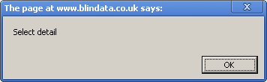

W107. Blindata Image

The image was missing. Fixed.

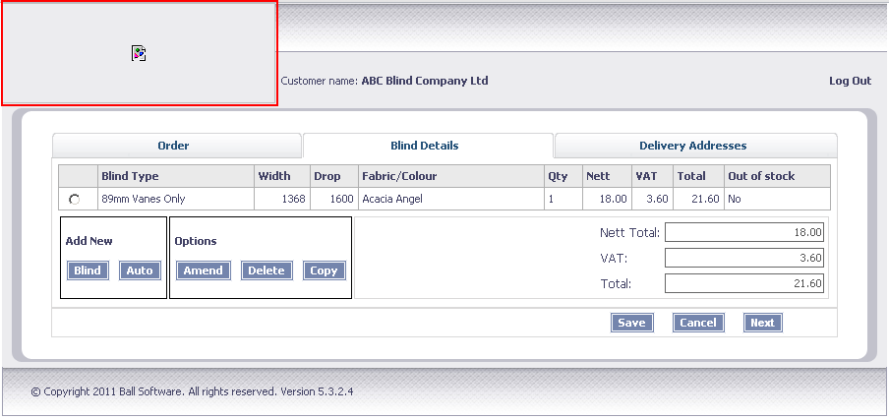

W108. Order Entry

When amending a vanes only detail line, the number of vanes and the price was zeroised. Fixed.

