Blindata Release Note 5.3.7 

15 April 2011

Bug Fixes and Enhancements

3367. Works Order – Bespoke 34

We made a change in 5.3.6 to remove the address from the left hand box (invoice address) but the customer company name was also removed. This has been restored.

3368. Order Processing > Orders

There was a problem with this filter. It now defaults to all choices being ticked. Previously the default has ‘Part Manufactured’ and ‘Part Invoiced’ switched off.

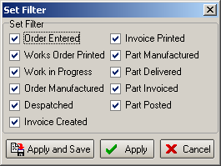

3369. Order Processing > Quotations

If ‘Use Quotation Revision’ is switched on, an error appeared when you opened the Quotations form. Fixed.

3371. Order Processing > Orders

There was a problem with selecting options. We made a change recently so the sequence number in the ‘Link Option’ tab would be used.

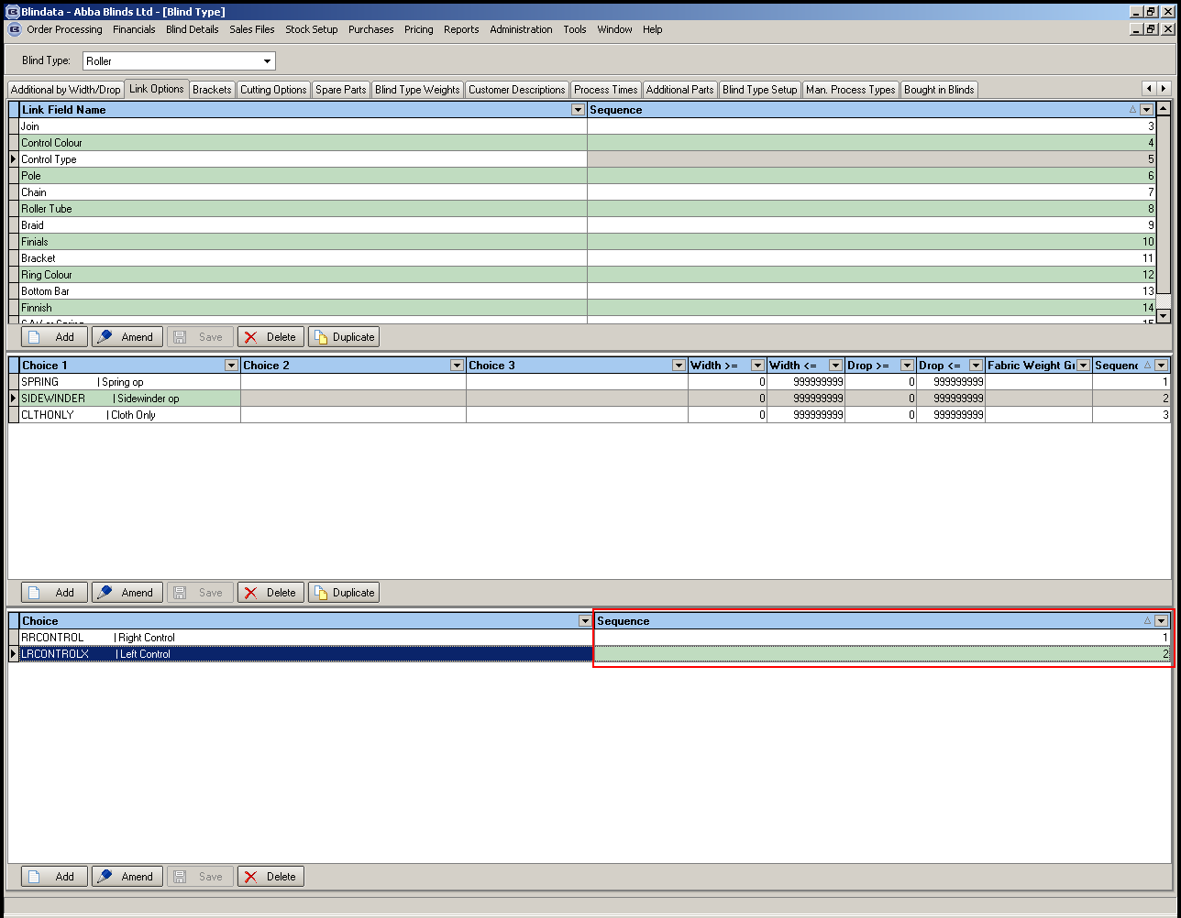

For example, if you entered a roller blind, and changed options for ‘Control Colour’ or ‘Bracket’, it always sets the ‘Control Type’ to Right Control, even if it has been set to ‘Left Control’. This was happening because it looked at the sequence number (above). This is good for finding tube sizes, but caused an unintended side effect.

We have remedied this by having a sequence number of 0. If this is set, then the option will not get reselected after an option change.

New Work and Customer Requests

2155. Process Scanning

We have made some changes to the Process Scan functionality. We have added an extra drop down box where the operator can select a process. When a blind is scanned, the system checks to see if a process exists for that blind type. If not, an error message appears in the output window (the message says ‘There are no processes set up for this blind type’). If it does, then the process transaction is added against the blind and a success message (‘Process scan successful’) appears in the output. However, if the process already exists for the blind, then an error message appears in the output (‘Process has already been scanned’). This means the processes do not need to be scanned in a set sequence.

These process scans are completely separate from the WIP and Blind Made status scans. This means the status scans will work regardless of any process transactions. As well as that, the process transactions are scannable at any status from Works Order Printed to Despatched. Lastly there may be certain situations where the same process needs scanned twice for one blind. For example if the colour is entered incorrectly, but the mistake is only picked up after part of the blind is built. In this case, the ‘Enquiry Scan’ will be used to reset the order status to order entered. When this happens, any existing process transactions are flagged as ‘Enquiry Scan’. The system will only allow a process to be re-scanned if this is flagged.

2159. Carriage Charges for Re-despatches

If an order is generated by using the ‘Redespatch’ button, previously carriage was not added to the order. The price of the carriage will now be the customer’s standard carriage charge as identified by the ‘Area’ field on their customer record. This only applies to redespatches and not any orders created via the Remake or Repair buttons.

2160. Allow Amendments Permission

Users without ‘Allow amendments’ could previously make too many amendments. This permission is located on the Advanced Permission tab of the user setup form. By default users can no longer amend any orders that have gone past the ‘Order Entered’ status unless they have this permission selected.

2161. Works Order – Label 1

‘Description’ fields in the top labels has been replaced by the delivery days for the customer.

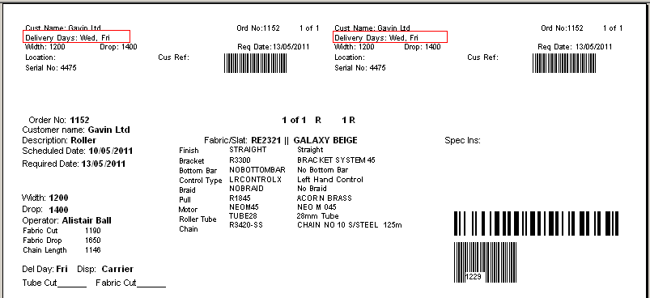

2163. Works Order – Label 1

Repair notes entered against ‘Repair’ detail lines and special instructions entered on standard detail lines both display on the same area on our works orders (‘Works order – Label’ and ‘Works order – Label 1 (No Colour)’. We have increased the print size for repairs to be the same as special instructions.

2176. Company Details > Email Text

We now have a field choice for ‘Order Number’ in the ‘Email Text’ tab of this form.

2177. Dispatch

‘Despatch’ has been changed to ‘Dispatch’ for Canada. This is already done for USA.

2178. Sidemark/Tag

“Sidemark” has been changed to “Tag” system wide for Canada.

