Blindata Release Note 5.3.6 

8 April 2011

Bug Fixes and Enhancements

3360. Order Processing > Orders

If you enter a component line for an item that has a ‘Unit Of Sale’ tab record, the unit quantity and the price are now updated as soon as the product is selected.

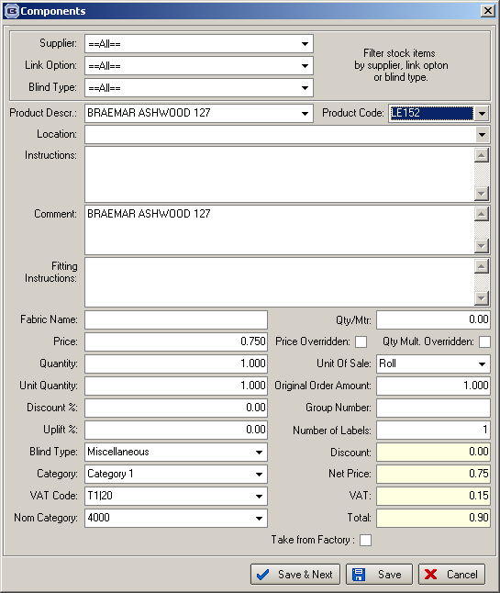

3363. Contact Management

If you selected ‘Future Activity’ and then tried to save a contact management record, an error occurred. Fixed.

3365. Label Print – 200 x 24mm

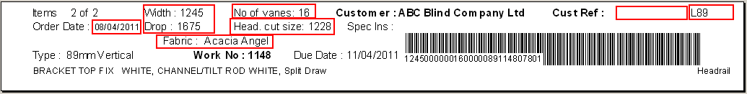

Customer reference is larger, width and drop, number of vanes larger, removed headrail cut. Moved ‘No of Vanes’ down to line with ‘Fabric’ on it.

Pleated – number of pleats is now on label

Made blind type code larger

Slat quantity now appears on the Venetian ticket

1 L89, 2 R etc to print on the label

3366. Works Order – Label 34

The address has been removed from here.

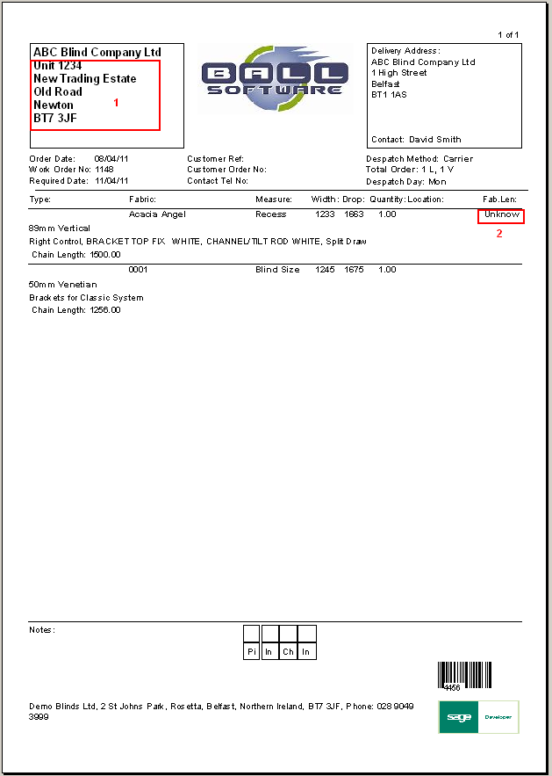

New Work and Customer Requests

2143. Label Print – Bespoke 33A

On the top label the following fields now print..
Wood/Woodstyle

- O/N
- Customer name
- Quantity (I.E 1 of 2)
- Delivery Date
- Product and colour
- Width and Drop
- Control Position
- Tape or Braid – State colour
- Ctrl Length
- Headrail Colour

Vertical

- O/N
- Customer Name
- Quantity (I.E 1 of 2)
- Delivery Date
- Product, fabric and colour
- Width and Drop
- Control Length
- Control Position
- Combination of vanes (I.E 3a, 2b etc)
- Metal or Plastic Op
- Headrail colour.

2148. Option Price Enquiry > Price Per Metre

It is now possible to price options by price per metre, but also have functionality so that the price below a certain size is fixed. For example, the price of an item is 5.00 per metre, within a minimum charge of 5.00 (ie one metre). Therefore if a width was 1650mm, the option price would be 5.00 + 3.25 = 8.25. If the width was 750mm, the option price would be 5.00.

This is held in ‘Option Price Enquiry’ and we have a new price method called ‘Price Per Metre’. There is also a new column in the form form called ‘Minimum Price Per Metre’.

2150. OOS Email

We recently added functionality to generate an email to customers to advise them whenever an order gets flagged Out of Stock. However not all of our customer’s customers want this. Previously this was activated by the ‘Send OOS Message to Customer’ check box on the Defaults tab of the Parameters form. We have moved this check box to the Options tab of the Customer card. We now use this to identify which customers are to get the OOS emails. If a customer does not have this option selected, then an OOS email is not sent to them. It is still possible to send the internal OOS emails, so the functionality for that still works (as it did before we introduced Send OOS Message to Customer.

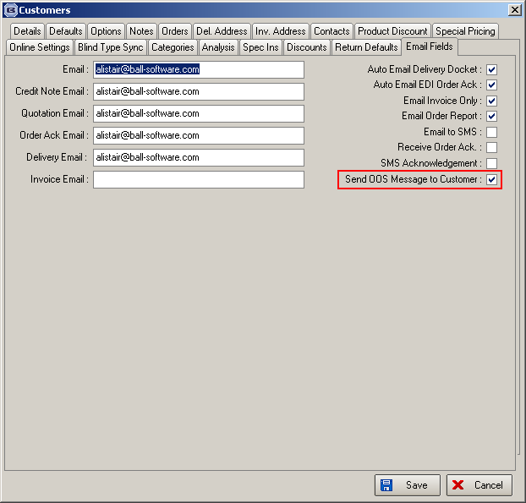

2158. Order Processing > Global Search

A few small changes have been made here.

Added validation to ensure a start date is always entered.
A button has been added to print an order acknowledgement.
A column has been added for the orders total Net price.

2162. Blind Details > Blind Types > Blind Type Setup tab

The Blind Type Setup Tab on the Blind Type form did not display correct for a lot of users as a result of this form layout being changed. The form layout has been modified to correct this.

2164. Order Enquiry > Enquiry Scan

There is a button on the Order Enquiry form called ‘Enquiry Scan’. This button will reset an order status to Order Entered. This is used if you need to recall an order from the factory to be amended for any reason. Previously there was validation on this button to only allow an order to be changed back if it is at status WIP or below. We have changed this to allow orders to be Enquiry Scanned up to Despatched status. It only prevents orders at Invoice Created or after from getting scanned.

2165. Copy Selected Field Value

There is a useful function called ‘Copy Selected Field Value’ in the right click menu of the ‘Order Amend Enqiury’ screen, which has now been included in ‘Archive Enquiry’, ‘Order Enquiry’ and ‘Global Search’ screens.

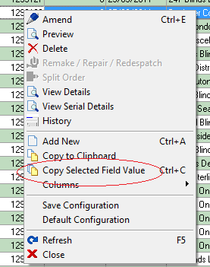

2166. Canada Sales Tax

If ‘US Zip Code’ is set as the default in Administration > Parameters, then the system now says ‘Sales Tax’ instead of ‘VAT’ – this is system wide.

2167. Order Processing > Orders

We have created a parameter in Administration > Parameters called ‘Display Discount Multiplier’. If this is set to true, then the discount multiplier will be displayed instead of ‘Discount %’. in the order detail line entry, Totals tab and also customer record.

2168. Blind Types / Order Processing

We now have valance / return functionality for all blind types. The ‘Enter Valance Size’ parameter field in the ‘Blind Type’ record is now enabled for all blind types.

2169. Default Page Size

For the USA and Canada the default page size has been changed to 8.5 x 11for all sales analysis reports. The remaining reports will be changed in due course.

2172. Financials > Invoice Batch Print

There is now a field choice for ‘Customer’ below Department.
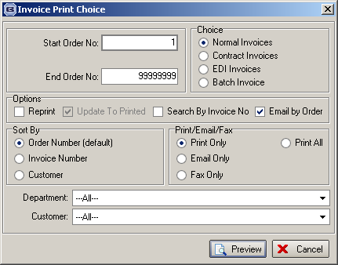

2173. Order Processing

There is now a column for ‘Sage Transaction Number’ in both ‘Order Amend Enquiry’ and ‘Archive Enquiry’.

