Blindata Release Note 5.3.5 

1 April 2011

Bug Fixes and Enhancements

3338. JL EDI Import

Delivery address now imports for laminated rollers.
Options are now in the correct order after the file has been imported as an order
Location is used for EDI invoice for wood and bamboo, and also now for laminated roller.
Orders in the JL Import routine no longer go on customer hold when they are imported.

3353. JL EDI Import

There was a parsing failure message when you try to import rx003441 to the EDI enquiry. Fixed.

3355. Order Processing > Orders

If an order is entered as Imperial and ‘Enter Valance Size’ is true for the blind type, the ‘Valance Width’ and ‘Return Length’ now appear in Imperial ie 50 ½ instead of 50.51 or whatever (and round it to the nearest 1/8). It is also possible to enter sizes in fractions in these fields.

3356. Invoice – Laser Print (Letterhead Logo 8.5 x 11)

The discount % is not shown if ‘Hide Detail Line Discount’ is switched on.
Invoice terms now appear on invoice, just above the parameterised text.
For component line, the ‘Comment’ is expandable.

3358. Purchase Order – Bought In (All Reports)

If these reports are set to Imperial (Use Measurement in PO), the width and drop now prints in imperial.

3361. Invoice – Bespoke 34

If settlement discount % = 0, then the settlement discount line does not appear on the invoice.

New Work and Customer Requests

2141. Blind Details > Blind Type

We now hold a minimum figure for drop of blind, below which the chain/control length deduction is zero. This field is called ‘Min. Drop for Chain Length Ded.’ and appears in the blind type record if ‘Chain Length’ is true. The chain length deduction is now calculated as 0 if the drop of the blind is below ‘Min Drop for Chain Length Ded’ ie the chain length will be the same as the blind drop.

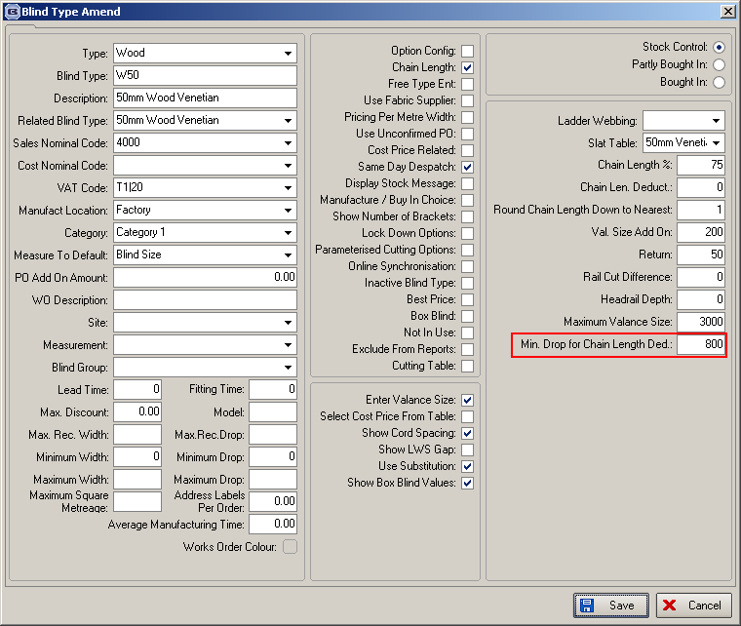

2142. Blind Details > Cord Spacing

We now hold an option field against the cord spacing record. If no option is entered, then the cord spacing calculation is done as normal. If there is an option in the cord spacing record and that option has been entered in the order detail line, then that cord spacing record will be used. In other words, for example, we could have different cord spacing sizes for ‘Left Control’ and ‘Right Control’.

2144. Purchase Order Enquiry > PO Delivery

If ‘Enable Factory Stock’ is true in Parameters, then if stock item is ‘Stock Held In House’, then ‘Factory Stock In Hand’ is set to false in PO Delivery.

2145. Stock Setup > Fabric Group Setup

There is now a column choice for stock code, and an update choice for ‘Stock Held In House’.

2146. Scheduling Report

There is now choice to enter a start date (always a Monday) on the ‘Total Of Orders Outstanding Report’. This will then determine the date the scheduling report starts from.

2147. Invoice – Bespoke 31

There is now a different telephone number for accounts. There a new telephone number field called ‘Accounts Tel Number in Administration > Company Details, which then prints on ‘Invoice – Bespoke 31’ instead of the normal ‘Tel Number’.

2151. Acknowledgement – Laser Print 8.5 x 11

- The detail line is now expandable
- ‘Unit Of Sale’ is printed for components.
- The option price no longer shows if it is a component line entry.

2152. Invoice - Laser Print ( Letterhead Logo) 8.5 x 11

- The detail line is now expandable
- ‘Unit Of Sale’ is printed for components.
- The option price no longer shows if it is a component line entry.

2153. Blindata Install

Blindata can now be updated when the database is installed on Windows 7 and SBS 2008.
We’ve found cause of this problem and solution for it. Please see on the link below.

http://www.linglom.com/2010/01/13/solved-activex-component-cant-create-object-sqldmo-sqlserver-on-sql-server-2008/

W101. Order Entry

This has been changed so the functionality that was done in dev 2063 is applied to the online order entry. ‘Return’ will be entered as an option instead of having it’s own field.

W102. Order Entry

If a customer does not have a delivery address set up, then the country defaulted to Afghanistan when an order is being entered. Fixed.

