Blindata Release Note 5.3.4 

25 March 2011

Bug Fixes and Enhancements

3158. Order Processing > Orders

There was a problem with the refreshing of options. For example, if you entered 50mm Sunwood Tape, choose a Tape option, it should then select the correct ‘Button’ option, but it was not doing so. It was selecting the default Button option, whereas it should be selecting the option with the lowest sequence number here. Fixed.

3258. Order Processing > Orders

If a link option is set up for a blind type and is dependent on size, the options are now refreshed properly after the size of the blind is changed.

3320. Order Processing > Orders

If a quote/order detail line is entered and an amount is manually entered against an option (eg Fitting), if you then change another option, this manually entered option amount is lost. This also applies to the Global change. It also happens if you enter a total or a discount % in the ‘Totals’ tab.

We have left the logic as it is, but have a message saying ‘You have changed an option price manually. This will be reset if anything else is changed in the detail line’.

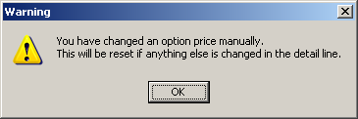

3340. Label Print – 200 x 24mm

If blind identifier = Venetian, and ‘Show Cord Spacing’ = true, the cord spacing now print on the label.

3341. Invoice Batch Print

If you select reprint and print/email a lot of invoices that have already got a status of ‘Invoice Posted’, the status of these orders now stays as ‘Invoice Posted’.

3342. Order Processing > Orders

If a stock item is set as ‘Non Discount Item’, it is now possible to change the price in the component entry. At the moment the price could not be changed.

3343. Credit – Bespoke 34

The detail line description now prints in full for components. Previously it was only showing one line.

3344. Order Processing > Orders

When the order status filter is done, if you only select ‘Despatched’, ‘Part Manufactured’ still appeared. Fixed.

3345. Order Processing > Orders

If you enter a component line that has more than one ‘Unit Of Sale’ record set up, if you then change the ‘Unit Of Sale’ more than once, it updated the ‘Unit Quantity’, but now also select the correct price.

3346. Audit Trail Report

When an audit trail report is printed, and includes an invoice with settlement discount on it, the VAT was incorrect on the report. Fixed.

3347. Administration > Parameters

When you try to enter a date in the ‘Start Quotation Filter Date’ field, the calendar lookup only shows days – it needs to show month and year as well.

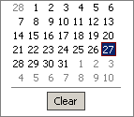

3348. Order Processing > Quotations

If the ‘Start Quotation Filter Date’ is filled, then then ‘Contact Management Reports’ button is not enabled.

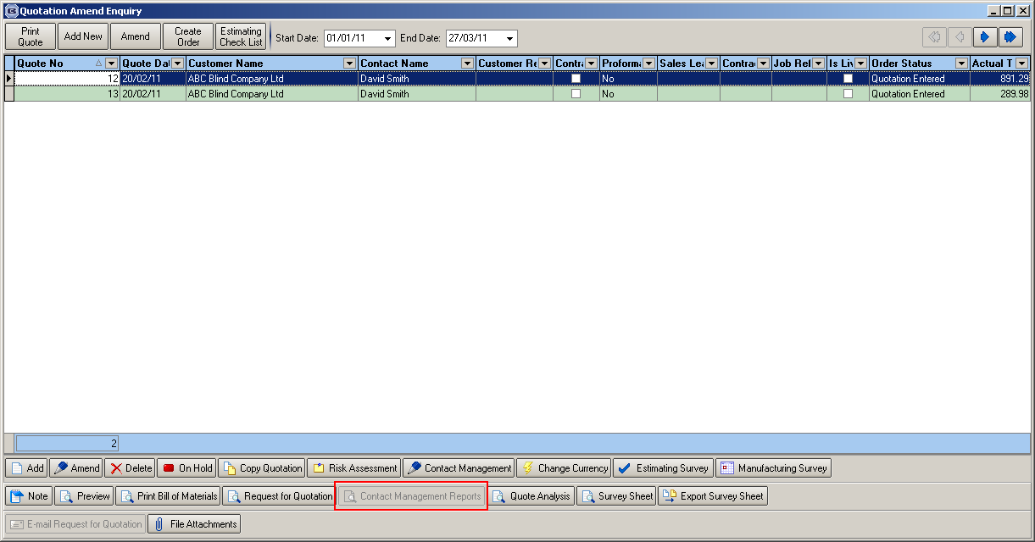

3351. Acknowledgement – Laser Print

If the detail line is for a component, then the stock code now prints before the description.

New Work and Customer Requests

2060. Invoice – Bespoke 22

We have a customer that has to send out invoices with the grid reference of where a price is in a spreadsheet. So if this price was found in a price table, we would refer to this as being in F4 (same as a spreadsheet co-ordinate).

This grid location can then be printed on the invoice (immediately after the fabric description) in brackets.

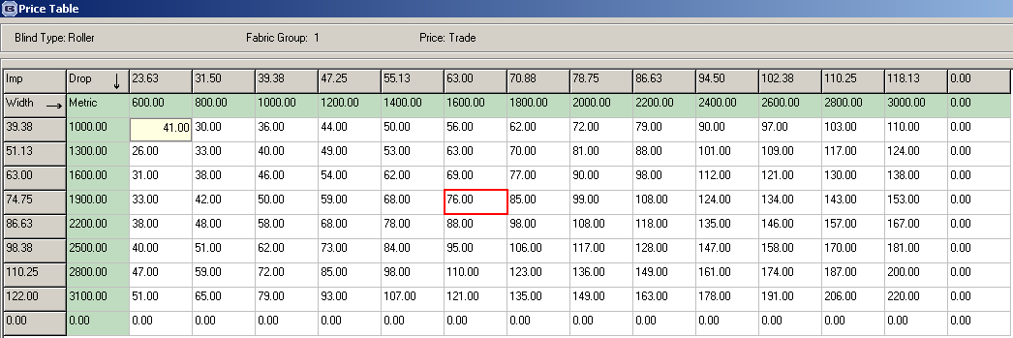

This can be applied to specified accounts, using a new flag in the customer record called ‘Print Price Table Grid Location).

It is only enabled on ‘Invoice – Bespoke 22’ at the moment.

2120. Quotations > Import Survey Sheet

It is now possible to import a quantity for a blind detail line and also to be able to import an unlimited number of detail lines.

2121. Order Processing > Quotations

There is a new parameter to set the start date for the quotation filter being displayed. This is called ‘Start Quotation Filter Date’ and is held in Administration > Parameters.

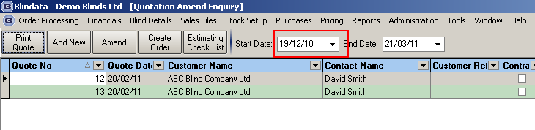

2122. Quotations > Contact Management Reports

The start date now defaults to the Start Quotation Filter Date’ in Administration > Parameters (see 2121).

2129. Stock Setup > Stock Items > Unit Of Sale

We have added two fields to this tab so that prices can be held against the ‘Unit Of Sale’.

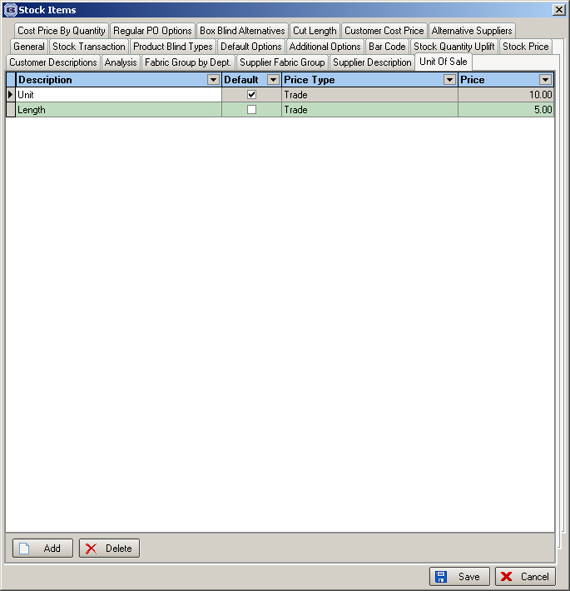

This means the price could be picked up from ‘Unit Of Sale’ when a component detail line is entered.

2130. Administration > Import From Excel

There is a new import routine called ‘Unit Of Sale Stock Prices’. This imports a spreadsheet containing these fields: stock code, unit of sale, price type, price.

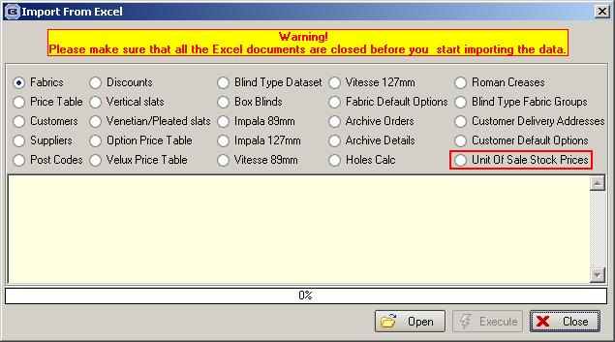

2131. Invoice – Bespoke 34

Settlement discount can now be calculated and printed on this invoice. Here are the settlement discount rules, according to HM Customs & Revenue.
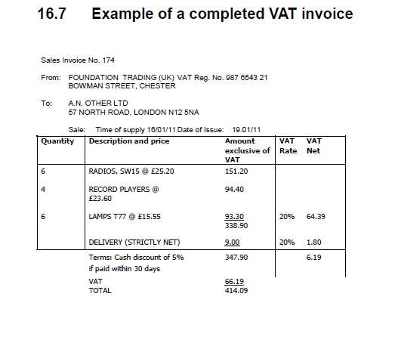

In this example, the invoice total before settlement discount is 347.90 + 20% VAT of 69.58 = 417.48. But you will notice that the VAT on the invoice is calculated as 66.19. This is because 5% has been taken off the goods value, but not off the delivery (carriage) charge.

What is missing from the invoice is the actual amount that the customer should pay, which would be (338.90 * (100 – 5)/100) + 9.00 + 66.19 = 397.14.

So on the invoice we now show ‘Amount to pay after settlement discount’, which in this case would be 397.14.

Work Done

Previously the settlement discount was only held against the customer record. When an invoice is created, it is now picked up from the customer record and stored in the order record. It is visible in the Totals tab of the order (under ‘Contractor Discount’ and ‘VAT Amount’).

If settlement discount % > 0, then the following is done.
The VAT is recalculated for the detail lines (except ‘Carriage’), and the VAT Total recalculated. The ‘Amount to pay after settlement discount’ = net total (excluding Carriage) less settlement amount + Carriage line + VAT Total.

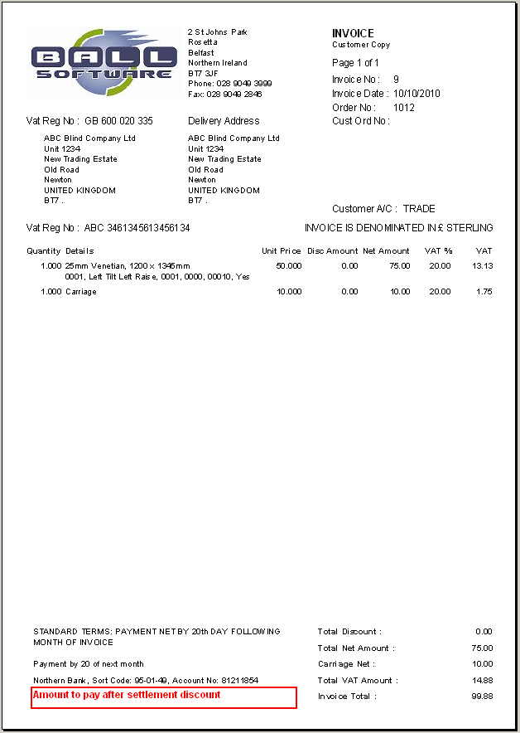

We have also make an adjustment to the amount that is posted to Sage. The full net total is posted but the VAT amount has the settlement % removed, except if it is a carriage line.

2132. Sales Analysis Performance Report

Previously this report was sorted by List Price, it is now by Total Net Sales.

2133. Order Processing > Orders

There is now a ‘Save & Next’ button on this form so the form reopens again. This means the user does not have to click ‘Save’, then ‘Blind’ in the ‘Add New’ section. This button has also been added to the ‘Components’ form.

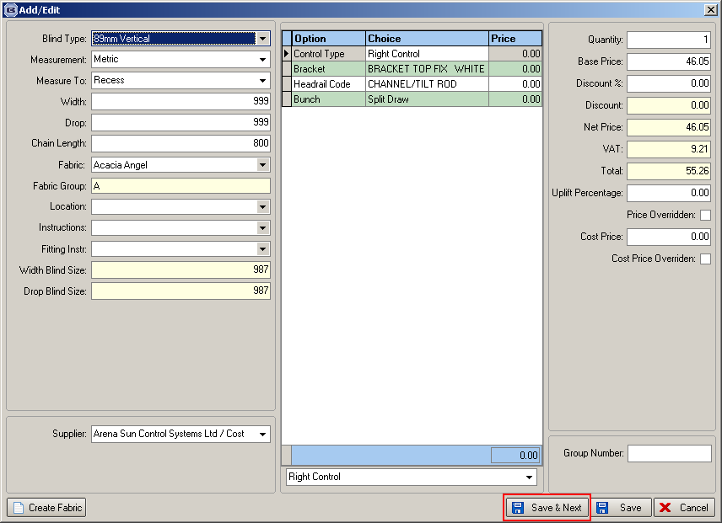

2134. Delivery Docket – Bespoke 34

The invoice address has been removed from the report

2135. Purchase Order Bought In Reports

There is a new parameter in Administration > Parameters > Report Parameters called ‘Show Cust Ref on PO’. If this is set to true, then ‘Show Our Order No on PO’ is set to false, and the customer reference from the sales order is printed in it’s place for each PO detail line.

2138. Works Order – Bespoke 34

We now print more description lines for components and the detail lines are expandable.
Previously there was a page break by blind identifier, but now different blind identifiers appear on same page, but are grouped by blind type. Components are grouped by category. Blind type detail lines print before component detail lines.

2140. Invoice – Bespoke 34

Stock code now print for components (same as in Acknowledgement – Bespoke 34).

W98. Blindata Online

When you tried to copy a detail line, an error occurred. Fixed.

