Blindata Release Note 5.3.3 

18 March 2011

Bug Fixes and Enhancements

3311. Label – 200 x 24mm

The width and drop sizes are now the ‘Blind Size – Metric’ amount for all blind types.

Previously the ‘Free Type’ printed on some labels – it now prints for all blind identifiers.

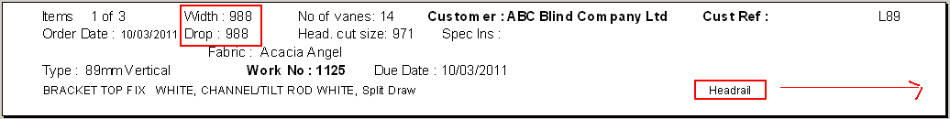

3328. Invoice – Bespoke 17a

This now prints the invoice date, not the order date.

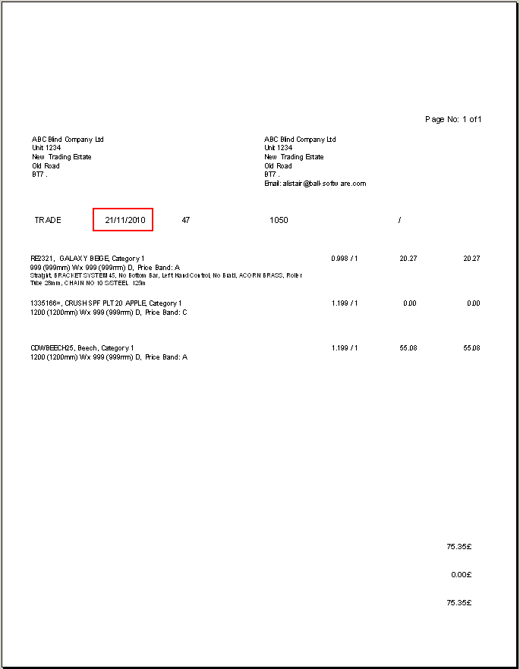

3329. Invoice – Bespoke 17

- Customer reference now prints in this box. ‘Cust Ref’ in the top box and field entry below.
- The invoice total is printed only on end of the last page. Previously it printed the total on every page.

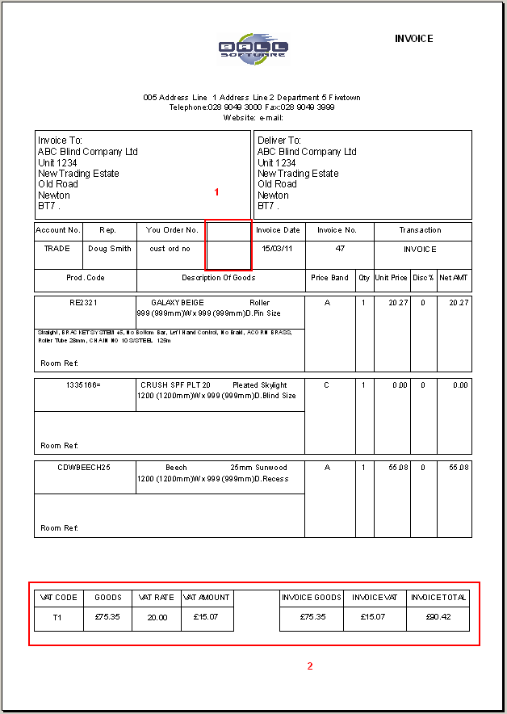

3330. EDI Import

If an order is imported from Blindata Online as a paid proforma, then the order does not go on credit hold, and does not need to be credit checked (because it has already been paid).

3333. Works Order – Label 1

Chain Length % no longer appears on the label.

3336. Delivery Docket – Laser Print 8.5 x 11

- The company customer name, address etc now come from Administration > Company Details, not from Department.
- If the detail line is miscellaneous, then it now prints with these details.

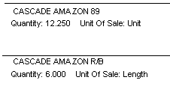
New Work and Customer Requests

2088. Emails

We have added a number of features for emailing quotations, order acknowledgements, delivery dockets and invoices recently, and have tidy a few things up.

Firstly we have improved emailing to allow for different email addresses for quotations, order acknowledgements, delivery dockets and invoices. There is now a tab for ‘Email Fields’ on the customer form. As well as having separate email addresses for each of the four possible reports in here, we have also moved other email related fields (in red rectangles below) into this tab. When this update is made, the email address in the Details tab (see immediately below) is copied into the ‘Quotation’s and ‘Order Ack’ email address.

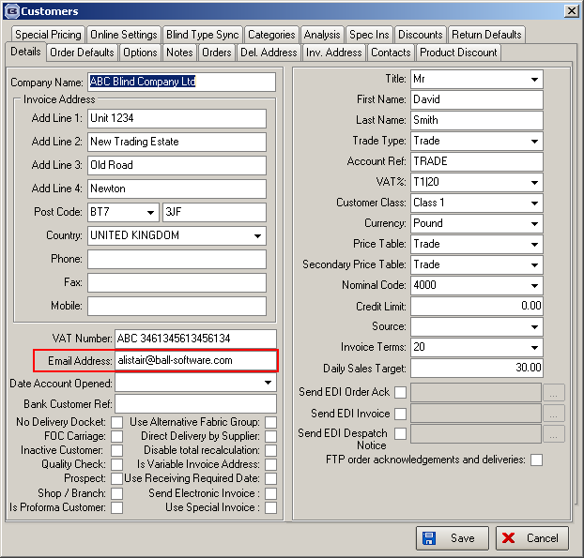

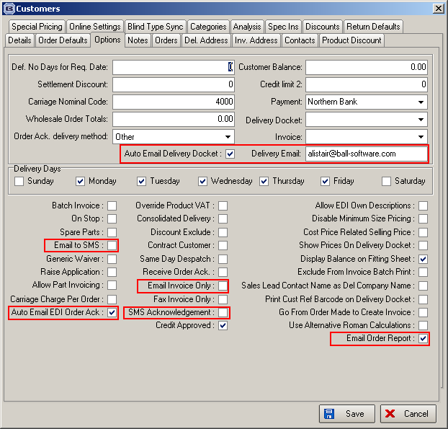

When a quotation is entered, the email held in the quotation is taken from the quotation email address that is held against the customer.

When an order is entered, the email held in the order should be taken from the order ack email address that is held against the customer. It should also hold the delivery email address and invoice email address.

Update Customer Form

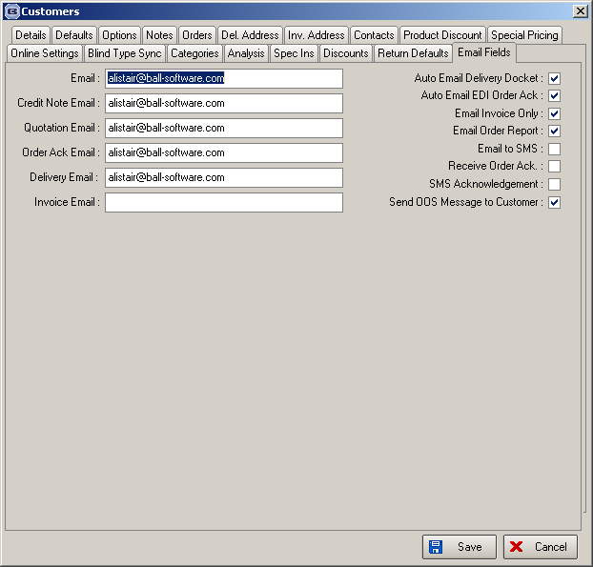

2089. Blindata Online

There is new functionality to restrict options for certain customers in Blindata Online and in the desktop version.

A new table has been created in Administration > System Tables called ‘Option Restrictions’, containing customer and stock item. If there is an option choice record in here for a customer, then the option choice will not appear for that customer when an order is entered.

2090. Purchase Orders

We have made some changes to the regular PO entry form.

- There is now a column for ‘Supplier Part No’ lookup.
- When entering the quantity, the program checks the ‘Minimum Order Quantity’ to see if it is high enough. If not, a message should say ‘The minimum order quantity for this item is nnn’.
- There is now a ‘Save’ button for detail lines.
- There is a button so ‘Notes’ can be entered against detail lines.

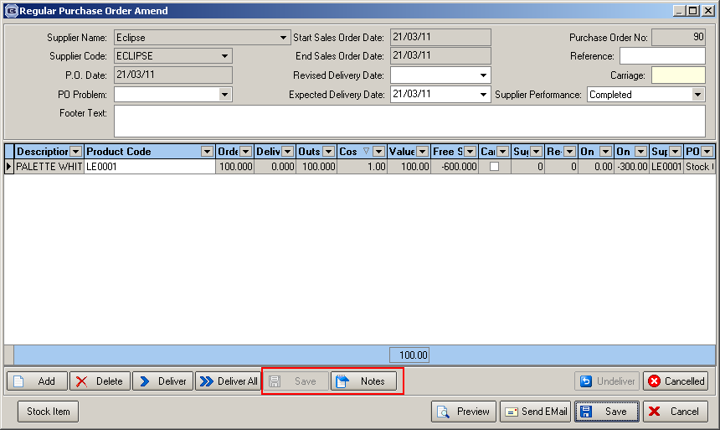

There is also an option to print the supplier part number on the regular PO reports (all of them) instead of the stock code. There is a flag in the supplier record called ‘Use Supplier Part No on PO’. If this is set to true, then the supplier part no will print instead of the stock code.

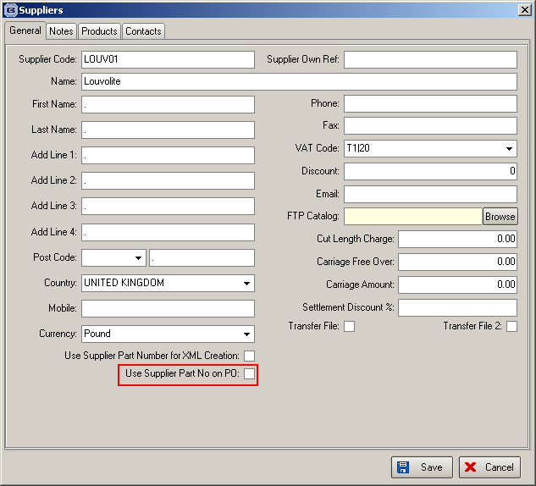

Also, if ‘Notes’ is not empty in the PO detail line, they print under the detail line.

2092. Sales Analysis Reports

There is now an option to exclude miscellaneous sales. There is a flag on the ‘Sales Analysis’ form called ‘Exclude Misc. Sales’. This will exclude all sales where blind type has blind identifier = M.

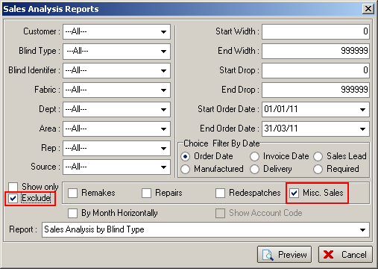

2093. Pricing > Discounts

If there are a lot of discounts set up, then adding a discount was very slow. This has been optimised.

2113. Rollout Production Planning Report

We have added two more columns on this report.

2116. Label – Bespoke 29

If an order is for a ‘Remake’ the label is printed all in red. If the required date has been changed, the ‘Customer Required’ date will be flagged and these labels now print in blue.

2118. Report Export Parameters

There is now a ‘Invoice – Laser Print (Letterhead Logo)’ report in ‘PDF Invoice’.

