Blindata Release Note 5.3.2 

15 March 2011

Bug Fixes and Enhancements

3315. Box Blind Add/Deduct Slat Calculation

Since we changed these box blind system tables, the add/deduct slat figure did not always seem to calculate correctly on works orders. The first blind entered calculated correctly, but subsequent blinds were incorrect. Fixed.

3317. Archiving > Delete Archived

When you tried to delete orders from AOrders in the archive (in large databases), an error message appeared. Fixed.

3316. Order Processing > Orders

When you tried to post invoices for component sales with non integer values, an error occurred. Fixed.

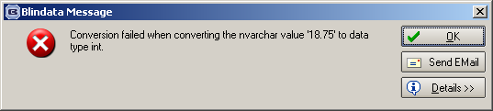

3319. Quotations

If a quotation has a status of ‘Survey Completed’, it is now possible to add/edit lines.

3321. Quotations/Orders

If a free type blind type is entered and saved, the free type entry appears in the ‘Window Blind Amend’ form. If the blind type is then changed to a non free type blind type, the free type previously entered is now removed.

3322. Export / Import Blind Type Dataset

We no longer export the ‘Stock Default’ data for the time being – please disable this for just now.

A mistake was maderecently because a change was made to not export and import the fabrics as part of this routine. This was wrong – we do need to do this for a number of reasons.

- The fabrics can only be imported by ‘Import From Excel’ after the blind type dataset has been created, because the blind type record is required.
- Default options do not get imported because the fabric codes are missing.
- The ‘Alternative F. Group’ will only ever be held against a fabric record (ie option = Fabric).

There was also a problem with importing options which has been resolved.

3323. Works Order – Bespoke 34

The ‘Location’ is now printing if blind identifier = Miscellaneous (ie component line entry).

3324. Acknowledgement – Bespoke 34

- If all detail lines are for components, then neither ‘Width’ nor ‘Drop’ now prints.
- ‘Comment’ field now prints instead of the fabric description for component lines.

3325. Blind Type Dataset Export / Import

There was still a problem with importing records for ‘Default Options’. This has been fixed.

3326. Acknowledgement – Schedule Date

This text was changed in v5.2.5. The text should actually say ‘Please note that this blind is out of specification, which may affect your warranty. Contact customer services for more information’. In other words, ‘Contact customer services for more information’ is now appended to the existing text. The full text should appear only if the blind is outside of the recommended max width/drop.

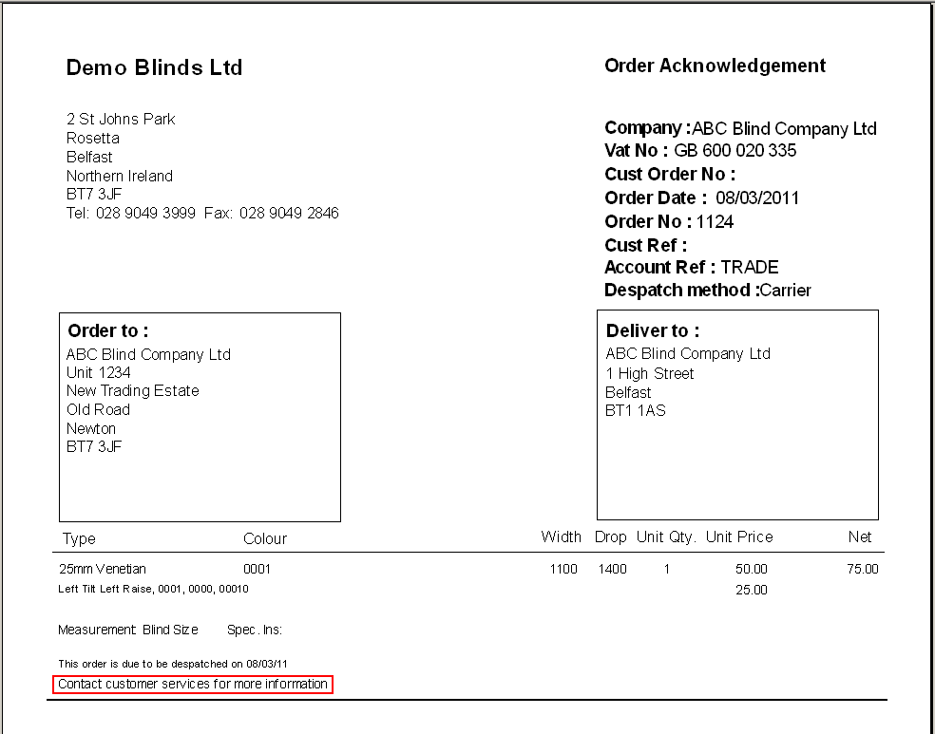

3327. Label – Bespoke 29

We have reinstalled the previous ‘Label – Bespoke 29’ back into 5.3.2 ie the one in version 5.3.0.

New Work and Customer Requests

2099. Sage Pay

We have made a number of changes to Sage Pay, both in the Blindata App and in Blindata Online.

There is now a flag on the customer record to allow a Sage Pay to be made online. It is called ‘Allow Online Payment’ and is in the ‘Online Settings’ tab.

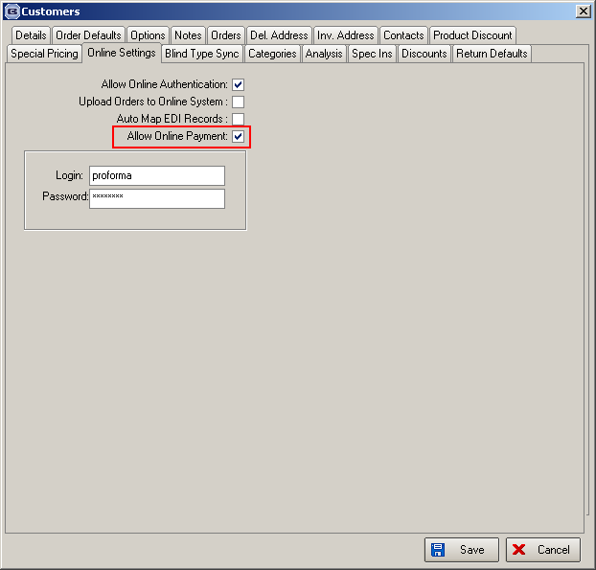

Previously Blindata Online did nothing with the Sage Pay output. We need to record this against the online order. The following can happen.

Accepted – submit order automatically.
Incorrect data – return to order list
Refused – return to order list

Proforma customers are unable to submit orders online. Instead, providing they have ‘Allow Online Payment’ set to true, they will have to click ‘Sage Pay’ first. When the Sage payment is made successfully, the order is submitted automatically.

Orders that are paid online import into Blindata with status of ‘paid’ proforma. There is also a flag on the order to say payment was made online.

There is a history record on the order for an online payment.

An email is also sent to credit control when a Sage Pay order is imported via EDI. We now hold a field for the credit control email in Administration > Parameters > Internal Email Addresses.

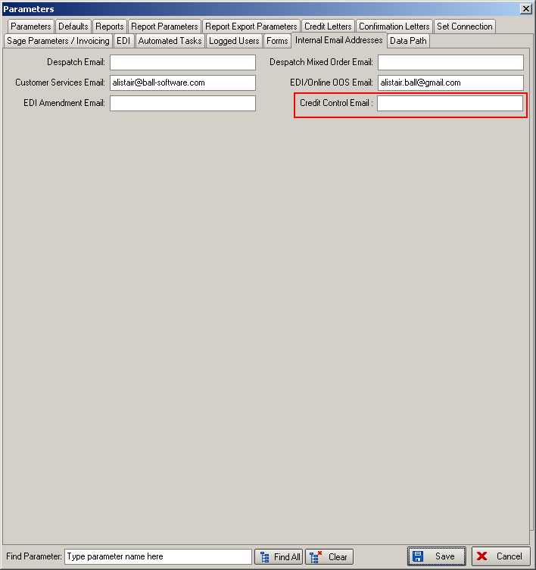

In the address in Sage Pay, nothing goes into the State field, as this only relates to the USA.

2100. Reports > Sales Analysis

In large databases sales analysis reports were timing out. These reports have been be optimised.

2101. Credit Note – Bespoke 34

There is now a credit note layout that has the same layout as ‘Invoice – Bespoke 34’ (report and pdf versions).

2102. Quotation – Bespoke 34

There is now a pdf version of ‘Quotation – Bespoke 34’ which can be set up in Parameters > ‘Report Export Parameters’.

2103. Order Processing > Credits

It is now possible to email a credit note. There is now a field for ‘PDF Credit Note’ in ‘Report Export Parameters’, and a button for ‘Email Credit Note’ in the Credit Enquiry form. This button has a permission flag in Administration > Users > Button Visibility.

2104. Fabric Group Setup

There is now a column for supplier on the main form so records can be filtered by supplier.

There is also a field for updating ‘Fabric Not In Use’.

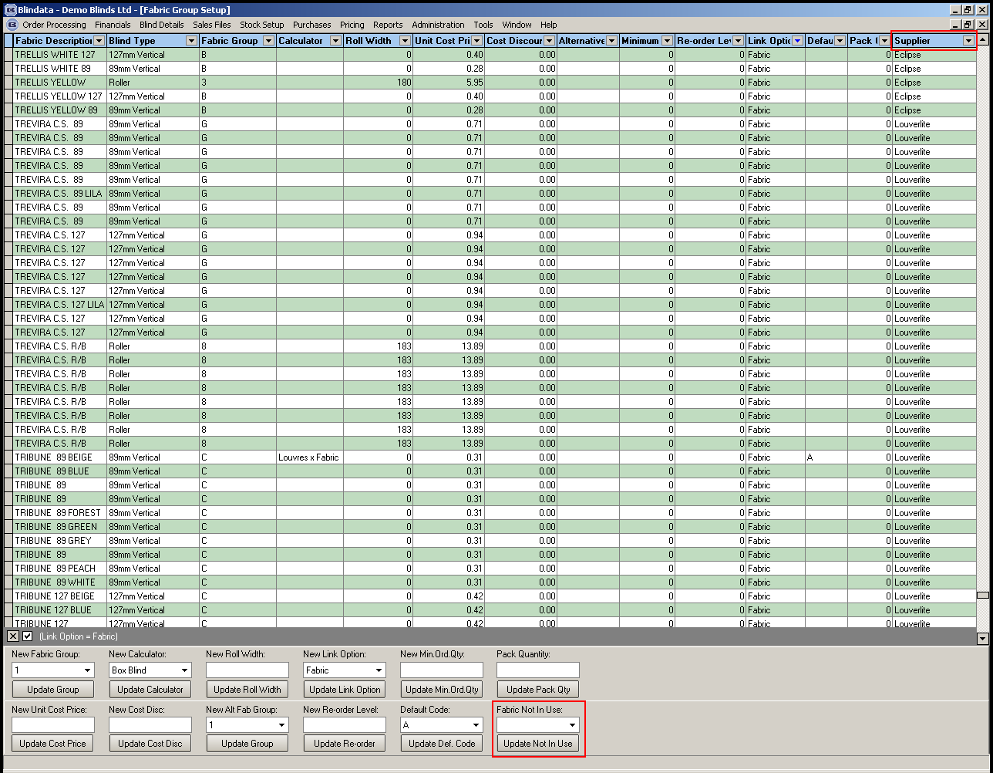

2105. Discount Multiplier

We have introduced a different method of calculating discount. For example, if a customer has a discount multiplier of 0.30, then if the net price before discount is £100, then the net price after discount is £30.

Previously, this would have to be held as 70% discount in Blindata. It is now possible to hold both methods against the customer blind type discount.

We have also amended the discount import routine in Administration > Import From Excel

Please note that the new Multiplier (0/1) flag has been placed in column K. If it’s absent then theexisting logic will be applied, except the multiplier value will be recalculated from ‘Discount %’ field.

2106. Export Blind Type Dataset

It is now possible to export secondary price band, also be able to export option default

2107. Import Blind Type Dataset

It is now possible to import secondary price band, also import option default

2109. Order Processing > Orders

There is now a prompt message to tell users to send an email order acknowledgement. If the customer ‘Order Ack Delivery Method’ field is set to ‘E-mail’, then when a user saves an order after clicking the ‘Checked’ option, they are prompted with a yes/no message reading ‘This customer has requested to receive E-Mail order acknowledgements. Do you want to send now?’. If Yes is selected, then the email confirmation is sent (in the same way as if ‘Email Order Ack’ button had been clicked on the Order Amend Enquiry form). However, if No is selected, then nothing happens.

An email is also sent (after question prompt) if ‘Order Ack Delivery Method’ = Email and ‘Display Checked’ = false, when the order is saved.

2110. EDI Import

It is now possible for ‘Same Day Despatch’ orders that go on credit hold to be automatically changed to normal orders.

There is a new parameter to switch this feature on and off called ‘Block Same Days for Credit Holds’.

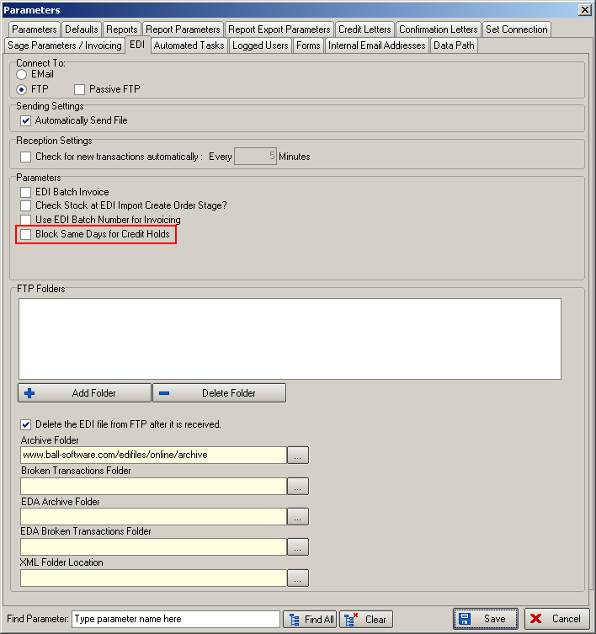

When an order is created during the EDI import, any same day despatch flags can now be ignored if the order is placed on credit hold and it is scheduled as a normal order for that customer (taking their must go status into consideration).

