Blindata Release Note 5.3.1 

4 March 2011

Bug Fixes and Enhancements

3309. Invoice – Bespoke 34

If ‘Hide Detail Line Discount’ is ticked in the Totals tab, the ‘Total Discount’ does not print.

3310. Works Order – Bespoke 34

If the works order goes onto more than one page, the header was shown on the subsequent pages. Fixed.

3313. Order Processing > Orders

If a customer is set up as ‘Use Alternative Fabric Group’ = true, then the selling price was not worked out correctly ie it found the price using the ‘Alternative F. Group’ in the fabric record. But if the blind type is ‘Bought In’ and it also looks up the cost price table, it was still selecting the price using ‘Fabric Group’ instead of ‘Alternative F. Group’. Fixed.

3314. Order Processing > Quotations

When splitting quotes, the order number sometimes appeared as zero. A separate version of the split procedure has been created for quotes that is based on the quotation_id.

New Work and Customer Requests

2063. Valance / Return Changes

‘Return’ is now handled as an option, and not as a separate field of its own. Therefore this field will no longer be displayed here, but will appear as an option.

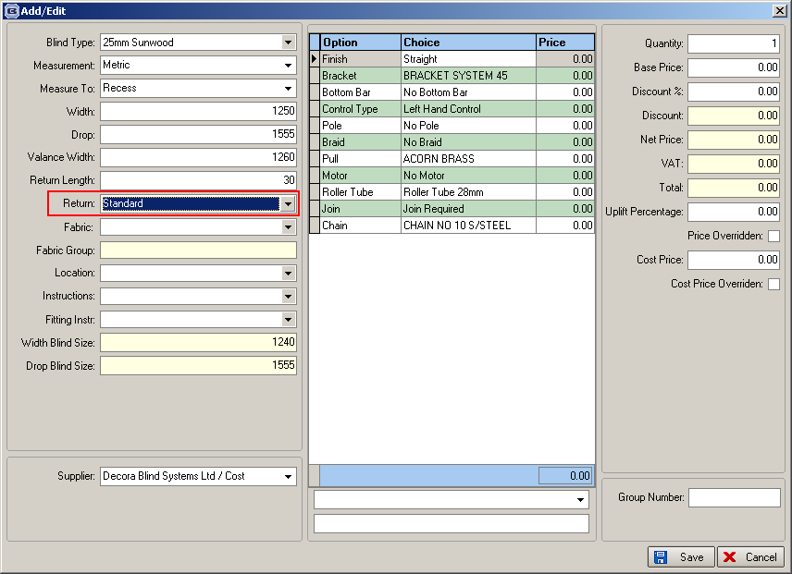

Therefore all the functionality that previously worked for ‘Return’ now work if it is set up as an option. We have create a code called ‘Return’ in the Option Names table to indicate that the option should then trigger the Return/Valance functionality.

We have also changed the ‘Return Valance Size Add On’ table to handle this, and also the report ‘Works Order – Label 1’.

Return Valance Size Add On

The ‘Return Description’ now looks up the ‘Fabrics’ table, but only shows ‘Return’ options (ie options where code is set to ‘Return’).

In order detail line entry, if a return is chosen as an option, and ‘Valance Calc’ is the code for the ‘Return’ option, the ‘Valance Width’ will be adjusted by adding on the ‘Return Add On’ amount from ‘Return Valance Size Add On’.

2067. Order Processing > Orders

Orders with blinds in the same manufacturing location that are under the maximum scheduling quantity are now always scheduled on the same day ie they are not split across two days.

2084. Financials > Invoice Batch Print

It is now possible to send out email invoices for customers who may have more than one invoice in a print run, and put all these invoices in the same pdf file, instead of sending out multiple pdf files.

2085. Quotation – Bespoke 34

A new quotation report has been created, called ‘Quotation – Bespoke 34’.

- Logo from Company Details.
- Address from Company Details.
- ‘PROPOSAL’ instead of ‘Quotation’.
- Logo 2 from ‘Company Details’.
- Quotation date
- Quote number (don’t need letters after it).
- Customer company name and address
- Customer contact name, email address, tel and fax number.
- Customer reference from quotation.
- Detail columns
- This is an example of ‘Quotation Text’ from quotation stored text. It is expandable.
- Quotation text (like 11).
- Quotation text (like 11).
- Rep name.
- VAT registration number from Company Details.
- Should say ‘Total Net Value of Proposal’.

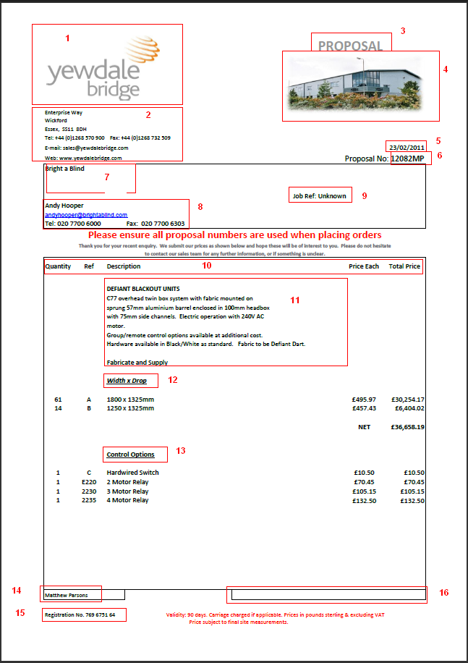

2087. Contact Management

We now hold email text for contact management emails in Administration > Company Details.

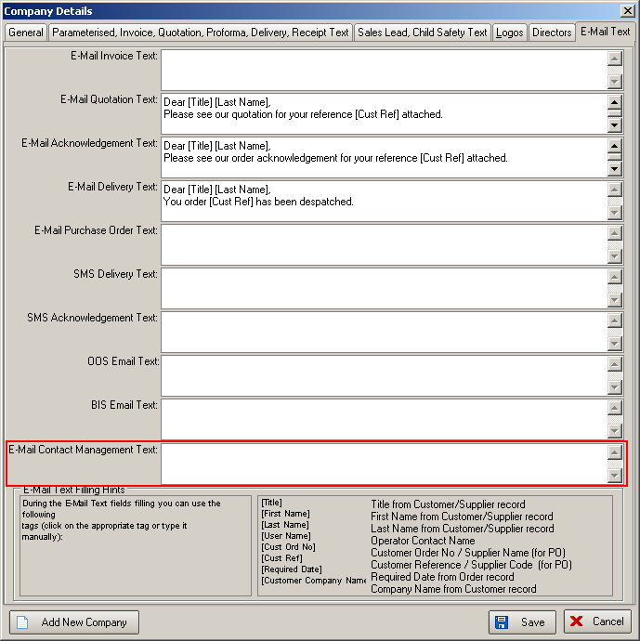

We have removed all fields except blind type, further details and action required from email body.

2091. Sales Analysis by Customer by Blind Type by Month

Account code is now included in this report (to the right of customer company name).

2095. Order Processing > Orders

There is now a column choice for ‘Consignment Note No’ in the Order Amend Enquiry form.

2097. Acknowledgement – Letterhead Right

We have created four new reports called ‘Quotation – Letterhead Right’, ‘Acknowledgement – Letterhead Right’ ‘Delivery Docket – Letterhead Right’ and ‘Invoice – Letterhead Right’ to allow for a new preprinted stationery layout.

2098. Bought In Purchase Order XML File

There is now an option that allows you to use the ‘Supplier Part No’ instead of the stock code when creating the XML file to be sent to a supplier (for a made to measure product). There is a flag for this in the supplier record called ‘Use Supplier Part Number for XML Creation’.

