Blindata Release Note 5.2.9 

18 February 2011

Bug Fixes and Enhancements

3284. Order Processing > Order Enquiry

If an order was entered and ‘Repair’ was ticked, and there was more than one repair detail line on the order, when ‘Blind Made Scan’ was done, the entire order was changed to ‘Order Manufactured’. This now only happens when all the blinds on the order have been manufactured.

3285. Invoice – Laser Print 11 Detail Lines

If there is a component detail line and it has a lot of text in the comment field, the detail line now expands to fit it in.

3288. Administration > Export Data

When the ‘Blind Type Dataset’ is exported, it no longer exports ‘Cost Price’ and ‘Selling Price’. Both these fields are filled with 0.

Also, we do not export ‘Stock Default’ records from Blind Types > Stock Defaults tab.

If ‘Use Company Acc Code as Supplier Code’ is set to true, then for fabric/stock records that are exported, ‘Calculator’ is always set to ‘Quantity’ and ‘Default Code’ to ‘A’.

3289. Administration > Import From Excel > Blind Type Dataset

If there is no ‘Measure To’ record set up in a database, then this type of spreadsheet row could not be imported. In the import routine a new ‘Measure To’ record is now created, and this line can be imported successfully.

3290. Works Order – Bespoke 34

If there is a quantity of 2, then only 1 detail line now prints. Also, if there is more than one ‘Works Order Control’ record, the report prints on more than one page.

New Work and Customer Requests

2039. Scheduling

We have added functionality to the way the scheduling works. Up until now Blindata has calculated scheduling times based on a manufacturing location held against a blind type record.

It is now possible to calculate scheduling based upon process types that are held against blind types. In other words, it is possible to hold multiple manufacturing locations against blind types.

When an order is entered, the schedule for the manufacturing locations held against the process types will be filled with the times that are held in Blind Details > Blind Types > Process Times tab.

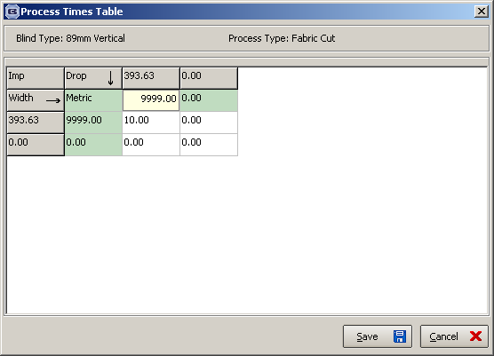

There is also a new report which is accessed in Order Processing > Total Of orders Outstanding. It is called ‘Scheduling Report’.

2045. Fitters Sheet / Sales Leads

As well as the existing diary, it is now possible to see a week view with all appointments on it ie by day and not by employee.

There is a new flag here called ‘Display Week – All appointments’.

It is now possible to move appointments from one day to another by dragging in this diary display format.

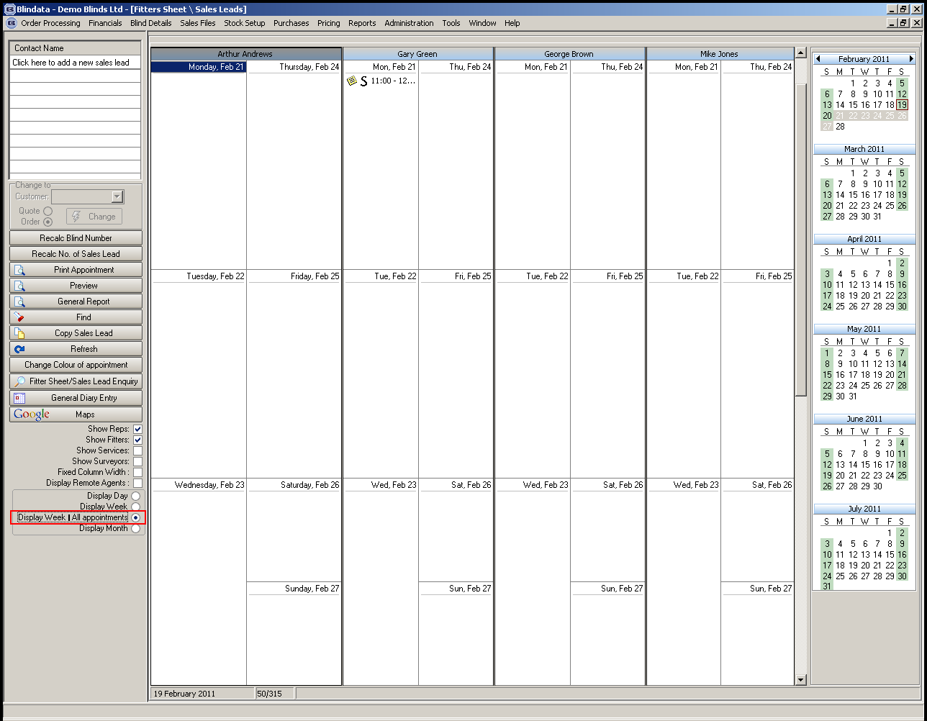

2047. Quotations / Orders > Import

We have made some improvements to the way large quotations / orders can be imported into Blindata.
At the moment we have an ‘Import’ option where a spreadsheet in this format can be imported as either quotation detail lines or order detail lines.

R | Blind Size | RE677 | 1290 | 1450
R | Blind Size | RE677 | 1650 | 980

We have added extra fields to this spreadsheet so it can be imported as either a quotation or order.

- There is now a facility to import a text line. If the first column says ‘TEXT’, then the second column will hold the text.
- There is a column for ‘Location’.
- There is a column to import the fitting price (need Field Name = Fitting in Blind Type > Option Setup)
- There is a column for ‘Price Uplift %’.

R | Blind Size | RE677 | 1290 | 1450 | Room 1, Window 1 | 5 | 35
R | Blind Size | RE677 | 1650 | 980 | Room 1, Window 2 | 5 | 35

Excel Survey Sheet

There is a new export/import routine to allow blinds to be imported into quotations/orders.

It is now possible to create a survey spreadsheet using the ‘Export Survey Sheet’ button in the quotation enquiry form. It is also possible to do this by right clicking on a sales lead in the diary.

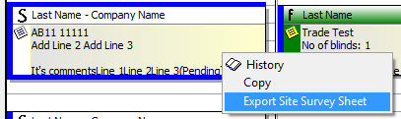

The completed survey sheet can then be imported to a quotation or order using the new ‘Import Survey Sheet’ button here.

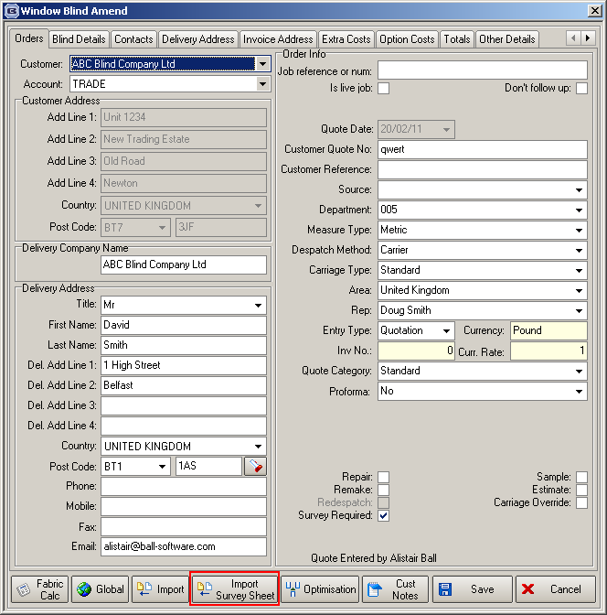

2049. Contact Management Reminder

When a user logs in, there is now a facility to bring up the contact management records for that user / all. There is a flag in the User form called ‘Display Current Contact Info on Login’. If this is set to true, then all contact records relating to that user for the current date display immediately after the user logs in.

2070. Administration > Import From Excel > Blind Type Dataset

This was originally part of dev 1881, but was not completed at the time.

When the spreadsheet is imported, it now imports the blind type record (if the blind type code does not already exist) and also the bought in record (containing blind type and supplier code). Where fields do not exist (eg sales nominal, VAT etc, we use defaults eg VAT code from Parameters, first sales nominal code in the nominal table).

A number of improvements have been made.

It now imports the manufacturing location.
It now imports the blind type line if the default ‘Measure To’ does not exist.
It now import ‘Option Names’.
If the blind type does import, the ‘Related Blind Type’ field is filled with the blind type.

So it should now be possible to export blind type(s) to a ‘Blind Type Dataset’ spreadsheet, and then import it to any other Blindata database. Once it is imported, the customer will be able to enter a sales order straight away for that blind type.

2071. Administration > Export Data > Blind Type Dataset

When a blind type dataset is exported, the user may not want to export the records for certain options in a blind type. Therefore we have added a new flag in Blind Types > Option Setup tab called ‘Export’. This defaults to true. If it is set to false, then when the blind type dataset is exported, the option record and fabric table records tied to this option will not be exported into the spreadsheet.

2072. Delivery Docket – Bespoke 34

There is a new delivery docket layout based on ‘Delivery Docket – Laser Print’ and is called ‘Delivery Docket – Bespoke 34’.

1. Despatch Method prints in header section.
2. If detail line is a component line, the stock code prints before the description
3. The ‘Delivery Text’ now prints in the bottom left.
4. The logo from ‘Company Details’ prints in the middle of the header.

2073. Works Order – Bespoke 34

There is a new works order layout based on ‘Works Order – Delivery 8’ and is called ‘Works Order – Bespoke 34’.

- Customer company name, address, tel number and fax now print on the right of the header.
- If there are special instructions, they now print. Also, if ‘Chain Length’ = true, it prints to the right of special instructions. If there are no special instructions, then ‘Chain Length’ moves left.

