Blindata Release Note 5.2.8 

11 February 2011

Bug Fixes and Enhancements

3279. Administration > Sage Utilities

When you run ‘Create / Update Customer Details from Sage’, the first part of the postcode is now imported properly.

3280. Order Processing > Global Search

If ‘Alternative Sizes Change’ is switched on in Administration > Users (for Quotes or Orders), it is possible to amend the width and drop in the order. It is no longer possible to make any changes to a quotation or order in the ‘Global Search’ form.

3281. Order Processing > Global Search

If you clicked ‘Find’ on the form without entering any search criteria, the program hung. We have added some validation here. If no criteria have been entered and ‘Find’ is clicked, a message ‘Please enter search text in at least one field’ appears.

3282. SMS Order Acknowledgement

The following error occurred when you try to send an SMS order acknowledgement with smtp set up. Fixed.

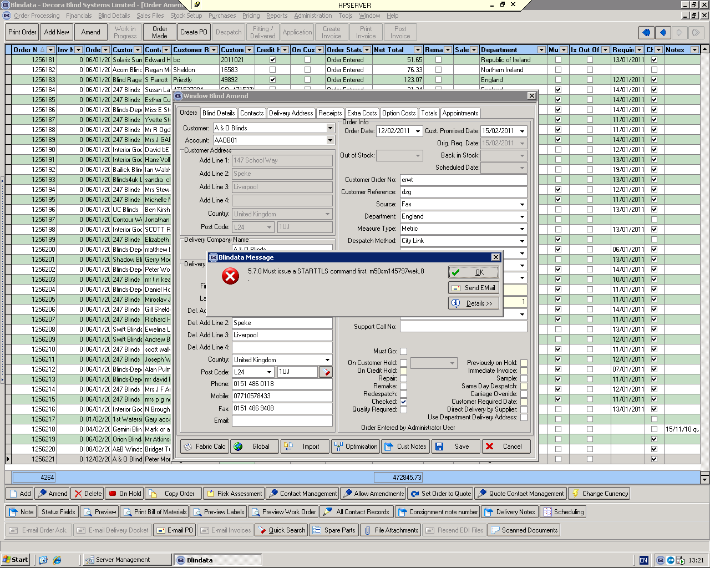

3283. Order Processing > Orders

The chain length now always appear as an integer (if size is metric). Previously, if a chain length % was calculated, it could appear to 2 decimal places.

New Work and Customer Requests

2031. Delivery Docket Email

It is now possible to set up customers so that the delivery docket text (in Company Details > Email Text) will be emailed to them when the order is despatched. There is a new flag in the customer record called ‘Auto Email Delivery Docket’ and also a separate delivery email address.

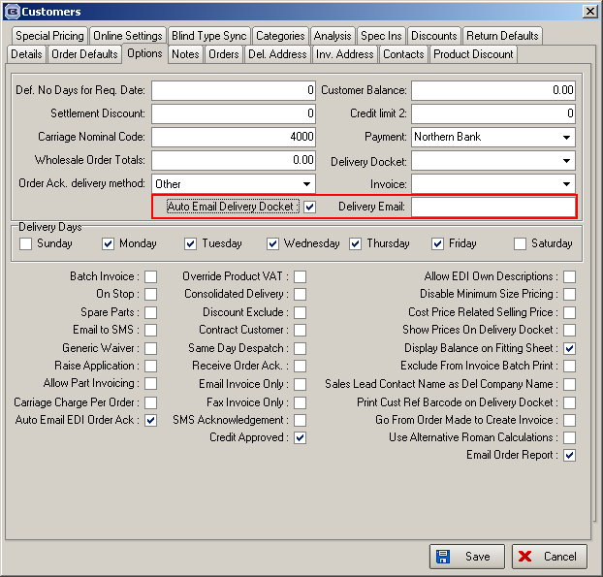

There is also a parameter in Administration to say whether a delivery docket pdf should be sent or not.

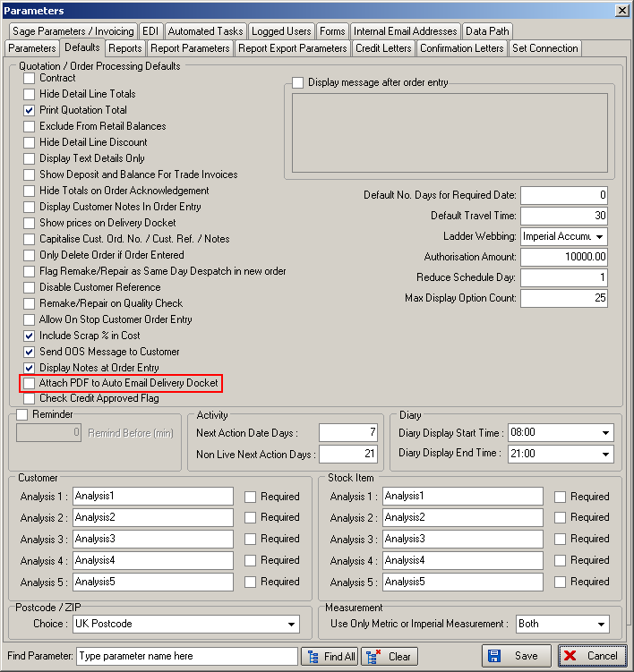

2040. Quotation – Bespoke 16

If location on a detail line is the same as the previous detail line, it now prints on the quote.

2041. Quotations

The ‘Survey Completed’ button is now called ‘Estimating Survey’. If ‘Survey Required’ is set to true in the quotation, a further button called ‘Manufacturing Survey’ is displayed.

It is therefore possible that two surveys may be done for a job. The estimating survey is required if ‘Survey Required’ is true and this survey has to be done before the quotation can be converted to an order. The manufacturing survey can be carried out at either the quote or order stage.

For ‘Manufacturing Survey’, it is possible to record that an order is only part manufacturing surveyed as well as not done of fully surveyed. So we will have ‘Not Surveyed’, ‘Part Surveyed’ and ‘Fully Surveyed’.

‘Survey Completed’ and ‘Manufacturing Survey Status’ are now both column choices in the quotation enquiry. We have different colour choices for the manufacturing survey status column.

2042. Quotations

There is a new button called ‘Estimating Check List’. This opens a form where there will be a list of items to be flagged as checked. When these are checked, a history record will be written.

There is a new system table called ‘Estimating Check List’ to store checklist texts. This is a description text field.

2043. Order Processing > Orders

It is now possible to print out an order overview document. This is a standalone report that has no effect on the order status. There is a new button on the order amend enquiry form called ‘Sales Info Sheet’. It has button visibility permission.

2044. Order Processing > Orders

There is a new button on the order amend enquiry form called ‘Install Info’. This has fields for ‘Manufacturing Survey Date’, ‘Install Date’, ‘Install Notes’, ‘Confirmed Install with Site’, and ‘Fitting Appointments Confirmed’. There is also a field for ‘Manufacturing Survey Status’ (which may or may not have been filled in the quotation). ‘Manufacturing Survey Date’ and ‘Install Date’ are dates, ‘Install Notes’ is a text field, ‘Confirmed Install with Site’ and ‘Fitting appointments Confirmed’ are flags. These fields are also all column choices in the order amend enquiry form.

2046. Customers

There is a new credit control flag against customer which can be checked when an order is created. This flag is called ‘Credit Approved’ in the customer record.

There is a new parameter called ‘Check Credit Approved Flag’. If this is set to true in Administration > Parameters, then when an order is entered (or converted from a quotation), if ‘Credit Approved’ is false in the customer record, the order goes on credit hold.

2050. Quotation > Create Order

At the moment we hold a job reference against a quote. What can happen is that a quotation can become multiple orders, but later on a further quotation will be added, and is tied to the original quote by job no / ref. We now pull that ref through to the order so all orders for that job / contract can be tied together.

We may then have multiple orders which all have the same job reference held against them.

2052. Despatch Status

It is now possible to change ‘Despatched’ status to ‘Installed’. This can be done by changing the ‘Order Status’ record description in System Tables > ‘Order Status Codes’ and it will still apply the colour in the order status field in ‘Order Amend Enquiry’.

2053. Archive Enquiry

It is now possible to bring a job back for snagging purposes (ie minor fixes). We have used the ‘Remake/Repair/Redespatch’ button to do this with one small amendment – we do not want to bring back any blind detail lines – just the order header along with the contract number.

2054. Order Enquiry

We now hold ‘Install Date’ and ‘Manufacturing Survey Status’ fields as column choices.

2055. Fitting Appointments

It is now possible to copy diary appointments – in diary and also in Orders > Appointments. This is required because more than one employee may be required for a job – in particular for fittings.

2058. Credit Note – Bespoke 30

There is now a credit note print that will fit onto the same stationery as ‘Invoice – Bespoke 30’, the onlt difference being that it says ‘CREDIT NOTE’ instead of ‘INVOICE’ and the credits are not batched – there will be one credit note print per credit note.

2059. Production Lists > Production List By Customer

One of our customers requested a new page for each customer. This is nowa choice before the report is printed called ‘Page Break by Customer’.

