Blindata Release Note 5.2.7 

4 February 2011

Bug Fixes and Enhancements

3206. Credit Notes

The date that is on the credit note was not the one being used when doing sales analysis reports. This was happening because if the credit note date is altered in the credit note form, it should also have updated the dat_invoice field in the Order table. Fixed.

Also, when you update the ‘Credit Note Date’ in the ‘Status Fields’ button, it now also updates the correct date.

3268. Pricing > Discounts

Several problems have been discovered with the new Discounts form. It is also very slow. For the time being we have reverted to the old discount form until we analyse this properly.

3270. Order Processing > Orders

If ‘Allow Proforma Edit’ in Administration > Parameters = false and ‘Edit Proforma Order’ = true, the user is allowed to edit ALL the fields in an order (as if it was a normal order).

If ‘Allow Proforma Edit’ in Administration > Parameters = false and ‘Edit Proforma Order’ = false, it is not possible to edit a proforma order.

3271. Order Processing > Orders

If ‘Credit Hold at Order Entry’ is set to true, then if an order is amended, it can only be set automatically to ‘On Credit Hold’ if the status of the order is ‘Order Entered’. In other words, the credit limit / balance functionality will only be applied when an order is saved at ‘Order Entered’ stage. This part works.

The credit control department can change an order to ‘On Credit Hold’ by using the ‘On Hold’ button. We made a change to include a new advanced permission called ‘On Hold Full Permission’. This did not work satisfactorily. The logic for ‘Credit Hold at Order Entry’ is no longer related to the ‘On Hold’ button. If a user has permission for ‘On Hold’, then they are able to use it up to and including order status ‘Order Manufactured’.

3273. Quotations

If you did a price uplift in the totals tab, it applied the uplift percentage to the quote text lines as well. It no longer does this.

3274 Quotations / Orders

If you entered a free type blind type as a component line, then applied a price uplift in the totals tab, when you went back to amend the component line, you could not change the uplift %. Fixed.

3275. Financials > Post Credits to Sage

The following items have been fixed.

- The credit note number was missing.
- ‘Invoice Date’ now says ‘Credit Date’.
- The date was incorrect.

New Work and Customer Requests

2027. Order Acknowledgement Email

There is a new parameter so that an order acknowledgement can be sent by email at the point it becomes WIP. This parameter is called ‘Email Order Ack at WIP’. If it is set to true, then an order acknowledgement is emailed when the order is changed to WIP. It is not possible to email an order manually (using the ‘Email Order Ack’ button) before this, but it is possible to do it afterwards.

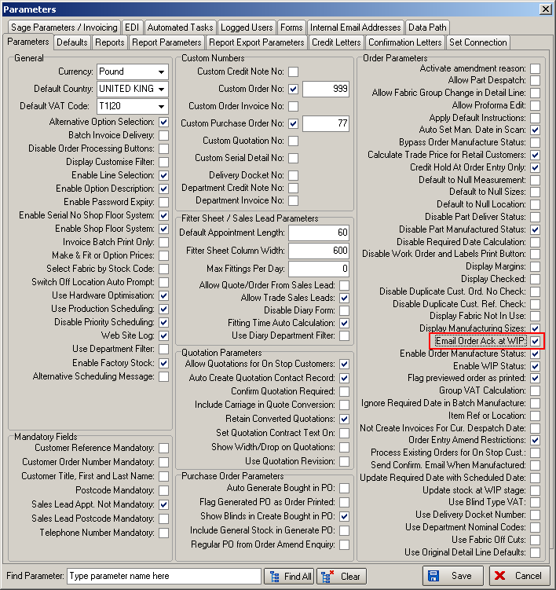

An order history record is also created for this order acknowledgement email.

2028. Out Of Stock Email

We added new functionality recently so that OOS emails could be sent to customers (Parameters > Send OOS Message to Customer). It produces text like this in the email, which is the same text as that sent if the email goes internally to the customer services email.

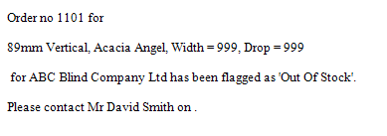

We have improved the subject and message within the email if it is going to the customer.

The subject is now:

[Company Name] Out Of Stock Message (where [Company Name] is the company name in ‘Company Details’.

[Company Name] Back In Stock Message (where [Company Name] is the company name in ‘Company Details’.

The body of the email message is picked up from one of two new fields in Administration > Company Details, called ‘OOS Email Text’ and ‘BIS Email Text’. These are added here.

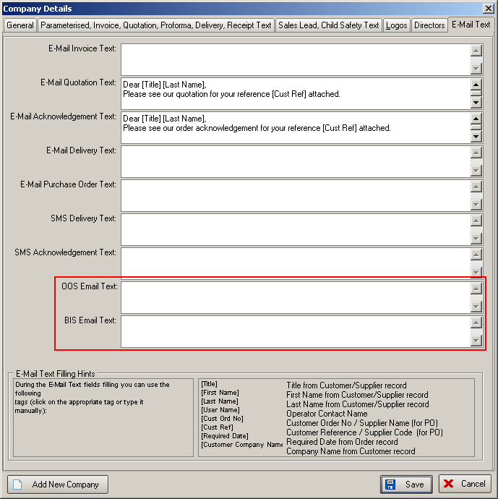

We then add the details of the blind that is out of stock to the email text.

2029. Contact Management

We have made some improvements to the contact management form.

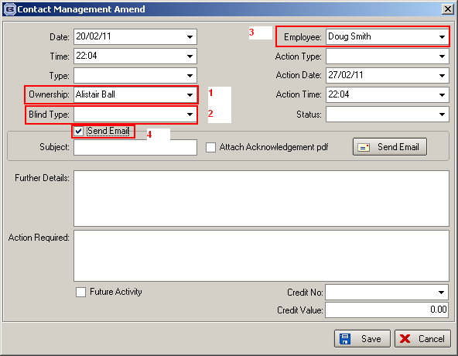

- ‘Ownership’ now defaults to the user who is entering the contact management record.
- It is now possible to have a choice of leaving blind type as an empty field.
- ‘Employee’ now defaults to the rep that is held against the order.
- There is now a flag called ‘Send Email’. If set to true, then three more fields should appear. The first will be called ‘Subject:’ and will be the subject for the email. The second will be a flag called ‘Attach Acknowledgement pdf’. If this is set to true, then the order acknowledgement will be attached to the email. The third field is called ‘Send Email’ and is self explanatory. If an email is sent, then it should be recorded in order history as ‘Contact Management Email Sent’. The email contains all the fields in the contact management record except ‘Future Activity’, ‘Credit No’ and ‘Credit Value’.

2030. Acknowledgement – Bespoke 31

There is a new report called ‘Acknowledgement – Bespoke 31’. This is in ‘Report Parameters’ and also ‘Report Export Parameters’ ie both print and pdf versions. It is based on ‘Acknowledgement – Laser Print (Letterhead Logo) with the following changes.

- The style of the logo and company details are similar to ‘Invoice – Bespoke 31 ie in line horizontally.
- Department has been removed.
- The ‘Cust Ref’ line has been completely removed and lines below in header moved up.
- ‘Required’ says ‘Delivery’.
- If a detail line has already been flagged as OOS, then this appears on the order ack. The line says ‘Fabric for this item is currently out of stock. We will inform you as soon as it becomes available’.

2033. Label – Bespoke 33A

‘Despatch Method’ has been colour coded for this report. We hold colour in the ‘Despatch Method’ table and print in colour on label eg Delivery Van Monday in green.

2034. Sales Analysis by Customer by Month

We now show both account code and account name on report (when you choose ‘Show Account Code’).

2035. Sales Analysis by Customer by Blind Type by Month

There is now a line for quantity as well as value. This goes between the values.

2036. Sales Analysis by Category

Previously this report only showed categories. We still group the records by category, but beneath that there is a breakdown by blind type as well.

2037. Sales Analysis by Blind Type (Weekly)

There is now a total for each day at the bottom of the report.

