Blindata Release Note 5.2.5 

21 January 2011

Bug Fixes and Enhancements

3246. Order Processing > Orders

An order could have status ‘Works Order Printed’ on one computer and ‘Order Entered’ on another if the page has not been refreshed, and the blind details could be changed on the order entered computer.

There are lot of routines on the “Order Amend Enquiry” form which take data from page which might be not refreshed. We think it is the cause of this bug.

3250. Order Processing > Paid Proforma

If you try to ‘Create Order’ from the ‘Paid Proforma’ form, the following error occurred. Fixed.

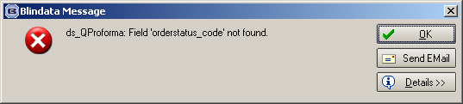

3252. Production Control Sheet

If a detail line has a quantity > 1, it now prints on the report.

3253. Label Print – Bespoke 29

If blind identifier = ‘Vertical’ or ‘Vanes Only’, the ‘Fabric Length’ now prints on the large label. The customer says this was working.

3254. Invoice – Laser Print (Letterhead Logo)

If several lines of text are entered in the ‘Comment’ line for a component, they now print on the invoice. The detail line is expandable so it prints all lines.

3255. Blind Details > Blind Types

If you tried to enter a new blind type, it could be saved because we could enter a ‘Measure To Default’. This is because we moved the ‘Blind Type Setup’ tab. We have removed the validation from the ‘Measure To Default’ field.

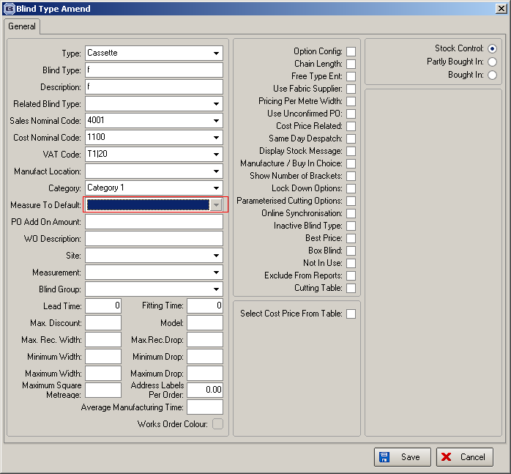

New Work and Customer Requests

2014. Administration > Sage Utilities

When we run ‘Create/Update Customer Details from Sage’, there was a problem with new customers in Sage that then have to be added to Blindata. The following fields were not filled in and an order could not be entered until the user had updated the fields in the Blindata customer record.

area_id
department_id
class_id
price_id
despatch_id
represent_id
nomcode
mon
tue
wed
thu
fri
is_batch_invoice

To solve this, there is a new tab in the ‘Sage Utilities’ form called ‘Defaults’. In this tab, there are lookups for these fields (same lookups as in Customer record) so when new customers are imported to Blindata from Sage using ‘Sage Utilities’, these defaults are used to fill the fields in the customer record. If the ‘Defaults’ tab is not filled in properly and ‘Create/Update Customer Details from Sage’ is run, a message should appear saying ‘Please fill in Defaults’ before running this routine.

2015. Acknowledgement – Scheduled Date

This text has now been changed to ‘Contact customer services for more information’.

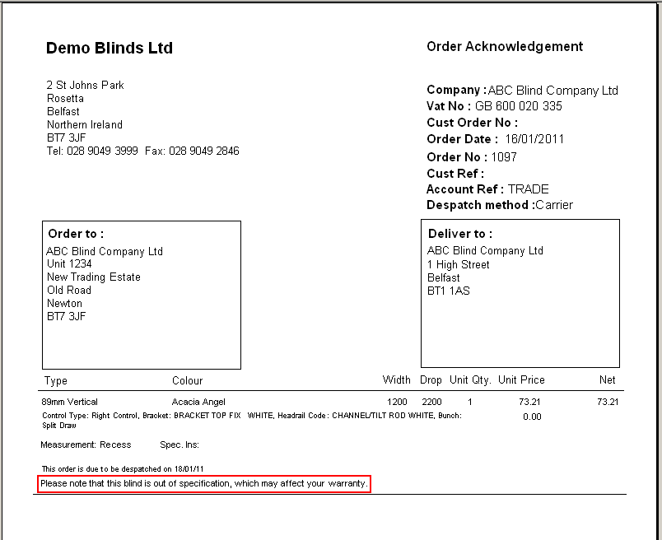

2016. Order Processing > Orders

We have made an alteration to the way the amount of fabric is calculated if a panel blind is made using roller fabric. We introduced code a while ago to do the calculation for panels ie if calculator = ‘Width or Drop’ and blind identifier = Panel, then calculate the amount of fabric according to the number of panels.

A problem has arisen where the panel blinds do not look good if width is used. We therefore now calculate the amount of panel blind fabric based only on drop ie the fabric will always be calculated using ‘Drop’ calculator. Therefore if blind identifier = Panel and calculator = ‘Width or Drop’, calculator ‘Drop’ is used instead.

Also, if the total of the panel widths > roll width, then the BOM quantity previously did not get calculated properly. It now doubles the quantity of fabric required, or possibly triples it. For example, if 3 panels are required that are 900mm wide and the drop is 2200mm, and the roll width is 1900mm, then 4400mm of fabric would be required. If 5 panels of this size were required, then 6600mm would be required.

2017. EDI Import (Automated)

There are no longer any pop-ups during the EDI Import process. These should be written into the log instead. For example, this was happening with auto EDI Email acknowledgements. Occasional pop ups occurred on the EDI Import client when a customer was flagged for fax acknowledgements which then stopped the EDI Import process.

2018. Works Order – Label 1

The chain length percentage now print on this report if ‘Chain Length’ = true.

2019. Stock Setup > Stock Items

It is now possible to enter a quantity to 2 decimal places on the ‘Additional Items’ tab of the ‘Stock Items’ form.

2020. Order Processing > Orders

If an order is split, the original order is now flagged as ‘Carriage Override’.

2022. Order Processing > Orders

We now hold ‘Return’ defaults by customer. A new tab has been required in the Customer form called ‘Return Defaults’. It holds ‘Measure To’ and ‘Return’. If there is a record in here, it will be used when a detail line with a ‘Return’ is entered or imported via EDI.

2023. Stock Setup > Stock Items

There is now a column choice for ‘Location’.

2024. Administration > Archiving

It is now possible to delete records from the archive. There is a button that is only visible if you are pointing at a month in ‘Archived Orders’. If this is clicked a message appears saying ‘Are you sure you want to do this?. Deleted records cannot be recovered’. If the user clicks ‘Yes’, then the orders for that month are deleted completely from the database.

There is an advanced permission for this button in Administration > Users.

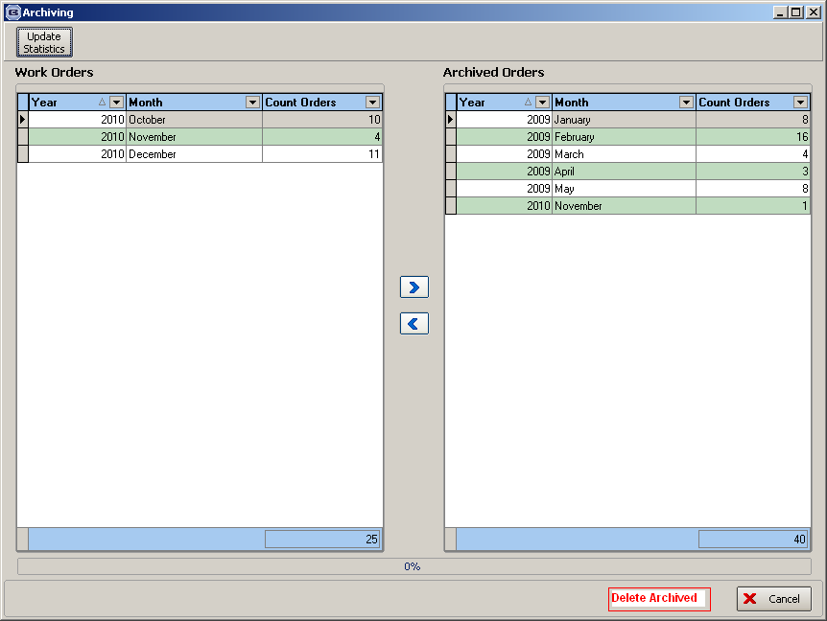

2025. Financials > Create Invoices

If a customer is set up with ‘Batch Invoice’ = true and ‘Carriage Charge Per Order’ = false and ‘FOC Carriage’ = false, when invoices are created, then if the total of the orders per invoice number is less than the carriage free amount, then carriage is only applied to the last order.

