Blindata Release Note 5.2.4 

14 January 2011

Bug Fixes and Enhancements

3240. Sales Analysis by Blind Type by Fabric

This report has reverted to the same as it was in v4.4.8. We made a change so that miscellaneous lines always had a quantity of 1 but this should not apply to this report.

New Work and Customer Requests

2010. Fabric Optimisation

We have made an improvement to the fabric optimisation so we can look at all possible combinations and then select the best one.

Previously, on occasions, the optimisation routine did not always work out the most efficient way to cut the fabric. Here is an example using a ‘Width or Drop’ (turnable) fabric.

We have also put more information in the ‘Optimisation Print’. We now show the width and drop of the blind as well as the width and drop of the piece of fabric that has to be cut. Also, we have one colour for a piece that has not been turned and another colour for a piece that has been turned.

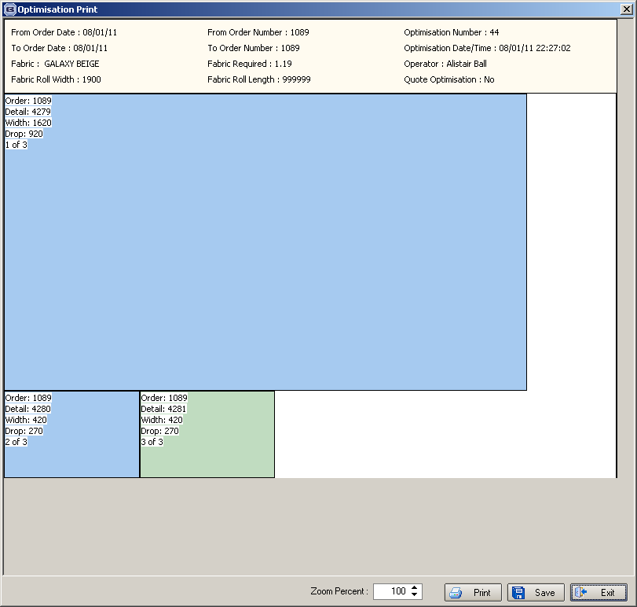

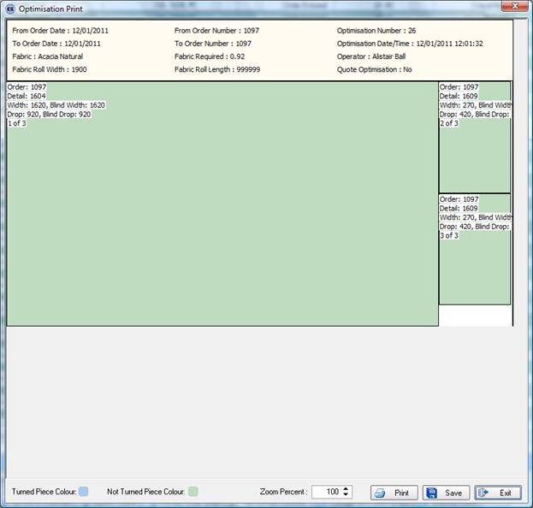

2011. Fabric Optimisation

When the optimisation print is done, it is now done to scale.

2012. Venetian Barcode 2

When the Venetian barcode 2 is generated, it looks at the ‘Model’ field that is held against the blind type record. We have added some more model descriptions with their mapped numbers.

HW01 -> 06
HW02 -> 07
WA01 -> 08
WA02 -> 09

EU25 -> 01
BB25 -> 02
WD25 -> 03
PI22 -> 04
EU35 -> 05
BB35 -> 06
PV50 -> 07
EU50 -> 08

